Lecture-12 Transformation of E&M field
- Let us consider two plates in the xz-plane in Frame $S$. The surface charge density $±σ$
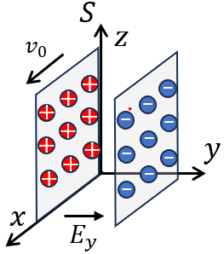
$E_{y}=\frac{σ}{ϵ_{0}} \left(SI\right)$ ( $E_{y}=4πσ \left(CGS\right)$ )
The two plates move along x-direction at the speed $v_{0}$
- $j_{x}=σv_{0}$, thus$B_{z}=μ_{0}j_{x}=μ_{0}σv_{0} \left(SI\right)$ ($B_{z}=\frac{4π}{c}σv_{0} (CGS)$)

We consider another frame $S’$, which moves at the speed $u$ along the x-axis with respect to S, what the field observed in $S’$?
In $S’$, the velocity of the two plates:
$v_{0}^{'}=\frac{v_{0}-u}{1-v_{0}u/c^{2}}=c\frac{β_{0}-β}{1-β_{0}β}$ here $β_{0}=\frac{v_{0}}{c}$ and $β=\frac{u}{c}$
In $S’$, the charge density $σ^{'}=σ\frac{γ_{0}^{'}}{γ_{0}}$ (See Lec. 9, Sec. 6)
here $γ_{0}=\frac{1}{\sqrt{1-β_{0}^{2}}}$ and $γ_{0}^{'}=\frac{1}{\sqrt{1-{\left(\frac{β_{0}-β}{1-β_{0}β}\right)}^{2}}}=\frac{1-β_{0}β}{\sqrt{(1-β_{0}^{2})(1-β^{2})}}$
- $σ^{'}=σ\frac{1-β_{0}β}{\sqrt{((1-β^{2})}}=σγ(1-β_{0}β)$ here $γ=\frac{1}{\sqrt{1-β^{2}}}$
Thus $j_{x}^{'}= σ^{'}v_{0}^{'}= γσ\left(1-β_{0}β\right)∙ c\frac{β_{0}-β}{1-β_{0}β}=σc γ\left(β_{0}-β\right)$
$$E_{y}^{'}=\frac{σ^{'}}{ϵ_{0}}=\frac{σ}{ϵ_{0}}γ(1-β_{0}β)$$
- $B_{z}^{'}=μ_{0}j_{x}^{'}=μ_{0}σ^{'}v_{0}^{'}=μ_{0}σcγ\left(β_{0}-β\right)=μ_{0}γ(σv_{0}-σu)$
- $\left\{\begin{aligned}E_{y}^{'}=γ\left(E_{y}-cβB_{z}\right) \\ B_{z}^{'}=γ(-\frac{β}{c}E_{y}+B_{z})\end{aligned}\right.$ ------ $SI$

We can derive the rules for other components: $S’$ is moving at speed of $v$ along the x-direction with respect to $S$:
$\begin{aligned}&E_{x}^{'}=E_{x}, E_{y}^{'}=γ(E_{y}-cβB_{z}), E_{z}^{'}=γ(E_{z}+cβB_{y}) \\ &B_{x}^{'}=B_{x}, B_{y}^{'}=γ\left(\frac{β}{c}E_{z}+B_{y}\right) , B_{z}^{'}=γ({-\frac{β}{c}E_{y}+B}_{z})\end{aligned}$ ------ $SI$

Or $\begin{aligned}&E_{x}^{'}=E_{x}, E_{y}^{'}=γ(E_{y}-βB_{z}), E_{z}^{'}=γ(E_{z}+βB_{y}) \\ &B_{x}^{'}=B_{x}, B_{y}^{'}=γ\left(B_{y}+βE_{z}\right) , B_{z}^{'}=γ(B_{z}-βE_{y})\end{aligned}$ -------CGS

Case 1: To the first order ($γ=1$, i.e. $u≪c$) ${\overset{⃑}{E}}^{'}≈\overset{⃑}{E}+\overset{⃑}{u}×\overset{⃑}{B}$
$${\overset{⃑}{B}}^{'}≈\overset{⃑}{B}-\frac{\overset{⃑}{u}}{c^{2}}×\overset{⃑}{E}$$
Case 2: Suppose in the $S$ with $B=0$, then:
$\begin{aligned}&E_{x}^{'}=E_{x}, E_{y}^{'}=γE_{y}, E_{z}^{'}=γE_{z} \\ &B_{x}^{'}=0, B_{y}^{'}=γ\frac{β}{c}E_{z} , B_{z}^{'}=-γ\frac{β}{c}E_{y}\end{aligned}$
$B_{x}^{'}=0, B_{y}^{'}=\frac{β}{c}E_{z}^{'} , B_{z}^{'}=-\frac{β}{c}E_{y}^{'}$
Then ${\overset{⃑}{B}}^{'}=-\frac{\overset{⃑}{u}}{c^{2}}×\overset{⃑}{E}'$
Similarly, in the $S$ with $E=0$, then in $S'$: ${\overset{⃑}{E}}^{'}=\overset{⃑}{u}×\overset{⃑}{B}'$

- A conducting rod moving in $B$-field ($v≪c$)
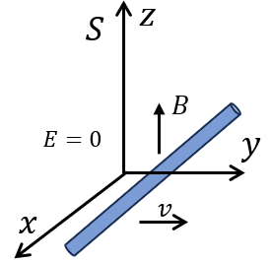
In $S$ frame, $E=0, B=B\hat{z},$ the rod is moving along y-direction.
Lorenz force $\overset{⃑}{f}=q\overset{⃑}{v}×\overset{⃑}{B}$
$\overset{⃑}{f}$ drives that charge accumulates at ends （right hand rule）.
- $q\overset{⃑}{E}=-\overset{⃑}{f}$
- $\overset{⃑}{E}=-\overset{⃑}{v}×\overset{⃑}{B}$
$\overset{⃑}{E}:$ induced internal field.
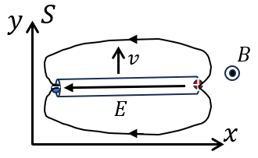
In $S:$
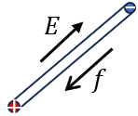

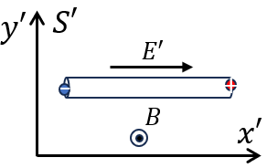
Now let us sit the co-moving frame $S'$ ($u=v$) with $S$. For the moment, we neglect the rod, then we will see in the frame $S'$, there exist ${\overset{⃑}{B}}^{'}$ and ${\overset{⃑}{E}}^{'}$:
$${\overset{⃑}{E}}^{'}=\overset{⃑}{v}×\overset{⃑}{B}'≈\overset{⃑}{v}×\overset{⃑}{B}$$
${\overset{⃑}{B}}^{'}≈\overset{⃑}{B}-\frac{\overset{⃑}{v}}{c^{2}}×\overset{⃑}{E}≈\overset{⃑}{B}$ up to $β^{2}$

In $S'$, the rod is at rest, ${\overset{⃑}{E}}^{'}$ induces charge distribution in the rod, which in turn rebalance the field resulting in no electric field inside the rod! Therefore, there is no motion of electric charge!

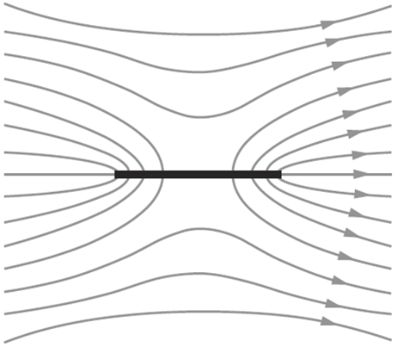
Total $\overset{⃑}{E}$ distribution in $S'$

