Lecture-13：Electro-magnetic induction
- A loop of wire moving in non-uniform B-field, Lab frame with zero $E$ field.
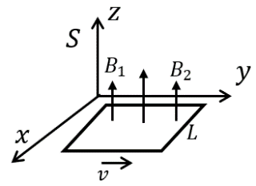

Two edges (left and right) will feel Lorenz force along the loop and for the other edges, the Lorenz force is perpendicular to the loop.

Work: $\oint{\overset{⃑}{F}∙d\overset{⃑}{l}}=qv(B_{1}-B_{2})L$ left-right
Define: electromotive force ($emf$): $�!E=\frac{\oint{\overset{⃑}{F}∙d\overset{⃑}{l}}}{q}=Lv(B_{1}-B_{2})$
$emf$ old definition: the work per unit charge involved in moving a charge around a circuit containing a voltaic cell. Now it’s broadened to include any influence that causes charge to circulate around a closed path.
Or we define magnetic flux: $Φ=\iint{d\overset{⃑}{a}∙\overset{⃑}{B}}$
$\frac{dΦ}{dt}=\frac{B_{2}Lv∆t-B_{1}Lv∆t}{∆t}=Lv(B_{2}-B_{1})$
- $�!E=-\frac{dΦ}{dt}$ ----$SI$ $E=-\frac{1}{c}\frac{dΦ}{dt}$ ----$CGS$
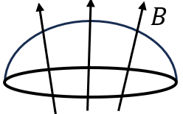
Due to the fact there is no magneticd charge $∇∙\overset{⃑}{B}=0$, the flux penetrating a surface only depends on the boundary. As long as the boundary is specified, it doesn’t matter which surfaces you measure.

$*** �!E$ can also be represented as $�!E=\frac{\oint{\overset{⃑}{F}∙d\overset{⃑}{l}}}{q}=\oint{(\overset{⃑}{v}×\overset{⃑}{B})∙d\overset{⃑}{l}}$
Lorenz’s law gives rise to $E=-\frac{dΦ}{dt}$ !!!
The flux generated by the induced current should be in an opposite direction to the change of $Φ$ (not $Φ$ itself, but $dΦ$).
*** Lenz’s law: The direction of the induced electromotive force is such that the induced current creates a magnetic field that opposes the change in flux.

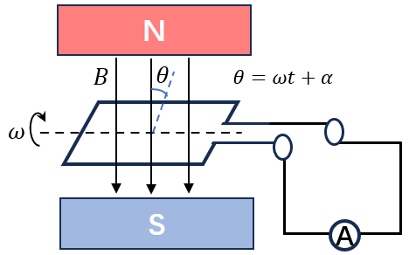
Example: Generator,
$Φ=BS\sin{(ωt+α)} S$: the area.
$E=-\frac{dΦ}{dt}=-BSω\cos{(ωt+α)}$
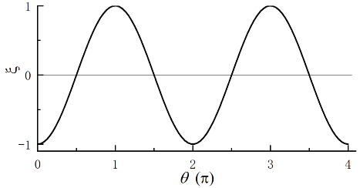

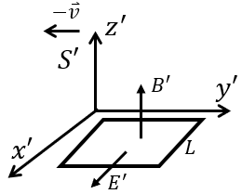
- A stationary loop in a changing $B$ field
In the comoving frame $S'$ of the loop (with $\overset{⃑}{v}$ with respect to $S$, there exists electric field $E'$. $emf$ is purely generated by $E'$.
${\overset{⃑}{E}}^{'}=\overset{⃑}{v}×\overset{⃑}{B}'$ (see Lec. 12, Ex. 1)
$$E^{'}=\oint{\overset{⃑}{E}'∙d\overset{⃑}{l}}=Lv(B_{1}^{'}-B_{2}^{'})$$
Now, $B'$ is moving with $-\overset{⃑}{v}$ in $S'$. Hence for the flux lost or gained at either end of the
loop in a time interval $dt'$： $dΦ^{'}=LvB_{2}^{'}dt^{'}-LvB_{1}^{'}dt^{'}$
$E'=-\frac{dΦ'}{dt'}$
Please note that we have to use $E'$, $B'$ and $t'$, consistently.
Faraday’s law $\oint{\overset{⃑}{E}∙d\overset{⃑}{l}}=-\frac{d}{dt}\iint{\overset{⃑}{B}∙d\overset{⃑}{a}}$
$∇×\overset{⃑}{E}=-\frac{∂\overset{⃑}{B}}{∂t}$ SI according to Stokes’ law
$∇×\overset{⃑}{E}=-\frac{1}{c}\frac{∂\overset{⃑}{B}}{∂t}$ ---CGS
- Mutual inductance
Consider two current loops $C_{1}$ and $C_{2}$, position fixed
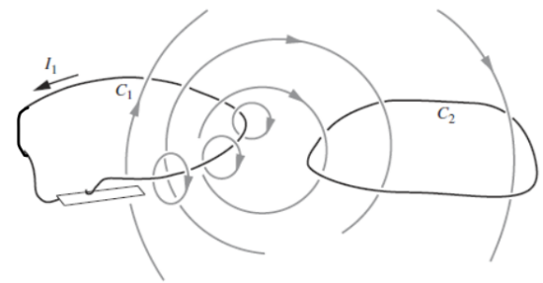
Flux from $C_{1}$ through $C_{2}$ :
$$Φ_{21}=\iint_{S_{2}}{\overset{⃑}{B}∙d{\overset{⃑}{a}}_{2}}=I_{1}*const.$$
$Φ_{21}$: flux in $C_{2}$ generated by $C_{1}$.
$$E_{21}=-const.\frac{dI_{1}}{dt}=-M_{21}\frac{dI_{1}}{dt}$$
$$E_{12}=-M_{12}\frac{dI_{2}}{dt}$$
$M_{21}, M_{12}$ is mutual inductance.
Example: two coplanar, concentric rings: $C_{2}$ enclosed by $C_{1}$ $R_{2}≪R_{1}$
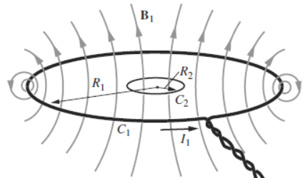
$B_{1}$ at the center of the ring
$B_{1}=\frac{μ_{0}I_{1}}{2R_{1}}$ (Lec. 11, Sec. 3)
$Φ_{21}=\left(πR_{2}^{2}\right)\frac{μ_{0}I_{1}}{2R_{1}}=\frac{πμ_{0}R_{2}^{2}I_{1}}{2R_{1}}$
$M_{21}=\frac{Φ_{21}}{I_{1}}=\frac{πμ_{0}R_{2}^{2}}{2R_{1}}$ or $\frac{1}{c}\frac{2π^{2}R_{2}^{2}}{cR_{1}}---CGS$
And the $emf$ induced in $C_{2}:$
$$E_{21}=-M_{21}\frac{dI_{1}}{dt}=-\frac{πμ_{0}R_{2}^{2}}{2R_{1}}\frac{dI_{1}}{dt}$$
****SI Unit of inductance: [M]: Henry=[volt]/[amp/s] Named after Joseph Henry.
**** CGS Unit of inductance: [statvolt]/[esu/s] or [s]²/[cm] ([statvolt]=[esu]/[cm])
$μ_{0}=4π∙{10}^{-7} kg m/C$ $M_{21}=\left(2π^{2}∙{10}^{-7} kg\frac{m}{C}\right)R_{2}^{2}/R_{1}$
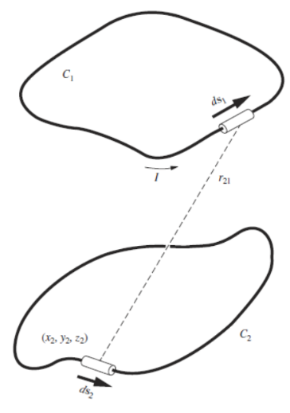
Reciprocal theorem: $M_{21}=M_{12}$
Proof: in $C_{2}:$ $Φ_{21}=\int_{C_{2}}{{\overset{⃑}{A}}_{21}({\overset{⃑}{r}}_{2})∙d{\overset{⃑}{l}}_{2}}$ and ${\overset{⃑}{A}}_{21}\left({\overset{⃑}{r}}_{2}\right)=\frac{μ_{0}}{4π}\int_{C_{1}}{\frac{I_{1}\left({\overset{⃑}{r}}_{1}\right)d{\overset{⃑}{l}}_{1}}{r_{21}}}$
- $Φ_{21}=\frac{μ_{0}I_{1}}{4π}\int_{C_{2}}{\int_{C_{1}}{\frac{d{\overset{⃑}{l}}_{2}d{\overset{⃑}{l}}_{1}}{r_{21}}}}$
Similarly: $Φ_{12}=\frac{μ_{0}I_{2}}{4π}\int_{C_{1}}{\int_{C_{2}}{\frac{d{\overset{⃑}{l}}_{1}d{\overset{⃑}{l}}_{2}}{r_{12}}}}$
Here: $r_{12}=r_{21}$ $\frac{Φ_{21}}{I_{1}}=\frac{Φ_{12}}{I_{2}}$ $M_{21}=M_{12}=\frac{μ_{0}}{4π}\int_{C_{2}}{\int_{C_{1}}{\frac{d{\overset{⃑}{l}}_{2}d{\overset{⃑}{l}}_{1}}{r_{21}}}}$

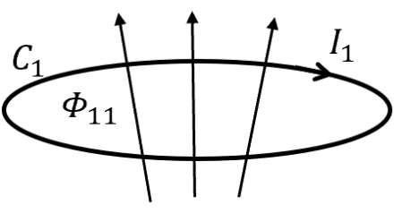
- Self-inductance – the $emf$ in loop $C_{1}$ generated by the change of current $I_{1}$
$$E_{11}=-\frac{dΦ_{11}}{dt}=-L_{1}\frac{dI_{1}}{dt}$$
$Φ_{11}:$ the flux through circuit 1 is from field $B_{1}$ generated by the current $I_{1}$ in circuit 1.
$L_{1}$: self-inductance of the circuit. 。，们
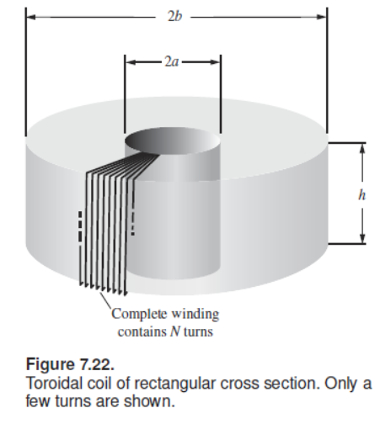
***Example: Consider a Toroidal coil:
$$B∙2πr=μ_{0}NI$$
$$B=\frac{μ_{0}N}{2πr}I$$
- $Φ\left(one turn\right)=\int_{a}^{b}{Bhdr}=h\int_{a}^{b}{\frac{μ_{0}N}{2πr}Idr}$
$=\frac{μ_{0}hN}{2π}I ln\left(b/a\right)$
Then flux threading the circuit of N turns:
$$Φ\left(n turns\right)=\frac{μ_{0}hN^{2}}{2π}I ln\left(b/a\right)$$
- $E=-\frac{dΦ}{dt}=$-$\frac{μ_{0}hN^{2}}{2π} ln\left(b/a\right)\frac{dI}{dt}$
- $L=\frac{μ_{0}hN^{2}}{2π} ln\left(b/a\right)$ $L=\frac{2hN^{2}}{c^{2}} ln\left(b/a\right)$ ----$CGS$
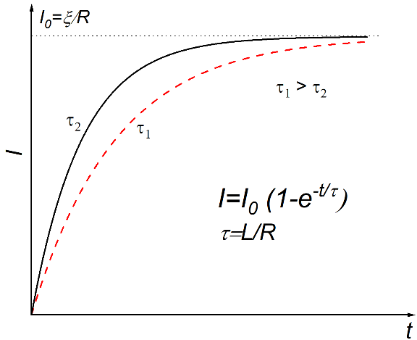
- L-R circuit
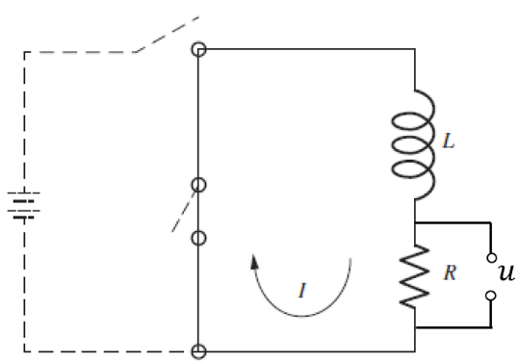

i: turn on $u=IR=E_{0}-L\frac{dI}{dt}$
Or $\left\{\begin{aligned} \frac{dI}{dt}=-I\frac{R}{L}+\frac{E_{0}}{L}=-\frac{R}{L}(I-\frac{E_{0}}{R}) \\ I\left(t=0\right)=0\end{aligned}\right.$
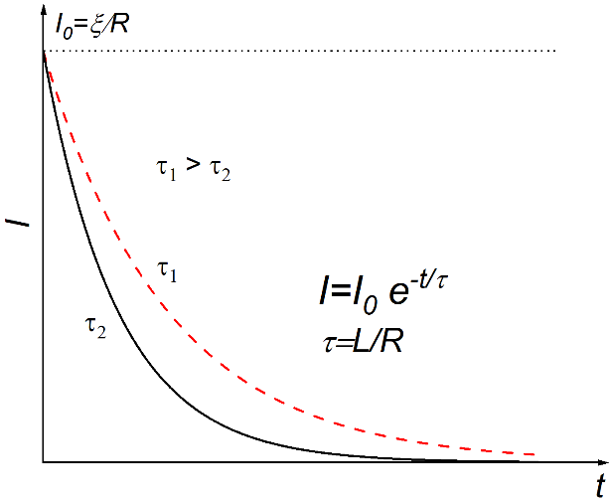
- $I-\frac{E_{0}}{R}=-\frac{E_{0}}{R}e^{-\frac{R}{L}t}$ $I=\frac{E_{0}}{R}(1-e^{- t/(L/R)})$
Define: $τ=L/R$ relaxation time and $I_{0}=\frac{E_{0}}{R}$
$$I=I_{0}(1-e^{-\frac{t}{τ}})$$
$L$ prevent the jump of current.
i: turn off $\left\{\begin{aligned}-L\frac{dI}{dt}=IR \\ I\left(t=0\right)=I_{0}\end{aligned}\right.$
- $I=I_{0}e^{-t/(L/R)}=I_{0}e^{-t/τ}$

- Energy stored in magnetic field
The energy dissipation is generated by $R$ (turn off case)
$$U=\int_{0}^{∞}{I^{2}\left(t\right)Rdt}=I_{0}^{2}R\int_{0}^{∞}{e^{-2t/τ}dt}=\frac{τ}{2}I_{0}^{2}R=\frac{1}{2}LI_{0}^{2}$$
This amount of energy was initially stored in the coil as magnetic energy.
- $U=\frac{1}{2}LI^{2}$
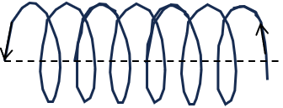
***Consider a long coil:
Flux $Φ=NBS$ , $B=μ_{0}NI/l$ $Φ=μ_{0}N^{2}SI/l$
- $L= μ_{0}N^{2}S/l$
- $U=\frac{1}{2}LI^{2}=\frac{1}{2}μ_{0}N^{2}\frac{S}{l}I^{2}=\frac{1}{2μ_{0}}B^{2}lS=\frac{1}{2μ_{0}}B^{2} ∙Vol$
- Magnetic energy density: $u=\frac{1}{2μ_{0}}B^{2}$ or $\frac{1}{8π}B^{2}$ ----$CGS$
- In general case: $U=\frac{1}{2μ_{0}}\int{B^{2}dv}$
For a E&B field: $u=\frac{1}{2}ϵ_{0}E^{2}+ \frac{1}{2μ_{0}}B^{2}$ or $u=\frac{1}{8π}(E^{2}+ B^{2})$

Joseph Henry (December 17, 1797 – May 13, 1878) American scientist
He discovered the electromagnetic phenomenon of self-inductance. He also discovered mutual inductance independently of Michael Faraday, though Faraday was the first to make the discovery and publish his results. Henry developed the electromagnet into a practical device. He invented a precursor to the electric doorbell (specifically a bell that could be rung at a distance via an electric wire, 1831) and electric relay (1835). His work on the electromagnetic relay was the basis of the practical electrical telegraph. In his honor, the SI unit of inductance is named the henry (plural: henries; symbol: H).

