Lecture-6 Electric current
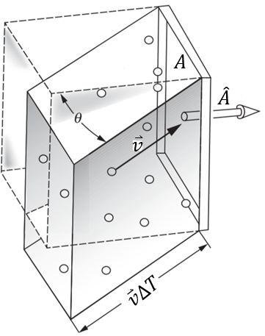
- Current$I$: the amount of charge passing a fixed mark on the wire in unit time.
$Q=nev∆T\cos{θ}A$ : charge across a section at $∆T$
$I=\frac{Q}{∆T}=nev Acosθ=nevA_{⊥}=ne\overset{⃑}{v}∙\overset{⃑}{A}$
$n:$ carrier density. $ρ=ne$
*** $I$ is scalar.
- Current density $\overset{⃑}{J}$: the current per unit area
$\overset{⃑}{J}=ne\overset{⃑}{v}$
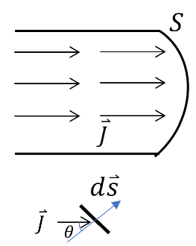
$\overset{⃑}{v}:$ drift velocity: the average velocity of charge carriers driven by external field.
$\overset{⃑}{J}$ is a vector.
$$dI=\overset{⃑}{J}∙d\overset{⃑}{s}$$
$$I=\int{dI}=\int{\overset{⃑}{J}∙d\overset{⃑}{s}}=\int{\overset{⃑}{J}\cos{θ}∙ds}$$
Or $I=\int{dI}=\int{\overset{⃑}{J}∙d\overset{⃑}{s}}=\int{ne\overset{⃑}{v}∙d\overset{⃑}{s}}$
- Steady current
A steady or stationary current system: the current density vector $\overset{⃑}{J}$ remains constant in time everywhere.
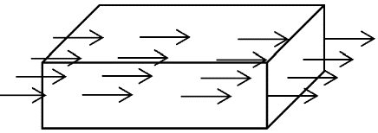
Charge conservation: $∯{\overset{⃑}{J}∙d\overset{⃑}{s}}=-\frac{d}{dt}\int_{V}{ρdV}$
Gauss theorem: $\frac{d}{dt}\int_{V}{∇∙\overset{⃑}{J}dV}=-\frac{d}{dt}\int_{V}{ρdV}$
$∇∙\overset{⃑}{J}+\frac{∂ρ}{∂t}=0$ Charge continuity function
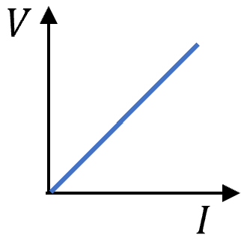
For steady state: $∇∙\overset{⃑}{J}=0$
- Ohm’s law $V=IR$
Current density is linear with the electric field.
$\overset{⃑}{J}=σ\overset{⃑}{E}$ $σ:$ conductivity, unit: ${\left(Ω.cm\right)}^{-1}$ or $S/cm.$ $S$: siemens.
Given $I=JS$ and $V=Ed$, $R=\frac{l}{σS}=\frac{ρl}{S}$, $ρ=1/σ:$ resistivity (Assuming uniform $σ$).
- For an isotropic material, $σ$ is a scalar, $\overset{⃑}{J}$ and $\overset{⃑}{E}$ has the same direction.
- In an anisotropic material (crystal with anisotropic structure, e.g. layered structure: graphite), $σ$ becomes a tensor.
$σ$=$\left(\begin{matrix}σ_{11} & σ_{12} & σ_{13} \\ σ_{21} & σ_{22} & σ_{23} \\ σ_{31} & σ_{32} & σ_{33}\end{matrix}\right)$ $σ_{ij}=σ_{ji}$
*** $\overset{⃑}{J}$ and $\overset{⃑}{E}$ still have a linear relation, but their direction is not necessarily the same .
If we choose a coordinator-axis along the three high symmetry lines of lattice, then the tensor reduced to
$σ$=$\left(\begin{matrix}σ_{11} & 0 & 0 \\ 0 & σ_{22} & 0 \\ 0 & 0 & σ_{33}\end{matrix}\right)$
$$\left(\begin{matrix}j_{x} \\ j_{y} \\ j_{z}\end{matrix}\right)=\left(\begin{matrix}σ_{11} & 0 & 0 \\ 0 & σ_{22} & 0 \\ 0 & 0 & σ_{33}\end{matrix}\right)\left(\begin{matrix}E_{x} \\ E_{y} \\ E_{z}\end{matrix}\right)$$
Resistivity tensor $\overset{⃑}{E}=ρ\overset{⃑}{J}$, $ρ=σ^{-1}$.
For a diagonal matrix, $ρ=\left(\begin{matrix}ρ_{11} & 0 & 0 \\ 0 & ρ_{22} & 0 \\ 0 & 0 & ρ_{33}\end{matrix}\right)=\left(\begin{matrix}σ_{11}^{-1} & 0 & 0 \\ 0 & σ_{22}^{-1} & 0 \\ 0 & 0 & σ_{33}^{-1}\end{matrix}\right)$
While for a general matrix, the matrix algebra is more complex. The $ρ$ element cannot be simply expressed by the inverse of corresponding $σ$ element.
Note: Ohm’ law is an empirical law, a generalization derived from experiment, not a theorem that must be universally obeyed. In fact, Ohm's law is bound to fail in the case of any particular material if the electric field is too strong (non-linear effect). We shall meet some interesting and useful materials in which "nonohmic" behavior occurs in rather weak fields, such as semiconductors and insulators.
*** In Lect. 5, we have learned $\overset{⃑}{E}$ is zero inside a conductor, you might be wondering why we are now talking about a nonzero internal field. In Lect. 5, we were dealing with static situations, in which all the charges have settled down after some initial motion. In this setup, the charges pile up at certain locations and create a field, cancelling the applied field. While dealing with currents in conductors, charges can’t settle down and $\overset{⃑}{E}$ is applied to drive charges to move against certain resistors.
Interface between two conductors
Steady current $∇∙\overset{⃑}{J}=0$
Given $σ$ is invariant in space, $∇∙\overset{⃑}{E}=0$， Gauss’s Law without charge.
If $σ$ varies from one place to another, $∇∙\overset{⃑}{E}=-σ^{-1}\overset{⃑}{E}∇σ≠0$, implying the presence of static charge.
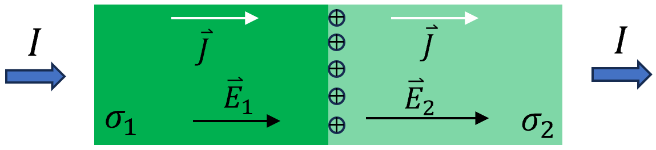

Two materials of different conductivity: $σ_{1}$ and $σ_{2}$. $J$ must be the same on the two sides of the interface; otherwise, charge would continue to pile up there. As a consequence, $\overset{⃑}{E}$ must be different in the two regions, with an abrupt jump in value at the interface. According to Gauss’s law, such a discontinuity must reflect the presence of a layer of static charge at the interface. Positive charge: $σ_{1}>σ_{2}$.
*** Example: the value of drift velocity in a copper wire
Consider a copper wire with length $L = 1 km$, exerting a voltage $6 V$. The carrier density $n=8×{10}^{22} cm^{-1}$.
Since: $E=V/L=ρJ=ρnev$ drift velocity: $v=V/ρLne=28 μm/s$
This is much slower than the average thermal speed $v_{th}$of an electron at room temperature ~${10}^{5} m/s$. (Fermi velocity in solid state physics.)
The time to drift once around the circuit is $t = 3.6×{10}^{7} s$, a little over a year.
Think about why the circuit instantly turned on when switch it on??? Will be learned in Lect. 15
- Scattering centers and mobility
In metals, the charge carriers are usually electrons. When subjected to external $E$ , charges will be accelerated $v=at=qEt/m$. $v$ as well $as$ $J$ will become infinite if there is no obstacle inside the materail. We all know that metals have resistance that resist the movement of charges, resulting in $v$ and $J$ proportional to $E$. Where does the resistance come from?
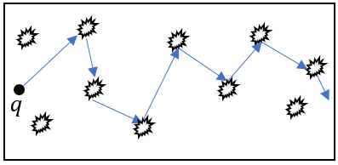
Scattering centers inside the materials, including impurities, defects, lattice imperfections…
Drude model: 1900 a classical model
Relaxation time: $τ$, an average time interval between two collisions.
$$mv=eEτ$$
$v=eEτ/m$ $J=nev=ne^{2}Eτ/m$
$σ=J/E=ne^{2}τ/m$
Define: $μ=eτ/m$ mobility (迁移率)
$$σ=neμ$$
$$v=Eeτ/m=μE$$
The ability of an electron to travel across a material in the presence of $E$.
Note: electron can also be scattered by other electrons or the vibration of lattice at finite temperature.
- Resistivity of typical material
Materials | Resistivity $ρ$ ($Ω.cm$)
Copper 293K | $$1.68×{10}^{-6}$$
Silver 293K | $$1.59×{10}^{-6}$$
Gold | $$2.44×{10}^{-6}$$
Aluminum | $$2.65×{10}^{-6}$$
Tungsten | $$5.6×{10}^{-6}$$
Germanium 273K | $$200$$
Water 291K | $$2.5×{10}^{7}$$
Sea water (varies with salinity) | $$25$$
Conductor: $10^{-2}$ $Ω.cm$
Semiconductor: $100$ $Ω.cm$ general criterion
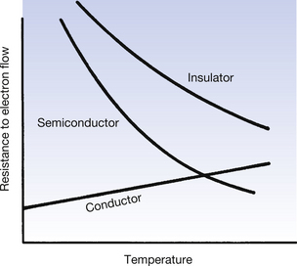
Insulator: > $>1 MΩ.cm$

Temperature dependence of resistance.

- Circuits elements
For an ordinary circuit, one may usually consider it as and reduce it to resistors in series or in parallel.
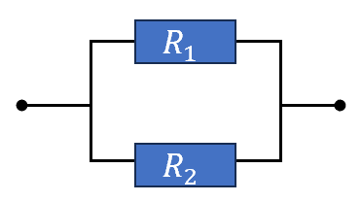
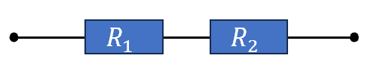
$R=R_{1}+R_{2}$ or $\frac{1}{R}=\frac{1}{R_{1}}+\frac{1}{R_{2}}$
While for a general network of resistors such as a bridge network, it can not be reduced to the above two elements.
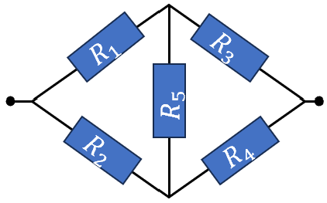
To calculate the equivalent resistance, there are alternative ways employing the following three conditions (Kirchhoff’s rules):

- The current through each element must equal the voltage across that element divided by the resistance of the element.
- At a node of the network, the algebraic sum of the currents into the node must be zero. ( Charge-conservation in circuit language.)
- The sum of the potential differences taken in order around a loop of the network is zero ($\oint{\overset{⃑}{E}∙d\overset{⃑}{l}}=0$).

Proof: $1) \left\{\begin{aligned}I=I_{1}+I_{2}=I_{3}+I_{4} \\ I_{1}=I_{3}+I_{5} \\ I_{4}=I_{2}+I_{5}\end{aligned}\right.$ $→\left\{\begin{aligned}I_{5}=I_{3}-I_{1} \\ I_{2}=I-I_{1} \\ I_{4}=I-I_{3}\end{aligned}\right.$
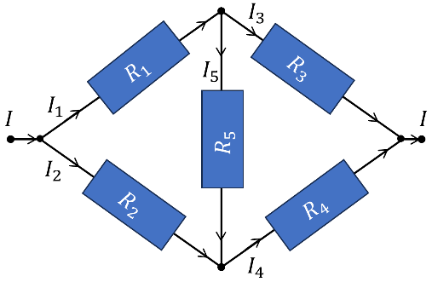
$$2) \left\{\begin{aligned}I_{1}R_{1}-I_{2}R_{2}+I_{5}R_{5}=0 \\ I_{3}R_{3}-I_{4}R_{4}-I_{5}R_{5}=0 \\ (IR=I_{1}R_{1}+I_{3}R_{3}=I_{2}R_{2}+I_{4}R_{4})\end{aligned}\right.$$
$$→ \left\{\begin{aligned}I_{1}\left(R_{1}+R_{2}-R_{5}\right)+I_{3}R_{5}-IR_{2}=0 \\ I_{1}R_{5}+I_{3}\left(R_{3}+R_{4}-R_{5}\right)-IR_{4}=0\end{aligned}\right.$$
$$→I_{1}\sim I, I_{3}\sim I$$
$$R=\left(I_{1}R_{1}+I_{3}R_{3}\right)/I$$
Balanced bridge conditions: $I_{5}=0$, $\left\{\begin{aligned}I_{1}R_{1}=I_{2}R_{2} \\ I_{1}R_{3}=I_{2}R_{4}\end{aligned}\right.→ \frac{R_{1}}{R_{3}}=\frac{R_{2}}{R_{4}} or \frac{R_{1}}{R_{2}}=\frac{R_{3}}{R_{4}}$.

- Wheatstone bridge (惠斯通电桥， Balanced bridge 平衡电桥)
：an electrical circuit used to measure an unknown electrical resistance by balancing two legs of a bridge circuit, one leg of which includes the unknown component.
The primary benefit of the circuit is its ability to provide extremely accurate measurements of resistance.
