Lecture 8 Special relativity II
- The relativistic velocity addition
$$\left(\begin{matrix}Δx^{'} \\ c∆t^{'}\end{matrix}\right)=\left(\begin{matrix}γ & −γβ \\ −γβ & γ\end{matrix}\right)\left(\frac{Δx}{c∆t}\right) ⟹v_{x}^{'}=\frac{dx^{'}}{dt^{'}}=\frac{γdx−γβcdt}{−γβ\frac{dx}{c}+γdt}=\frac{\frac{dx}{dt}−βc}{−\frac{β}{c}\frac{dx}{dt}+1} =\frac{v_{x}−u}{1−\frac{v_{x}u}{c^{2}}}$$
$$v_{y}^{'}=\frac{dy^{'}}{dt^{'}}=\frac{dy}{−γβ\frac{dx}{c}+γdt}=\frac{v_{y}}{γ(1−\frac{v_{x}u}{c^{2}})}, { v}_{z}^{'}=\frac{v_{z}}{γ(1−\frac{v_{x}u }{c^{2}})}$$
If $v_{x}=c$ $⟹$ $v_{x}^{'}=\frac{c−v}{1−v/c}=c$, light velocity doesn’t change!!!
If $v_{x}, v<c$ ⟹ $\frac{v_{x}^{'}}{c}=\frac{\frac{v_{x}}{c}−\frac{v}{c}}{1−\frac{v_{x}v}{c}}=\frac{β_{x}−β}{1−β_{x}β}<1$
$$\begin{aligned}(1−β_{x})(1+β)>0⇒1−β_{x}β>β_{x}−β \\ (1+β_{x})(1−β)>0⇒1−β_{x}β>β−β_{x}\end{aligned}\}⇒1−β_{x}β>|β_{x}−β|$$
Hence $|\frac{v_{x}^{'}}{c}|<1$
Light speed is the up limit of velocity in any frame.
- 4-vector
For 3-dimensions, vector $\overset{⃑}{A}=(x_{1},y_{1},z_{1})$ and $\overset{⃑}{B}=(x_{2},y_{2},z_{2})$. The inner product: $\overset{⃑}{A}∙\overset{⃑}{B}=\left|A\right|\left|B\right|\cos{θ}$, which is invariant under rotation transformation.
In the case of special relativity, time and space are inextricably mixed, and we could try to do the analogous things for four dimensions. Is there a similar quantity, invariant under Lorenz transformation.
In last lecture, $∆S^{2}=∆x^{2}−{\left(cΔt\right)}^{2}$ is invariant under Lorenz transformation. That is pretty nice, except that it depends on a particular choice of the x-direction. For four dimensions, we can add the contribution of y and z-direction and have a quantity $x^{2}+y^{2}+z^{2}−{\left(cΔt\right)}^{2}$, which is invariant under both Lorenz and rotation transformation （these operations consist complete Lorenz group）.
4-vector: $x^{μ}=(x_{1},x_{2},x_{3},ct)$ or ($x^{μ}=\left(ct,x_{1},x_{2},x_{3}\right)$ in Feynman’s lecture)
（Contravariant 抗变) $x^{μ}=(x,ct)$
$x_{μ}=(x_{1},x_{2},x_{3},−ct)$ （covariant 协变）
4-vector is the vector in Minkowski space (4D space combining space and time).
Inner product: $x^{μ}x_{μ}=x_{1}^{2}+x_{2}^{2}+x_{3}^{2}−{\left(ct\right)}^{2}$
$g_{μν}=g^{μν}=\left(\begin{aligned}\begin{matrix}1 & & \\ & 1 & \\ & & 1\end{matrix} \\ −1\end{aligned}\right)$ metric matrix，$x_{μ}=g_{μν}x^{ν}$, $x^{μ}=g^{μν}x_{ν}$
- For a 4-vector $q^{μ}=\left(q_{1},q_{2},q_{3},q_{4}\right)$, the transformation is as $q^{μ}=Λ_{ μ'}^{μ} q^{μ'}$
$Λ_{ μ'}^{μ}$ represents the general Lorenz transformation, satisfying $Λ^{T}gΛ=g$ or
${Λ^{T}}_{ μ'}^{μ}g_{μ'ν'}Λ_{ v}^{v'}=Λ_{ μ}^{μ'}g_{μ'ν'}Λ_{ v}^{v'}=g_{μν}$.
$Λ$ including: ----6-degrees of freedom.
$\left(\begin{aligned} 0 \\ R 0 \\ 0 \\ 0 0 0 1\end{aligned}\right)$ spatial part: 3D rotation, 3 degree of freedom.
$×$
$\left(\begin{aligned}γ 0 0 −γβ \\ 0 0 0 0 \\ 0 0 0 0 \\ −γβ 0 0 γ \end{aligned}\right)$ space-time boost along x (y, z) directions. 3-degrees of freedom.
The inner product of 4-vector is invariant under Lorentz transformation.
$q^{μ}q_{μ}=q^{μ}g_{μν}q^{ν}$=$q^{μ'}Λ_{ μ'}^{μ}g_{μν}Λ_{ v'}^{v}q^{ν'}=q^{μ'}g_{μ'ν'}q^{ν'}=q^{μ'}q_{μ'}$
- 4-velocity $v^{μ}=\frac{dq^{u}}{dτ}=\frac{1}{\sqrt{1−β^{2}}}(\frac{dx}{dt},\frac{dy}{dt},\frac{dz}{dt},c)$
- Doppler effect
Quotient rule: if $x^{μ}=(x,x_{4})$ is a 4-vector, and $k^{μ}=(k,k_{4})$ satisfies $x^{μ}k_{μ}=x∙k−x_{4}k_{4}$ is invariant in any Lorenz frame (scalar), then $k^{μ}$ is a 4-vector.
Proof: suppose two frames $S$ and $S^{'}$
$$k^{μ'}g_{μ'v'}x^{ν'}=k^{μ}g_{μν}x^{ν}=k^{μ}g_{μν}Λ_{ ν'}^{ν}x^{ν'}$$
⟹ $k^{μ'}g_{μ'v'}=k^{μ}g_{μν}Λ_{ ν'}^{ν}$
$g_{μ'ν'}=Λ_{ μ'}^{μ}g_{μν}Λ_{ v'}^{v}$ ⟹$k^{μ'}Λ_{ μ'}^{μ}g_{μν}Λ_{ v'}^{v}=k^{μ}g_{μν}Λ_{ ν'}^{ν}$
⟹ $k^{μ}=Λ_{ μ'}^{μ}k^{μ'}$, therefore $k^{μ'}$ is a 4-vector.
***For a wave, $ϕ=A\cos{(\overset{⃑}{k}∙\overset{⃑}{x}−ωt)}$, the phase factor $\overset{⃑}{k}∙\overset{⃑}{x}−ωt=k^{μ}g_{μν}x^{ν}$ is invariant in Lorenz transformation:
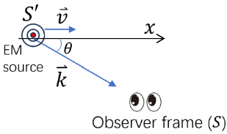
⟹ $k^{μ}=\left(\overset{⃑}{k}, ω/c\right)$ is a 4-vector.
- Consider a EM source moving with $\overset{⃑}{v}$ along x-axis.
In the co-moving frame $S^{'}$ $k_{4}^{'}=ω_{0}/c$.
$k_{4}^{'}=γ\left(k_{4}−βk_{1}\right)=ω_{0}/c$.
$k_{1}=\left|k\right|\cos{θ}=\frac{ω}{c}\cos{θ}$
$k_{4}=ω/c$ $⟹ γ\frac{ω}{c}\left(1−β\cos{θ}\right)=\frac{ω_{0}}{c} ⟹ω=\frac{1}{γ}\frac{ω_{0}}{1−β\cos{θ}}$
At $θ=0, π$, $ω=\frac{1}{γ}\frac{ω_{0}}{1∓β}$; When approaching, there is blue shift, leaving there is red shift.
At $θ=π/2$, $ω=ω_{0}/γ$
- Relativistic momentum
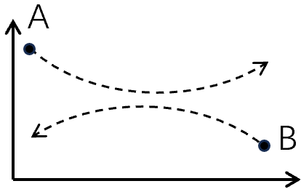
We want to maintain momentum conservation law. But the classic definition $\overset{⃑}{p}=m_{0}\overset{⃑}{v}$ does not work any more. We define “$m_{0}$” the rest mass measured in the frame where the particle is static.
Consider the following collision process:
This collision process in the frames moving with the same horizontal velocity.

At A’s frame
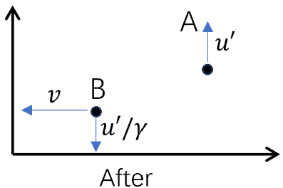
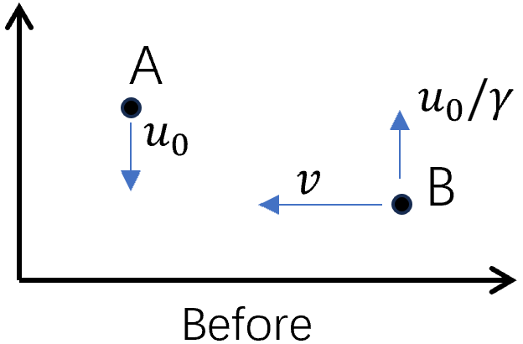

At B’s frame
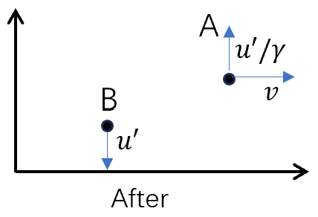
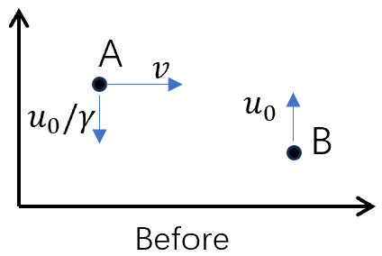

Before collision:
In B’s frame, B’s horizontal velocity is zero, vertical velocity $u_{0}$.
Then in A’s frame which has a relative $v$ with respect to B’s frame,
$v_{B,x}=−v$, $v_{B,y}=\frac{u_{0}}{γ}$
$$v_{A,x}=0, v_{A,y}=−u_{0}$$
After collision:
in A’s frame: $v_{A,x}^{'}=0, v_{A,y}^{'}=u^{'}$
$$v_{B,x}^{'}=−v, v_{A,y}^{'}=u^{'}/γ$$
We seek a conserved quantity similar to classical momentum. We define $\overset{⃑}{p}=m(v)\overset{⃑}{v}$, where $m(v)$ is a function of $v$ and has the unit of mass.
In A’s frame, the $p_{x}$ comes from B. Before collision,
$v_{B}={\left(v^{2}+\frac{u_{0}^{2}}{γ^{2}}\right)}^{1/2}$and after collision $v_{B}^{'}={\left(v^{2}+\frac{u^{'2}}{γ^{2}}\right)}^{1/2}$
$p_{x}^{before}=p_{x}^{after}$ $⇔$ $m\left(v_{B}\right)v=m(v_{B}^{'})v$ $⟹$ $m\left(v_{B}\right)=m\left(v_{B}^{'}\right)⟹v_{B}=v_{B}^{'}$ $⟹$ $u_{0}=u'$
Now let’s write the momentum conservation along y-axis:
$$−m\left(u_{0}\right)u_{0}+m\left(\sqrt{v^{2}+\frac{u_{0}^{2}}{γ^{2}}}\right)\frac{u_{0}}{γ}=m\left(u_{0}\right)u_{0}−m\left(\sqrt{v^{2}+\frac{u_{0}^{2}}{γ^{2}}}\right) u_{0}/γ$$
$⇔$ $m\left(\sqrt{v^{2}+\frac{u_{0}^{2}}{γ^{2}}}\right)=γm(u_{0})$
Set $u_{0}→0$, we have $m\left(v\right)=γm\left(0\right)=γm_{0}$ $m_{0}:$ rest mass.
Thus we define $\overset{⃑}{p}=m_{0}\overset{⃑}{v}/\sqrt{1−v^{2}/c^{2}}$ which is conserved.
Recheck: $m\left(\sqrt{v^{2}+\frac{u_{0}^{2}}{γ^{2}}}\right)=γm(u_{0})$
$$1/\sqrt{1−(v^{2}+u_{0}^{2}/γ^{2})/c^{2}}= γ/\sqrt{γ^{2}−(γ^{2}v^{2}+u_{0}^{2})/c^{2}}=γ/\sqrt{γ^{2}(1−v^{2}/c^{2})+u_{0}^{2}/c^{2}}= γ/\sqrt{1−u_{0}^{2}/c^{2}}$$
- Relativistic energy
We generalize newton’s second law $\overset{⃑}{F}=\frac{d\overset{⃑}{p}}{dt}=\frac{d}{dt}\left(\frac{m_{0}\overset{⃑}{v}}{\sqrt{1−v^{2}/c^{2}}} \right)$ to define kinetic energy:
$$E_{k}\left(v_{b}\right)−E_{k}\left(v_{a}\right)=\int_{a}^{b}{\overset{⃑}{F}∙d\overset{⃑}{r}}=\int_{a}^{b}{\frac{d\overset{⃑}{p}}{dt}∙d\overset{⃑}{r}}=\int_{a}^{b}{d\left(\frac{m_{0}\overset{⃑}{v}}{\sqrt{1−\frac{v^{2}}{c^{2}}}} \right)∙\overset{⃑}{v}}=\frac{m_{0}v^{2}}{\sqrt{1−\frac{v^{2}}{c^{2}}}}{\left.​\right|}_{a}^{b}−\int_{a}^{b}{\frac{m_{0}\overset{⃑}{v}}{\sqrt{1−\frac{v^{2}}{c^{2}}}}∙d\overset{⃑}{v}}=\frac{m_{0}v^{2}}{\sqrt{1−\frac{v^{2}}{c^{2}}}}{\left.​\right|}_{a}^{b}+m_{0}c^{2}\sqrt{1−\frac{v^{2}}{c^{2}}}{\left.​\right|}_{a}^{b}$$
($\overset{⃑}{v}∙d\overset{⃑}{v}=\frac{1}{2}d\left(\overset{⃑}{v}∙\overset{⃑}{v}\right)=\frac{1}{2}dv^{2}=vdv)$
Set $v_{a}=0 ⟹ E_{k}=\frac{m_{0}v_{b}^{2}}{\sqrt{1−\frac{v_{b}^{2}}{c^{2}}}}+m_{0}c^{2}\sqrt{1−\frac{v_{b}^{2}}{c^{2}}}−m_{0}c^{2}=\frac{m_{0}c^{2}}{\sqrt{1−\frac{v_{b}^{2}}{c^{2}}}}−m_{0}c^{2}=mc^{2}−m_{0}c^{2}$
total energy rest energy
Total energy $E=mc^{2}$ mass–energy equivalence.
- 4-momentum
We can combine momentum and energy as 4-vector:
$$p^{μ}=\left(\overset{⃑}{p}, m_{0}c/\sqrt{1−\frac{v^{2}}{c^{2}}}\right)=\left(m\overset{⃑}{v},mc\right)=\left(m\overset{⃑}{v},E/c\right)$$
Or $=\left(\frac{m_{0}}{\sqrt{1−\frac{v^{2}}{c^{2}}}}\frac{d\overset{⃑}{x}}{dt},\frac{m_{0}c}{\sqrt{1−\frac{v^{2}}{c^{2}}}}\right)=m_{0}(\frac{d\overset{⃑}{x}}{dτ},c\frac{dt}{dτ})$ $dτ=\sqrt{1−\frac{v^{2}}{c^{2}}}dt$
Here $(\frac{d\overset{⃑}{x}}{dτ},c\frac{dt}{dτ})$ is four-velocity. $dτ$ is the proper time interval for a moving body. 4-momnetum is just rest-mass times 4-velocity.
For a relativistic collision, all the 4-component must be conserved. Let us look at the 4th component, and consider the non-relativistic limit.
$E_{a}^{in}+E_{b}^{in}=E_{a}^{fin}+E_{b}^{fin}$ expand to second order of $v$
$$m_{a,0}^{in}c^{2}+\frac{1}{2}m_{a,0}^{in}{v_{a}^{in}}^{2}+\left(a→b\right)=m_{a,0}^{fin}c^{2}+\frac{1}{2}m_{a,0}^{fin}{v_{a}^{fin}}^{2}+\left(a→b\right)$$
$$m_{0}^{in}c^{2}+T^{in}=m_{0}^{fin}c^{2}+T^{out}$$
For elastic collision, $T^{in}=T^{out}$ ⟹ Rest mass is conserved in elastic collision.
For inelastic collision, $m_{0}^{in}≠m_{0}^{fin}$, particles can gain mass by gaining internal energy.
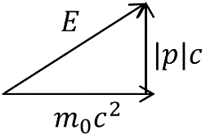
Useful relations ($\overset{⃑}{p},E/c$)
$β=\frac{v}{c}=\frac{\overset{⃑}{p}c}{E}$, $p^{μ}p_{μ}=p^{2}−\frac{E^{2}}{c^{2}}=−{\left(m_{0}c\right)}^{2}$ crosscheck $(0,0,0, m_{0}c)$
$$E^{2}={\left(pc\right)}^{2}+{\left(m_{0}c^{2}\right)}^{2}$$
Example
- For an electron, rest energy ${E_{r}=m}_{e}c^{2}=0.5MeV,$ if $T=0.8MeV$
⟹ $E=E_{r}+T=1.3MeV$ and $pc=1.2MeV ⟹$ $β=\frac{pc}{E}≈0.92$
- Frank-Hertz experiment: in-elastic collision between electron and Hg atom. Electron looses Kinetic energy 4.9eV (It’s rest mass does not change since it’s a point particle). The energy is transferred into Hg atom to an excited state. The rest mass of Hg increase $∆m=\frac{4.9eV}{c^{2}}=8.7×{10}^{−36}kg$ $\frac{∆m}{m_{Hg}}≈2.6×{10}^{−11}$
- Neutron-induced fission
$$\begin{aligned}&{n+}^{235}U⟶^{ 90}K_{r}+^{143}B_{a}+3n \\ &ΔT_{kinetic}=200MeV, \frac{Δm}{M}≈0.1\%\end{aligned}$$
- Particle-antiparticle annihilation
$$e^{+}+e^{−}→γ$$
(This process cannot occur in free space because of momentum conservation, but can occur for an $e^{+}$ collide with an atom. )
Note: Minkowski space (or Minkowski spacetime) is 4D space that combines 3D Euclidean space and time. A spacetime interval between any two events in this space is independent of the inertial frame of reference in which they are recorded.
- Collisions – application of momentum and energy conservation
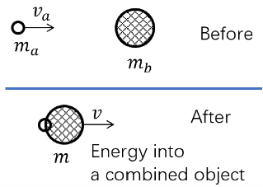
Example 1
Initial state: $p_{a,i}^{μ}=(m_{a0}γ_{a}v_{a},0,0,m_{a0}γ_{a}c)$
$p_{b,i}^{μ}=(0,0,0,m_{b0}c)$
Final state: two particles combined into a single object
$$p_{f}^{μ}=(m_{0}γv,0,0,m_{0}γc)$$
Conservation: $p_{f}^{μ}=p_{a,i}^{μ}+p_{b,i}^{μ}=(m_{a0}γ_{a}v_{a},0,0,m_{a0}γ_{a}c+m_{b0}c)$
$$⟹ m_{0}^{2}γ^{2}c^{2}(1−v^{2}/c^{2})={\left(m_{a0}γ_{a}c+m_{b0}c\right)}^{2}−{\left(m_{a0}γ_{a}v_{a}\right)}^{2}$$
$$⟹ (m_{0}c)^{2}=(m_{a0}c)^{2}+(m_{b0}c)^{2}+2m_{a0}m_{b0}γ_{a}c^{2}$$
$$⟹ m_{0}=(m_{a0}^{2}+m_{b0}^{2}+2m_{a0}m_{b0}γ_{a})^{1/2}>(m_{a0}+m_{b0})$$
The finally rest mass is large than the sum of initial rest mass.
$$\frac{\vec{v}}{c}=\frac{m_{0}γv}{m_{0}γc}=\frac{m_{a0}γ_{a}v_{a}}{(m_{a0}γ_{a}+m_{b0})c}⇒v=\frac{m_{a0}γ_{a}}{m_{a0}γ_{a}+m_{b0}}v_{a}$$
Example 2： elastic head on collision,
In Lab frame, object $a$ has a velocity $v_{a}$, calculate $v_{b}$ after Collison. The rest mass $m_{a0}$ and $m_{b0}$ is known.
Lab frame $S$:
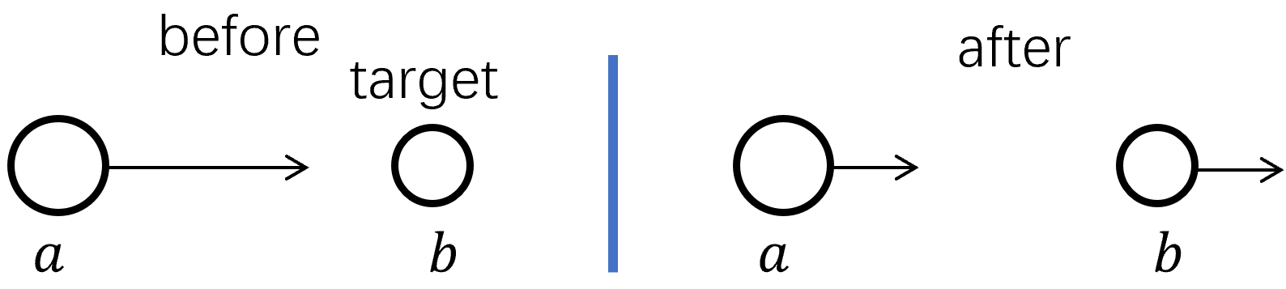
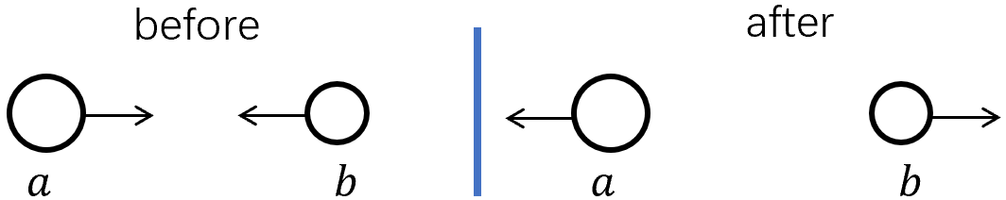
CM frame $S'$:

In the lab frame, the final state will be difficult to calculate. But in the CM frame, they just reverse the direction (simple!).
Lab frame $S$: $p_{tot}^{μ}=\left({\overset{⃑}{p}}_{a} ,\frac{E_{a}}{c}\right)+\left(0,m_{b0}c\right)=\left({\overset{⃑}{p}}_{a} ,\frac{E_{a}+m_{b0}c^{2}}{c}\right)$
CM frame $S'$: which has relative velocity $βc$ with respect to Lab frame.
$p_{1}^{μ'}=γ\left(p_{a}−\frac{β}{c}\left(E_{a}+m_{b0}c^{2}\right)\right)=0 ⟹ β=\frac{p_{a}c}{E_{a}+m_{b0}c^{2}}$ Lorenz transformation
(Center of mass frame is zero momentum frame $p_{cm}^{μ}= (0,0,0,E_{cm,total}/c )$.)
In this frame, the final state of $b$ can be obtained from the initial $p_{b}^{μ}=(0,m_{b0}c)$ in the lab frame.
In the CM frame: $p_{b,in, 1}^{μ'}=γ\left(0−βm_{b0}c\right)=−γβm_{b0}c$
$p_{b,in, 4}^{μ'}=γ\left(−β∙0+m_{b0}c\right)=γm_{b0}c$ $p_{b,fin}^{μ'}=(γβm_{b0}c,0,0,γm_{b0}c)$
Back to Lab frame: $p_{1,b,fin}^{μ}=γ\left(p_{1,fin}^{μ'}+βp_{4,fin}^{μ'}\right)=γ\left(γβ+γβ\right)m_{b0}c=2γ^{2}βm_{b0}c$
$$p_{4,b,fin}^{μ}=γ\left(βp_{1,fin}^{μ'}+p_{4,fin}^{μ'}\right)=γ\left(γβ^{2}+γ\right)m_{b0}c=γ^{2}(β^{2}+1)m_{b0}c$$
The final velocity of $b$ in Lab frame: $v_{b}=\frac{p_{1}c}{p_{4}}=\frac{2γ^{2}β}{γ^{2}(β^{2}+1)}c=\frac{2β}{(β^{2}+1)}c$
- Threshold energies
$a+b→d+…+g$ $a$: incident particle, $b:$ target particle
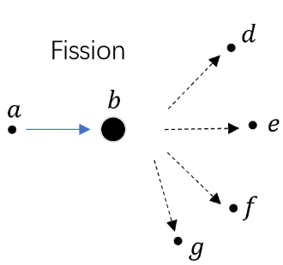
Which is the minimum energy of $a$ in the lab frame to create $d,⋯,g$.
Lab frame: $p_{tot}^{μ}=({\overset{⃑}{p}}_{a},E_{a}/c)+(0,m_{b0}c)=\left({\overset{⃑}{p}}_{a},\frac{E_{a}+m_{b0}c^{2}}{c}\right)$
Transforming to CM frame: $β=v/c=\frac{p_{a}c}{E_{a}+m_{b0}c^{2}}$
In CM frame: the total energy: ${\left(\frac{E_{CM,tot}}{c}\right)}^{2}={\left(\frac{E_{a}+m_{b0}c^{2}}{c}\right)}^{2}−p_{a}^{2}$
$$⟹ E_{CM, tot}^{2}=E_{a}^{2}+m_{b0}^{2}c^{4}+2E_{a}m_{b0}c^{2}−p_{a}^{2}c^{2}=\left(m_{a0}^{2}+m_{b0}^{2}\right)c^{4}+2E_{a}m_{b0}c^{2}$$
Requirement of reaction: $E_{CM}≥\sum{m_{fin}c^{2}}$ $⟹ \left(m_{a0}^{2}+m_{b0}^{2}\right)c^{4}+2E_{a}m_{b0}c^{2}≥{\left(\sum{m_{fin}}\right)}^{2}c^{4}$
⟹ $E_{a}≥ \frac{{\left(\sum{m_{fin}}\right)}^{2}−m_{a0}^{2}−m_{b0}^{2}}{2m_{b0}}c^{2}$

- Massless particle – photon
$$p^{μ}p_{μ}=p^{2}−\frac{E^{2}}{c^{2}}=0$$
$E=\left|p\right|c$ $p=mc$massless particle only travels with velocity $c$.
Wave-interpretation $\overset{⃑}{p}=ℏ\overset{⃑}{k}$, $E=ℏω$, $ω=kc$
$$p^{μ}=\frac{ℏω}{c}(\hat{k},1)$$
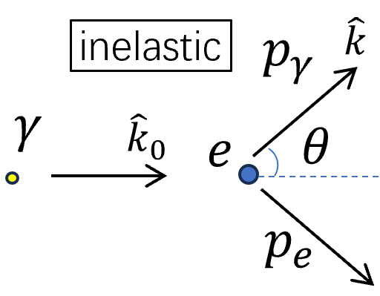
- Compton scattering: light scattering from free electrons

Scattered light has a longer wavelength.
What is $∆λ$？
$p_{γ,in}^{μ}=\frac{ℏω_{0}}{c}({\hat{k}}_{0},1)$ $p_{γ,out}^{μ}=\frac{ℏω}{c}(\hat{k},1)$
$$p_{e,in}^{μ}=\left(0,0,0,m_{e0}c\right) p_{e,out}^{μ}=?$$
Conservation: $p_{γ,in}^{μ}+p_{e,in}^{μ}=p_{γ,out}^{μ}+p_{e,out}^{μ}$
$$p_{e,out}^{μ}p_{μ,e,out}=p_{e,in}^{μ}p_{μ,e,in}+p_{γ,in}^{μ}p_{μ,γ,in}++p_{γ,out}^{μ}p_{μ,γ,out}+2p_{γ,in}^{μ}p_{μ,e,in}−2p_{γ,in}^{μ}p_{μ,γ,out}−2p_{e,in}^{μ}p_{μ,γ,out}$$
$$⟹ −m_{e0}^{2}c^{2}=−m_{e0}^{2}c^{2}+0+0+2p_{e,in}^{μ}\left(p_{μ,γ,in}−p_{μ,γ,out}\right)−2p_{γ,in}^{μ}p_{μ,γ,out}$$
$$⟹ p_{e,in}^{μ}\left(p_{μ,γ,in}−p_{μ,γ,out}\right)=p_{γ,in}^{μ}p_{μ,γ,out}$$
Only $p_{e,in,4}^{μ}$ is nonzero ⟹ $−m_{e0}c\left(\frac{ℏω_{0}}{c}−\frac{ℏω}{c}\right)=\frac{ℏ^{2}ω_{0}ω}{c^{2}}(\hat{k}∙{\hat{k}}_{0}−1)$
$⟹$ $m_{e0}c\left(ω_{0}−ω\right)=\frac{ℏ}{c}ω_{0}ω(1−\cos{θ})$
$⟹$ $\frac{1}{ω}−\frac{1}{ω_{0}}=\frac{ℏ}{m_{e0}c^{2}}(1−\cos{θ})$
$$λ=\frac{2πc}{ω}$$
$∆λ=\frac{h}{m_{e0}c}(1−\cos{θ})$

Compton wavelength is a quantum mechanical property of a particle, defined as the wavelength of a photon the energy of which is the same as the rest energy of that particle.
Compton wavelength of the electron $λ_{cp}=\frac{h}{m_{e0}c}≈2.43 pm$.

