Lecture-9 Electric field of moving charges
- 4-vectors
- 4-velocity and 4-momentum
$x^{μ}=(x,y,z,ct)$ $⟹$ $v^{μ}=dx^{μ}/dτ$, $τ$: proper time, which is a relativistic scalar. Hence, $v^{μ}$ is a 4-vector.
$$dτ=dt\sqrt{1-{(v/c)}^{2}}$$
$v^{μ}=\left(\frac{\overset{⃑}{v}}{\sqrt{1-{(v/c)}^{2}}},\frac{c}{\sqrt{1-{(v/c)}^{2}}}\right)=γ_{v}(\overset{⃑}{v},c)$ 4-velocity
It means that $v^{μ}$ satisfies the Lorenz transformation:
$\left.\left(\begin{aligned}v_{1}^{'} \\ v_{4}^{'}\end{aligned}\right.\right)=γ\left(\begin{matrix}1 & -β \\ -β & 1\end{matrix}\right)\left(\begin{aligned}v_{1} \\ v_{4}\end{aligned}\right)$, $v_{2}^{'}=v_{2}$ and $v_{3}^{'}=v_{3}$
Actually, the above results are not easy to derive. I leave it as a homework problem!
Momentum: $p^{μ}=m_{0}v^{μ}=\left(\frac{m_{0}\overset{⃑}{v}}{\sqrt{1-{(v/c)}^{2}}},\frac{m_{0}c}{\sqrt{1-{(v/c)}^{2}}}\right)=γ_{v}m_{0}\left(\overset{⃑}{v},c\right)=(\overset{⃑}{p},E/c)$ is 4-momentum.
$\left.\left(\begin{aligned}p_{1}^{'} \\ p_{4}^{'}\end{aligned}\right.\right)=γ\left(\begin{matrix}1 & -β \\ -β & 1\end{matrix}\right)\left(\begin{aligned}p_{1} \\ p_{4}\end{aligned}\right)$, $p_{2}^{'}=p_{2}$ and $p_{3}^{'}=p_{3}$
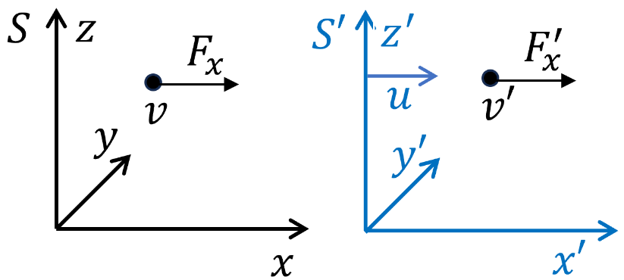
- 4-force
Define $K^{μ}=dp^{μ}/dτ$, ⟹ $K_{i}=\frac{1}{\sqrt{1-{(v/c)}^{2}}} \frac{dp_{i}}{dt}=\frac{F_{i}}{\sqrt{1-{(v/c)}^{2}}}$
$K_{4}=\frac{1}{\sqrt{1-{(v/c)}^{2}}} \frac{dp_{4}}{dt}=\frac{1}{c\sqrt{1-{(v/c)}^{2}}} \frac{dE}{dt}=\frac{\overset{⃑}{F}∙\overset{⃑}{v}}{c\sqrt{1-{(v/c)}^{2}}}$
$K^{μ}=\frac{1}{\sqrt{1-{\left(\frac{v}{c}\right)}^{2}}}\left(\overset{⃑}{F}, \overset{⃑}{F}∙\frac{\overset{⃑}{v}}{c}\right)=γ_{v}(\overset{⃑}{F}, \overset{⃑}{F}∙\frac{\overset{⃑}{v}}{c})$ 4-force
$\left.\left(\begin{aligned}K_{1}^{'} \\ K_{4}^{'}\end{aligned}\right.\right)=γ\left(\begin{matrix}1 & -β \\ -β & 1\end{matrix}\right)\left(\begin{aligned}K_{1} \\ K_{4}\end{aligned}\right)$ ⟹ $\begin{matrix}K_{1}^{'}=γ(K_{1}-βK_{4}) \\ K_{4}^{'}=γ({-βK}_{1}+K_{4})\end{matrix}$
$${K'}_{1}=γ\left(K_{1}-βK_{4}\right) ⟹ \frac{F_{x}^{'}}{\sqrt{1-(\frac{v'}{c})^{2}}}=γ\left(\frac{F_{x}}{\sqrt{1-(\frac{v}{c})^{2}}}-\frac{β\vec{F}⋅\vec{v}}{c\sqrt{1-(\frac{v}{c})^{2}}}\right)$$
$K_{2}^{'}=K_{2}⟹$ $\frac{F_{y}^{'}}{\sqrt{1-{(v'/c)}^{2}}}=\frac{F_{y}}{\sqrt{1-{(v/c)}^{2}}}$
In order to simplify, we prove the following identity:
$$1-\frac{{v'}^{2}}{c^{2}}=(1-\frac{u^{2}}{c^{2}})(1-\frac{v^{2}}{c^{2}})/(1-\frac{v_{x}u}{c^{2}})^{2}$$
Proof: $\frac{v_{x}^{'}}{C}=(\frac{v_{x}}{C}-\frac{u}{C})/(1-\frac{v_{x}u}{C^{2}}),$ $\frac{v_{y}^{'}}{C}=\frac{v_{y}/c}{1-\frac{v_{x}u}{C^{2}}}\sqrt{1-\frac{u^{2}}{C^{2}}}$ , $\frac{v_{z}^{'}}{c}=\frac{v_{z}/c}{1-\frac{v_{x}u}{c^{2}}}\sqrt{1-(\frac{u}{c})^{2}}$ (Lec. 8)
$v_{x,y,z}:$ velocity in $S$ frame (observation); ${v'}_{x,y,z}:$ velocity in $S'$ frame. $u:$ drift velocity of $S'$ frame along x-axis.
$$\begin{aligned}1-\frac{{v^{'}}^{2}}{c^{2}}=1-\frac{1}{(1-\frac{v_{x}u}{c})^{2}}\left[{\left(\frac{v_{x}}{c}\right)}^{2}+{\left(\frac{u}{c}\right)}^{2}-2\left(\frac{v_{x}u}{c^{2}}\right)+\left[1-{\left(\frac{u}{c}\right)}^{2}\right]\frac{v_{y}^{2}+v_{z}^{2}}{c^{2}}\right] \\ =\frac{1}{(1-\frac{v_{x}u}{c^{2}})^{2}}\left[1+(\frac{v_{x}u}{c})^{2}-(\frac{v_{x}}{c})^{2}-(\frac{u}{c})^{2}-[1-(\frac{u}{c})^{2}]\frac{v_{y}^{2}+v_{z}^{2}}{c^{2}}\right] \\ =[1-(\frac{u}{c})^{2}]\left[1-(\frac{v}{c})^{2}\right]/(1-\frac{v_{x}u}{c^{2}})^{2}\end{aligned}$$
Or $\frac{1}{\sqrt{1-\frac{{v^{'}}^{2}}{c^{2}}}}=γ\frac{1-\frac{v_{x}u}{c^{2}}}{\sqrt{1-\frac{v^{2}}{C^{2}}}}$
$\frac{F_{x}^{'}}{\sqrt{1-(\frac{v'}{c})^{2}}}=γ\left(\frac{F_{x}}{\sqrt{1-(\frac{v}{c})^{2}}}-\frac{β\vec{F}⋅\vec{v}}{c\sqrt{1-(\frac{v}{c})^{2}}}\right)$⟹ $F_{x}^{'}=(1-\frac{v_{x}u}{c^{2}})^{-1}[F_{x}-\frac{u}{c^{2}}(\vec{F}.\vec{v})]$
$\frac{F_{y}^{'}}{\sqrt{1-{(v'/c)}^{2}}}=\frac{F_{y}}{\sqrt{1-{(v/c)}^{2}}}$ ⟹ $F_{y}^{'}=\frac{F_{y}}{γ\left(1-\frac{v_{x}u}{c^{2}}\right)}$
Summary $\left\{\begin{aligned}F_{x}^{'}=\frac{F_{x}-\frac{u}{c^{2}}\left(\vec{F}.\vec{v}\right)}{1-\frac{v_{x}u}{c^{2}}} \\ F_{y}^{'}=\frac{\sqrt{1-{\left(\frac{u}{c}\right)}^{2}}F_{y}}{1-\frac{v_{x}u}{c^{2}}}, F_{z}^{'}=\frac{\sqrt{1-{\left(\frac{u}{c}\right)}^{2}}F_{z}}{1-\frac{v_{x}u}{c^{2}}}\end{aligned}\right.$
If $\overset{⃑}{v}=0$, i.e. the velocity of particle is zero, then $F_{x}^{'}=F_{x}, F_{y}^{'}=\frac{1}{γ}F_{y}, F_{z}^{'}=\frac{1}{γ}F_{z}$
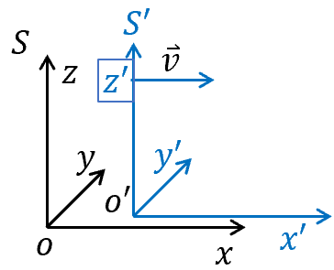
- Recap of Lorenz transformations
Consider $S'$ frame moving with a velocity $v$ along x-axis with respect to $S$ frame:
$\left.\left(\begin{aligned}x^{'} \\ t^{'}\end{aligned}\right.\right)=\left(\begin{matrix}γ & -γβ \\ -γβ & γ\end{matrix}\right)\left(\begin{aligned}x \\ t\end{aligned}\right)$ $β=\frac{v}{c}$, $γ=1/\sqrt{1-β^{2}}$
$$y^{'}=y , z^{'}=z$$
- Lorenz transformation of E&M field:
$$E_{x}^{'}=E_{x}, B_{x}^{'}=B_{x}$$
$\left.\left(\begin{aligned}E_{y}^{'} \\ {cB}_{z}^{'}\end{aligned}\right.\right)=\left(\begin{matrix}γ & -γβ \\ -γβ & γ\end{matrix}\right)\left(\begin{aligned}E_{y} \\ cB_{z}\end{aligned}\right)$ $\left.\left(\begin{aligned}E_{z}^{'} \\ {cB}_{y}^{'}\end{aligned}\right.\right)=\left(\begin{matrix}γ & γβ \\ γβ & γ\end{matrix}\right)\left(\begin{aligned}E_{z} \\ cB_{y}\end{aligned}\right)$ ---$SI$
$\left.\left(\begin{aligned}E_{y}^{'} \\ B_{z}^{'}\end{aligned}\right.\right)=\left(\begin{matrix}γ & -γβ \\ -γβ & γ\end{matrix}\right)\left(\begin{aligned}E_{y} \\ B_{z}\end{aligned}\right)$ $\left.\left(\begin{aligned}E_{z}^{'} \\ B_{y}^{'}\end{aligned}\right.\right)=\left(\begin{matrix}γ & γβ \\ γβ & γ\end{matrix}\right)\left(\begin{aligned}E_{z} \\ B_{y}\end{aligned}\right)$ ---$CGS$

Proof：
- For $E_{x}^{'}=E_{x}$, $B_{x}^{'}=B_{x}$,
Proof:
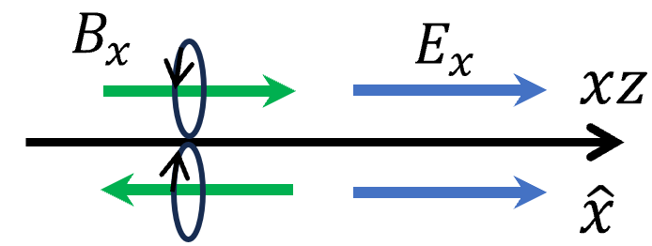
- All the x-components are rotationally invariant with respect to the boost axis (x-axis), therefor $E_{x}^{'}$ and $B_{x}^{'}$ is independent with the rotationally variant terms: $E_{y},E_{z},B_{y},B_{z}$.
- $E_{x}$ and $E_{x}^{'}$ is invariant under reflection with respect to xz-plane, while $B_{x}$ and $B_{x}^{'}$ is reversed under the same operation. Hence, the transformation cannot mix $E_{x}$ and $B_{x}$ terms.
- Then we simply have $E_{x}^{'}=λE_{x}$ and $B_{x}^{'}=λB_{x}$. $λ$ is independent of the boosting direction.
- If we perform one boost transformation, and then reverse the boost back to the original frame, we will find $λ^{2}=1.$ $⟹ E_{x}^{'}=E_{x}, B_{x}^{'}=B_{x},$
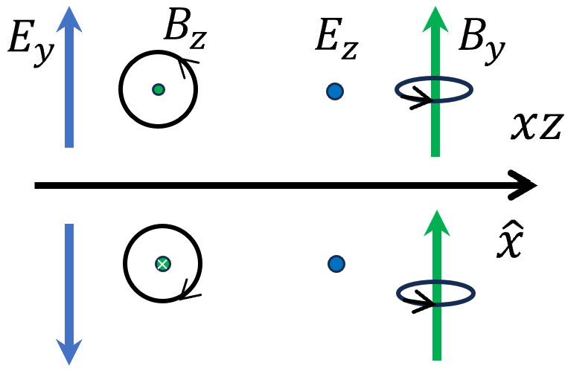
- For $\left.\left(\begin{aligned}E_{y}^{'} \\ B_{z}^{'}\end{aligned}\right.\right)$ and $\left.\left(\begin{aligned}E_{z}^{'} \\ B_{y}^{'}\end{aligned}\right.\right)$
Proof: For the transverse component, $B_{z}$ and $E_{y}$ is odd under the mirror reflection of xz-plane and xy-plane. $B_{y}$ and $E_{z}$ transforms oppositely. Hence, $B_{z}$ and $E_{y}$ transforms into each other under Lorenz transformation, so does $B_{y}$ and $E_{z}$.
Assuming: $\left.\left(\begin{aligned}E_{y}^{'} \\ {cB}_{z}^{'}\end{aligned}\right.\right)=\left(\begin{matrix}a_{11} & a_{12} \\ a_{21} & a_{22}\end{matrix}\right)\left(\begin{aligned}E_{y} \\ cB_{z}\end{aligned}\right)$, the matrix element only depends on the boost velocity $v$. （Why there is a $c$? Keeping the basic unit consistent.）
Preparation: The force on a drift electric charge $q$ in an EM field: $F_{q}=q\overset{⃑}{E}+qv_{q}×\overset{⃑}{B}$---$SI$, $v_{q}:$drift velocity of charge. ${\overset{⃑}{F}}_{L}$ Lorenz force.
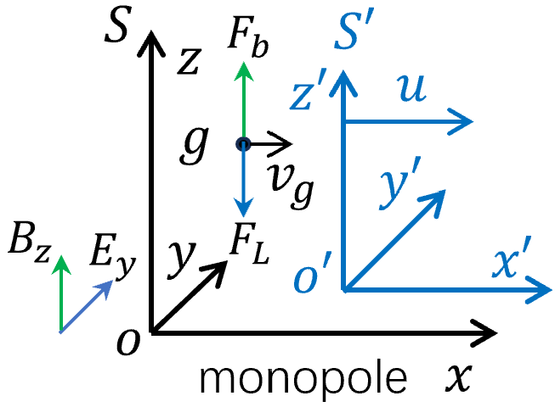
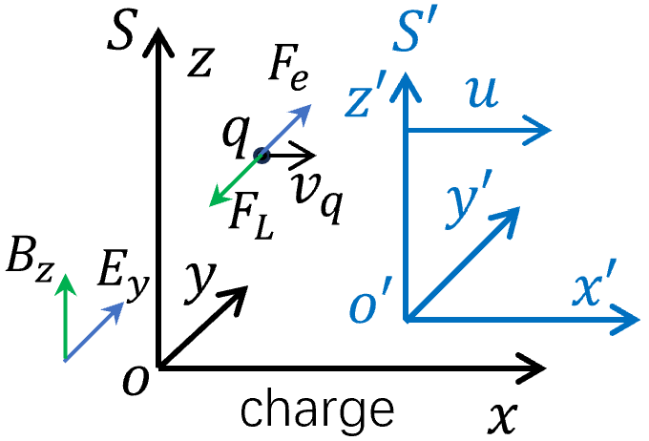
On the other hand, assuming the existence of magnetic monopoles with magnetic charge $g$, the force: $F_{g}=g\overset{⃑}{B}-g\frac{v_{g}}{c^{2}}×\overset{⃑}{E}$ --- $SI$
($F_{q}=q\overset{⃑}{E}+q\frac{v_{q}}{c}×\overset{⃑}{B}$ and $F_{g}=g\overset{⃑}{B}-g\frac{v_{g}}{c}×\overset{⃑}{E}$ ---$CGS$)
Let’s choose a special configuration in $S$ frame and consider a charge move with a constant drift velocity $v_{q}$ along x-axis. Balance conditions give rise to:
$qE_{y}=q v_{q}B_{z}$ (electric force=Lorenz force)
⟹ $\frac{E_{y}}{B_{z}}= v_{q}$
Furthermore, we consider the boost velocity $u= v_{q}$, the charge is at rest in $S'$ frame (co-moving frame). ${\overset{⃑}{F}}_{L}$ becomes zero. Then the electric field should vanish $E_{y}^{'}=0$.
⟹ $E_{y}^{'}=a_{11}E_{y}+a_{12}cB_{z}=0$ ⟹ $\frac{a_{12}}{a_{11}}=-\frac{E_{y}}{cB_{z}}=-\frac{v_{q}}{c}=-\frac{u}{c}=-β$
Similarly for magnetic monopole in $S$ frame, we yield $gB_{z}=g\frac{v_{g}}{c^{2}}E_{y}$ $⟹$ $B_{z}/E_{y}=v_{g}/c^{2}$. Considering $u=v_{g}$, one yields $B_{z}^{'}=0$ in $S'$ frame (co-moving). ⟹ $B_{z}^{'}=a_{21}E_{y}+a_{22}cB_{z}=0$
$$⟹ \frac{a_{21}}{a_{22}}=-\frac{{cB}_{z}}{E_{y}}=-\frac{v_{g}}{c}=-\frac{u}{c}=-β$$
Note: we set $u=v_{g}=v_{q}$, the balance condition of $E_{y} \& B_{z}$ for charge and monopole in $S$ frame is not necessarily the same.
Now let’s consider a general charge drift with velocity $v^{*}$ in $S$ frame with corresponding $B_{z} \& E_{y}$ such that $β^{*}=\frac{v^{*}}{c}=\frac{E_{y}}{cB_{z}}$. Under a Lorenz boost $β=u/c$, the charge remains a drift motion. The drift velocity $v^{'}$ in $S'$ frame:
$$\frac{v^{'}}{c}=\frac{E_{y}^{'}}{{cB}_{z}^{'}}=\frac{a_{11}E_{y}+a_{12}cB_{z}}{a_{21}E_{y}+a_{22}cB_{z}}=\frac{a_{11}}{a_{22}}\frac{β^{*} -β}{1-ββ^{*}}$$
In a similar wise, for a monopole with the same drift velocity $v^{*}$ in $S$ frame and choose the cross field configuration with $\frac{{cB}_{z}}{E_{y}}=\frac{v^{*}}{c}=β^{*}$. By the same Lorenz boost ($u$), the drift velocity in $S^{'}$ frame:
$$\frac{v^{'}}{c}=\frac{{cB}_{z}^{'}}{E_{y}^{'}}=\frac{a_{21}E_{y}+a_{22}cB_{z}}{a_{11}E_{y}+a_{12}cB_{z}}=\frac{a_{22}}{a_{11}}\frac{β^{*}-β}{1-ββ^{*}}$$
Comparing the above two equations ⟹ ${\left(\frac{a_{11}}{a_{22}}\right)}^{2}=1$
⟹ $\frac{a_{11}}{a_{22}}=1$ considering the limit case of $v^{*}=0$.
⟹ $\frac{v^{'}}{c}=\frac{β^{*}-β}{1-ββ^{*}}$ velocity addition law (also see Lect. 8)

Then we have
$\left.\left(\begin{aligned}E_{y}^{'} \\ {cB}_{z}^{'}\end{aligned}\right.\right)=a\left(\begin{matrix}1 & -β \\ -β & 1\end{matrix}\right)\left(\begin{aligned}E_{y} \\ cB_{z}\end{aligned}\right)$ $a=a_{11}$
Define： $L=E_{y}^{2}-{\left(cB_{z}\right)}^{2}$ Lagrangian of EM field.
$L^{'}=E_{y}^{'2}-{\left(cB_{z}^{'}\right)}^{2} =a^{2}\left(1-β^{2}\right)\left[E_{y}^{2}-{\left(cB_{z}\right)}^{2} \right]=λ\left[E_{y}^{2}-{\left(cB_{z}\right)}^{2} \right]=λL$
Here set $λ=a^{2}\left(1-β^{2}\right).$
$L$ should be insensitive to the boost direction since it involves the square of fields, then $λ$ is an even function of $β$. If we perform one boost transformation, and then reverse the boost back to the original frame, we will find $L=λL^{'}=λ^{2}L$ $λ=1.$
⟹ $a=1/\sqrt{1-β^{2}}=γ$
$⟹$ $\left.\left(\begin{aligned}E_{y}^{'} \\ {cB}_{z}^{'}\end{aligned}\right.\right)=γ\left(\begin{matrix}1 & -β \\ -β & 1\end{matrix}\right)\left(\begin{aligned}E_{y} \\ cB_{z}\end{aligned}\right)$
Similarly one can derive (by rotating ${90}^{o}$ around x-axis)
$$\left.\left(\begin{aligned}-E_{z}^{'} \\ {cB}_{y}^{'}\end{aligned}\right.\right)=γ\left(\begin{matrix}1 & -β \\ -β & 1\end{matrix}\right)\left(\begin{aligned}-E_{z} \\ cB_{y}\end{aligned}\right)$$
$\left.\left(\begin{aligned}E_{z}^{'} \\ {cB}_{y}^{'}\end{aligned}\right.\right)=γ\left(\begin{matrix}1 & β \\ β & 1\end{matrix}\right)\left(\begin{aligned}E_{z} \\ cB_{y}\end{aligned}\right)$
Consider the case that there is only electric field in $S$, then $E_{||}^{'}=E_{||}, E_{⟘}^{'}=γE_{⟘}$, where $||$ and ⟘ mean the field component along and perpendicular to the relative motion between $S and S'.$
- Electric field of a moving charge at the velocity $v$
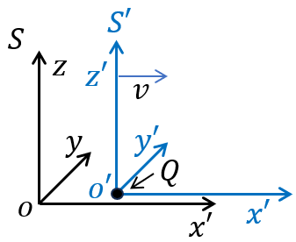
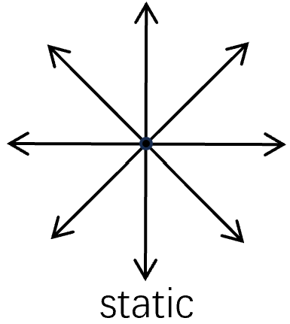
$Q$ is static at the origin of the $S'$ frame. Consider xz-plane:
$$E_{x}^{'}=\frac{1}{4πϵ_{0}}\frac{Qx^{'}}{{\left({x'}^{2}+{z'}^{2}\right)}^{3/2}}$$
$$E_{z}^{'}=\frac{1}{4πϵ_{0}}\frac{Qz'}{{\left({x'}^{2}+{z'}^{2}\right)}^{3/2}}$$

Suppose Frame $S'$ is moving along $\hat{x}$ at the speed of $v$ with respect to $S$ frame (so as $Q$)
$⟹ \left(\begin{matrix}x' \\ ct'\end{matrix}\right)=\left(\begin{matrix}γ & -γβ \\ -γβ & γ\end{matrix}\right)\left(\begin{matrix}x \\ ct\end{matrix}\right)$,
At $Q$ passes the origin of $S$, $t=0$. At this moment of $t^{'}$, $\left\{\begin{aligned}x'=γx \\ z'=z\end{aligned}\right.$. the field measured in $S$ should be
$$E_{x}\left(\overset{⃑}{r},t=0\right)={E'}_{x}\left(\overset{⃑}{r}',t'\right)=\frac{1}{4πϵ_{0}}\frac{Qx'}{{\left({x'}^{2}+{z'}^{2}\right)}^{3/2}}=\frac{1}{4πϵ_{0}}\frac{Qγx}{{\left[{(γx)}^{2}+z^{2}\right]}^{3/2}}$$
$$E_{z}\left(\overset{⃑}{r},t=0\right)=γ{E'}_{z}\left(\overset{⃑}{r}',t'\right)=\frac{1}{4πϵ_{0}}\frac{Qγz'}{{\left({x'}^{2}+{z'}^{2}\right)}^{3/2}}=\frac{1}{4πϵ_{0}}\frac{Qγz}{{\left[{(γx)}^{2}+z^{2}\right]}^{3/2}}$$
The total field (zx plane):
$E^{2}=E_{x}^{2}+E_{z}^{2}$ ⟹ $E^{2}=\frac{1}{{\left(4πϵ_{0}\right)}^{2}}\frac{Q^{2}γ^{2}(x^{2}+z^{2}) }{{\left[{(γx)}^{2}+z^{2}\right]}^{3}}=\frac{1}{{\left(4πϵ_{0}\right)}^{2}}\frac{Q^{2}(x^{2}+z^{2}) }{γ^{4}{\left[x^{2}+z^{2}(1-β^{2})\right]}^{3}}$
$$=\frac{1}{{\left(4πϵ_{0}\right)}^{2}}\frac{Q^{2}{\left(1-β^{2}\right)}^{2}}{{\left(x^{2}+z^{2}\right)}^{2}{\left(1-\frac{β^{2}z^{2}}{x^{2}+z^{2}}\right)}^{3}}$$
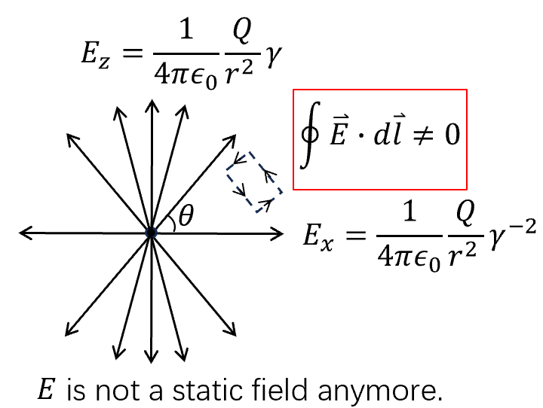
⟹ $E=\frac{1}{4πϵ_{0}}\frac{Q}{r^{2}} \frac{1-β^{2}}{{\left(1-β^{2}\sin^{2}{θ}\right)}^{3/2} }$

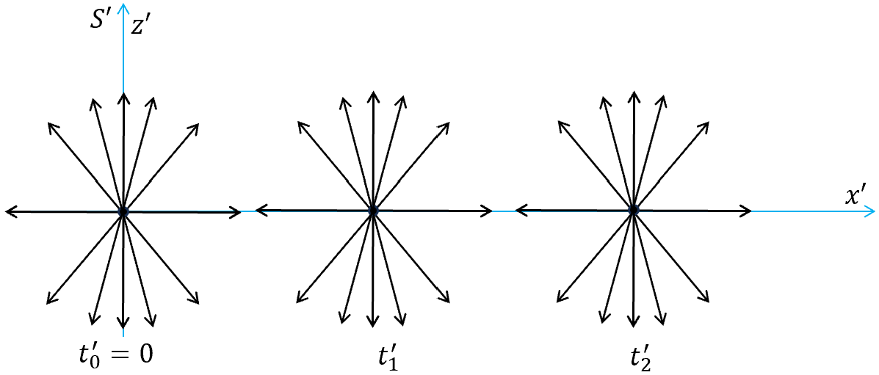
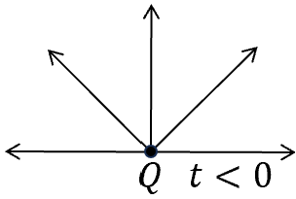
- Electric field of a sudden moving charge
At $t<0$, charge $Q$ is at rest at the origin.
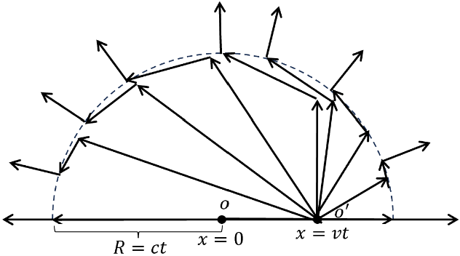
At $t>∆t>0$, charge $Q$ accelerates in a short time interval $∆t$ and then its velocity becomes $v$ along $\hat{x}$ direction at $t>∆t$. $∆t$ is very short. Then at the distance $R>ct$, one should not notice the motion of $Q$, thus field should be the same as these at $t<0$. At the distance $R<ct$, the field should be those of a moving charge at velocity $v$. The two different types of field line should connect at a thin shell with the thickness of $c∆t$.
Thus in the thin shell with radius of $R=ct$ and thickness of $c∆t$, the $E$ fields are along the polar (tangential) direction from the right pole to left pole. These fields are transverse field, which are different from the electrostatic fields that is longitudinal.
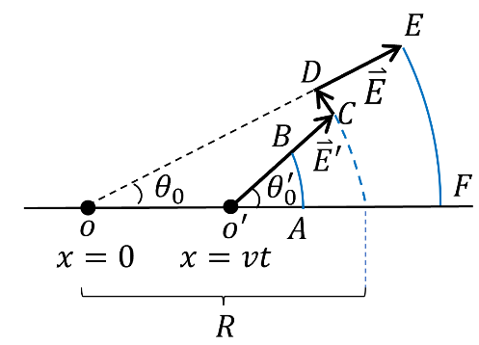
We need to decide how the two different regimes are connected. Consider the region of $A→B→C→D→E→F$, $A,B$ is the area which span the polar angle $θ_{0}^{'}$ with respect to $o'$, the field flux on area $AB$ are of
⟹ $\int{\overset{⃑}{E}∙d{\overset{⃑}{S}}_{AB}}=\int{E∙r^{'2}dΩ_{AB}}=\frac{1}{4πϵ_{0}}\int_{0}^{θ_{0}^{'}}{\sin{θ'}dθ'}2πQ \frac{1-β^{2}}{{\left(1-β^{2}\sin^{2}{θ^{'}}\right)}^{3/2} }$
$$(dΩ_{AB}=2π\sin{θ^{'}}dθ^{'})$$
The flux passes the area span by $EF$ are
⟹ $\frac{1}{4πϵ_{0}}\int_{0}^{θ_{0}}{r^{2}2π\sin{θ}dθ}Q/r^{2}$
All other area doesn’t contribute flux ⟹
($1-β^{2}$) $\int_{0}^{θ_{0}^{'}}{\frac{\sin{θ^{'}}dθ^{'}}{{\left(1-β^{2}\sin^{2}{θ^{'}}\right)}^{3/2} }} =\int_{0}^{θ_{0}}{\sin{θ}dθ}=1-\cos{θ_{0}}$
$$∫\frac{\sin^{'}θdθ^{'}}{(1-β^{2}\sin^{2}θ^{'})^{3/2}}=-∫\frac{d cosθ^{'}}{(1-β^{2}+β^{2}\cos^{2}θ^{'})^{3/2}}=-β^{-3}∫\frac{d cosθ^{'}}{(\cos^{2}{θ'}+\frac{1-β^{2}}{β^{2}})^{3/2}}$$
Given $∫\frac{dx}{(a^{2}+x^{2})^{3/2}}=\frac{x}{a^{2}(a^{2}+x^{2})^{1/2}}+c$,
$$⇒ \int_{0}^{θ_{0}^{'}}{ }\frac{\sin^{'}θdθ^{'}}{{\left(1-β^{2}\sin^{2}θ^{'}\right)}^{\frac{3}{2}}}={\left.-β^{-3}\frac{cosθ^{'}}{\frac{1-β^{2}}{β^{2}}{\left(\cos^{2}{θ'}+\frac{1-β^{2}}{β^{2}}\right)}^{\frac{1}{2}}}\right|}_{0}^{θ_{0}^{'}}=β^{-1}\left[\frac{β}{1-β^{2}}-\frac{\cos{θ_{0}^{'}}}{(1-β^{2})(\cos^{2}{θ_{0}^{'}}+\frac{1-β^{2}}{β^{2}})^{1/2}}\right]$$
⟹ $β^{-1}\left[β-\frac{\cos{θ_{0}^{'}}}{β^{-1}{\left(1-β^{2}\sin^{2}θ_{0}^{'}\right)}^{1/2}}\right]=(1-\cos{θ_{0}})$
$⟹$ $\cos{θ_{0}}=\frac{\cos{θ_{0}^{'}}}{\sqrt{1-β^{2}\sin^{2}θ_{0}^{'}}}$ or $\tan{θ_{0}^{'}}=γ\tan{θ_{0}}$
If we consider field lines is like a rod and every rod represents the same amount of flux, then the rods associated with the moving charge are steeper than those connecting to the rest position of charge. Their relation is
$$\tan{θ_{0}^{'}}=γ\tan{θ_{0}}$$

- Forces on a moving charge with $B$ field
We have assumed that for a static charge $\overset{⃑}{F}=q\overset{⃑}{E}$. We can show that for a moving charge, its electric field remains ${\overset{⃑}{F}}_{e}=q\overset{⃑}{E}$, let’s prove it. (it may contain additional Lorenz force which depends on velocity $\overset{⃑}{v}$).
Let us consider two different frames: in the lab frame $S$, particle is moving and electric field is static. In the particle’s frame $S'$, particle is static, but electric field isn’t.
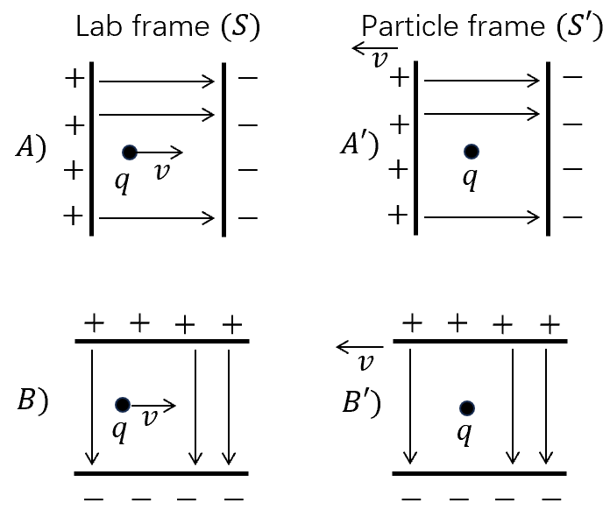

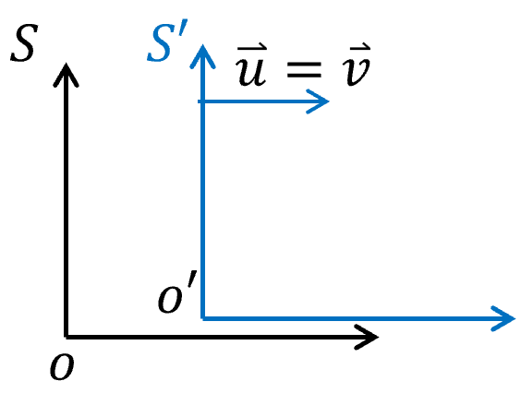
$\left(\begin{matrix}x \\ ct\end{matrix}\right)=\left(\begin{matrix}γ & γβ \\ γβ & γ\end{matrix}\right)\left(\begin{matrix}x' \\ ct'\end{matrix}\right)$
⟹ $cdt=βγdx^{'}+γcdt^{'}=\left(βγ\frac{dx^{'}}{dt^{'}}+γc\right)dt^{'}$
⟹ $dt=(1+ββ^{'})γdt^{'}$, where $β^{'}=\frac{1}{c}\frac{dx^{'}}{dt^{'}}=\frac{v^{'}}{c}$
$\left(\begin{aligned}p_{x} \\ E/c\end{aligned}\right)=\left(\begin{matrix}γ & γβ \\ γβ & γ\end{matrix}\right)\left(\begin{aligned}p_{x}^{'} \\ E'/c\end{aligned}\right)$ ⟹ $dp_{x}=γdp_{x}^{'}+\frac{γβ}{c}dE^{'}=γ\left(1+\frac{β}{c}\frac{dE^{'}}{dp_{x}^{'}}\right)dp_{x}^{'}$
$$\frac{1}{c}\frac{dE^{'}}{dp_{x}^{'}}=\frac{cp_{x}^{'}}{E^{'}}=β^{'}$$
⟹ $dp_{x}=γ\left(1+ββ'\right)dp_{x}^{'}$

At $S'$ frame, the velocity of particle is zero: $v^{'}=0$
$dp_{x}=γdp_{x}^{'}$ $⟹$ $\frac{dp_{x}}{dt}=\frac{dp_{x}^{'}}{dt^{'}}$
$p_{y}=p_{y}^{'}$ $⟹$ $\frac{dp_{y}}{dt}=\frac{1}{γ}\frac{dp_{y}^{'}}{dt^{'}}$
Or for two frames $S \& S'$, a particle is at rest in $S'$ and $S'$ moves at a velocity $\overset{⃑}{v}$ with respect to $S$. Decompose forces to parallel an perpendicular to $\overset{⃑}{v}$ as $F_{||} \& F_{⟘}$ and $F_{||}^{'} \& F_{⟘}^{'}$, there relation $\begin{matrix}\frac{dp_{||}}{dt}=\frac{dp_{||}^{'}}{dt^{'}} \\ \frac{dp_{⟘}}{dt}=\frac{1}{γ}\frac{dp_{⟘}^{'}}{dt^{'}}\end{matrix}$ is the same as $E$.
Then $\left\{\begin{aligned}\frac{dp_{||}}{dt}=\frac{dp_{||}^{'}}{dt^{'}}=qE_{||}^{'}=qE_{||} \\ \frac{dp_{⟘}}{dt}=\frac{1}{γ}\frac{dp_{⟘}^{'}}{dt^{'}}=\frac{1}{γ}qE_{⟘}^{'}=qE_{⟘}\end{aligned}\right.$ ⟹ $\left\{\begin{aligned}\frac{dp_{||}}{dt}=qE_{||} \\ \frac{dp_{⟘}}{dt}=qE_{⟘}\end{aligned}\right.$
A force of a moving charge in a static field is the same as that of the rest charge.

- Forces on a moving charge with $B$ field
Let us consider a situation where $\overset{⃑}{E}$ is zero everywhere, the test charge still feel a velocity dependent force:
$${\overset{⃑}{F}}_{L}\left(\overset{⃑}{v}\right)=q\vec{v}×\vec{B}$$
The form of Lorenz force is viewed as an experiment fact. We will give an explanation based on Lorenz transformation.
Lab frame: A line of positive/negative charge moving at speed $v_{0}$ to the right/left. In this frame, the line charge densities are $±λ$, respectively. Thus total charge is zero, no electric field.
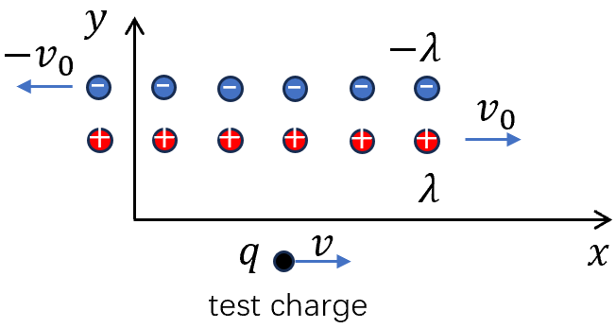
Put a test charge $q$at the speed of $v$ to the right. What’s the force on it?

Let us change to the frame $S'$ in which the test charge is at rest. Then the line charge densities $±λ$ are not equal any more due to different contraction. In this frame, the velocities of positive/negative charges are different.
$$v_{+}^{'}=\frac{v_{0}-v}{1-\frac{v_{0}v}{c^{2}}} v_{-}^{'}=\frac{v_{0}+v}{1+\frac{v_{0}v}{c^{2}}} define: β_{±}^{'}=\frac{v_{±}^{'}}{c} \& β_{0}=\frac{v_{0}}{c}$$
⟹ $β_{±}^{'}=\frac{β_{0}∓β}{1∓β_{0}β}$
For the positive charge, its line charge density in its rest frame should be: $λ_{0,+}=λ/γ_{0}$.
Similarly for negative charge, $λ_{0,-}=-λ/γ_{0}$.
⟹ in $S^{'}$ frame $λ_{±}^{'}=γ_{±}^{'}λ_{0,±}=±\frac{λ}{γ_{0}}γ_{±}^{'}$
the net charge density $∆λ^{'}=λ_{+}^{'}+λ_{-}^{'}=\frac{λ}{γ_{0}}(γ_{+}^{'}-γ_{-}^{'})$
$$γ_{+}^{'}-γ_{-}^{'}=\frac{1}{\sqrt{1-{\left(\frac{β_{0}-β}{1-ββ_{0}}\right)}^{2}}}-\frac{1}{\sqrt{1-{\left(\frac{β_{0}+β}{1+β_{0}β}\right)}^{2}}}=\frac{-2β_{0}β}{\sqrt{\left(1-β_{0}^{2}\right)\left(1-β^{2}\right)}}=-2β_{0}βγ_{0}γ$$
⟹ $Δλ^{'}=-2λβ_{0}βγ⇒ E_{y}^{'}=\frac{1}{2πϵ_{0}}\frac{Δλ^{'}}{r}=\frac{1}{πϵ_{0}}\frac{λγvv_{0}}{rc^{2}}$ (See Lec. 4, S3 for line charge)
⟹ $F_{y}^{'}=\frac{q}{πϵ_{0}}\frac{λγvv_{0}}{rc^{2}}$
in $S$ Frame $⟹$ $F_{y}=\frac{F_{y}^{'}}{γ}=-\frac{q}{πϵ_{0}}\frac{λvv_{0}}{rc^{2}}=\frac{μ_{0}I }{2πr}qv$ where $I=2λv_{0}$ is the current.
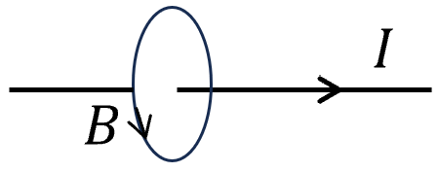
Ampere’s law $B=\frac{μ_{0}I}{2πr}$ ⟹ $F_{y}=qvB$ Lorenz force

Magnetic field from electric charge is indeed a relativistic effect. Because electric force usually is cancelled due to charge neutrality, magnetic force can appear! $E\&M$ are naturally relativistic although people didn’t realize it until Einstein point it out!

