Lecture 1 Vector algebra
- Vector algebra:
- Scalar: Quantities has magnitude but no direction.
Mass (non-relativistic), charge, density, temperature,
- Vector: Quantities has magnitude and direction.
Displacement ($\overset{⃑}{r}$), velocity ($\overset{⃑}{v}$), acceleration ($\overset{⃑}{a}$)
$\overset{⃑}{r}=\left(x,y,z\right)=x\overset{⃑}{i}+y\overset{⃑}{j}+z\overset{⃑}{k}$, $\overset{⃑}{i},\overset{⃑}{j} and \overset{⃑}{k}:unit basis$
$$\overset{⃑}{v}=\left(v_{x},v_{y},v_{z}\right)=v_{x}\overset{⃑}{i}+v_{y}\overset{⃑}{j}+v_{z}\overset{⃑}{k}$$
$$\overset{⃑}{a}=\left(a_{x},a_{y},a_{z}\right)=a_{x}\overset{⃑}{i}+a_{y}\overset{⃑}{j}+a_{z}\overset{⃑}{k}$$

- $\overset{⃑}{A}+\overset{⃑}{B}=\left(A_{x},A_{y},A_{z}\right)+\left(B_{x},B_{y},B_{z}\right)=\left(A_{x}+B_{x},A_{y}+B_{y},A_{z}+B_{z}\right)=\overset{⃑}{B}+\overset{⃑}{A}$
- $\overset{⃑}{A}∙\overset{⃑}{B}=A_{x}B_{x}+A_{y}B_{y}+A_{z}B_{z}= \overset{⃑}{B} ∙\overset{⃑}{A}$ (e.g $\overset{⃑}{W}=\overset{⃑}{F}∙\overset{⃑}{r}$)
***Kronecker symbol $δ_{ij}$:
$$\overset{⃑}{A}∙\overset{⃑}{B}=δ_{ij}A_{i}B_{j}$$
***symmetric $δ_{ij}=\left\{\begin{aligned}1 if i=j \\ 0 if i≠j \end{aligned}\right.$ $\left(\begin{matrix}1 & & \\ & 1 & \\ & & 1\end{matrix}\right)$
- $\overset{⃑}{A}×\overset{⃑}{B}=\left|\begin{matrix}i & j & k \\ A_{x} & A_{y} & A_{z} \\ B_{x} & B_{y} & B_{z}\end{matrix}\right|=\left(A_{y}B_{z}-A_{z}B_{y},A_{z}B_{x}-A_{x}B_{z},A_{x}B_{y}-A_{y}B_{x}\right)$
= $-\overset{⃑}{B}×\overset{⃑}{A}$ (e.g. $\overset{⃑}{L}=\overset{⃑}{r}×\overset{⃑}{p}$, $\overset{⃑}{τ}=\overset{⃑}{r}×\overset{⃑}{F}$)
***Levi-civita symbol：$ϵ_{ijk}$
$$\overset{⃑}{A}×\overset{⃑}{B}=ϵ_{ijk}{\overset{⃑}{e}}_{i}A_{j}B_{k}$$
$$ϵ_{ijk}=\left\{\begin{aligned}0 if any two indexes equal \\ 1 if ϵ_{123}= ϵ_{231}= ϵ_{312} \left(even permutation\right) \\ -1 if ϵ_{213}= ϵ_{132}= ϵ_{321} \left(odd permutation\right)\end{aligned}\right.$$

$\overset{⃑}{A}×\overset{⃑}{A}=0$
- $\left.\vec{A}⋅(\vec{B}×\vec{C})=\left|\begin{matrix}A_{x} & A_{y} & A_{z} \\ B_{x} & B_{y} & B_{z} \\ C_{x} & C_{y} & C_{z}\end{matrix}\right.\right|=\vec{B}⋅(\vec{C}×\vec{A})=\vec{C}⋅(\vec{A}×\vec{B})$
Determinant

- $\begin{aligned}\vec{A}×\vec{(B}×\vec{C})&=\vec{B}\left(\vec{A}⋅\vec{C}\right)-\vec{C}\left(\vec{A}⋅\vec{B}\right) \\ \left(\vec{A}×\vec{B}\right)×\vec{C}=-\vec{A}\left(\vec{B}⋅\vec{C}\right)+\vec{B}\left(\vec{A}⋅\vec{C}\right)\end{aligned}$

- $(\vec{A}×\vec{B})⋅(\vec{C}×\vec{D})=(\vec{A}⋅\vec{C})⋅(\vec{B}⋅\vec{D})-(\vec{A}⋅\vec{D})(\vec{B}⋅\vec{C})$
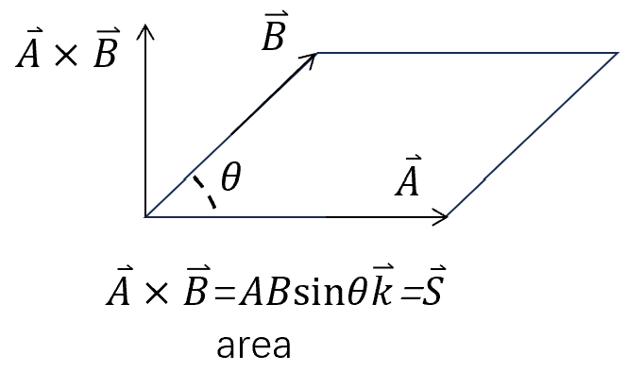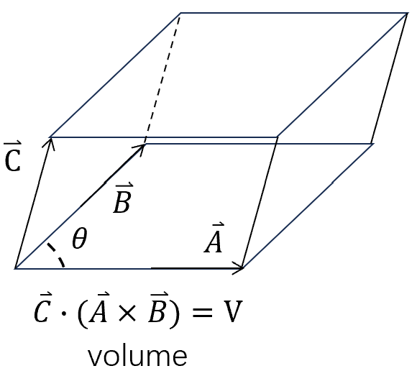
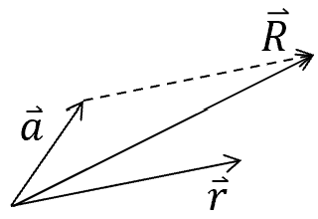
- Position and displacement
$$\vec{r}=x\vec{i}+y\vec{j}+z\vec{k} r=\sqrt{x^{2}+y^{2}+z^{2}}$$
$$\hat{r}=\frac{\vec{r}}{r}=\frac{x\vec{i}+y\vec{j}+z\vec{k}}{\sqrt{x^{2}+y^{2}+z^{2}}}$$
$${\vec{r}}_{12}={\vec{r}}_{1}-{\vec{r}}_{2}, \left|r_{12}\right|=\left|\vec{r}-{\vec{r}}_{1}^{'}\right|, {\hat{r}}_{12}=\frac{{\vec{r}}_{1}-{\vec{r}}_{2}}{|r_{1}-r_{2}|}$$

- Transformation of vector
- $\vec{r}$ is translated by $\vec{a}$, the resultant vector: $\vec{R}=\vec{r}+\vec{a}$
Matrix method: $\left(\begin{aligned}R_{x} \\ R_{y} \\ R_{z}\end{aligned}\right)= \left(\begin{aligned}r_{x} \\ r_{y} \\ r_{z}\end{aligned}\right)+ \left(\begin{aligned}a_{x} \\ a_{y} \\ a_{z}\end{aligned}\right)$

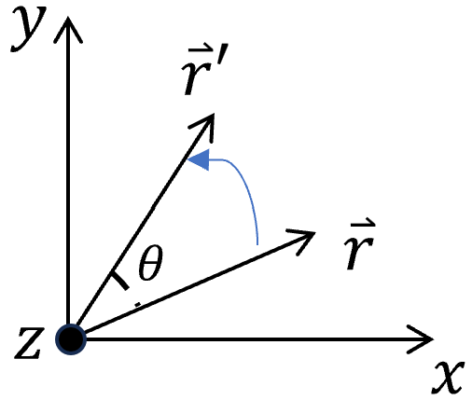
- Rotation, $\vec{r}$ is rotated around the $\vec{z}$-axis by angle $θ$,
$${\vec{r}}^{'}=R_{z}(θ)\vec{r}$$
Matrix: $\left(\begin{aligned}r_{x}^{'} \\ r_{y}^{'} \\ 0\end{aligned}\right)=\left(\begin{matrix}cos⁡θ & -sin⁡θ & 0 \\ sin⁡θ & cos⁡θ & 0 \\ 0 & 0 & 1\end{matrix}\right)\left(\begin{aligned}r_{x} \\ r_{y} \\ 0\end{aligned}\right)$
$R_{z}(θ)$: rotation matrix
Generally for 3D rotation: ${\vec{r}}^{'}=R\vec{r}$
$$\left(\begin{aligned}r_{x}^{'} \\ r_{y}^{'} \\ r_{z}^{'}\end{aligned}\right)=\left(\begin{matrix}R_{xx} & R_{xy} & R_{xz} \\ R_{yx} & R_{yy} & R_{yz} \\ R_{zx} & R_{zy} & R_{zz} \\ & & \end{matrix}\right)\left(\begin{aligned}r_{x} \\ r_{y} \\ r_{z}\end{aligned}\right)$$
$3×3$ orthogonal matrix: $R^{T}R=I, det\left(R\right)=1$ $SO\left(3\right) group:$ specific 3D rotation. $R^{T}$: Transpose matrix
- Inversion ${\vec{r}}^{'}=-\vec{r}$
$$\left.\left(\begin{aligned}r_{x}^{'} \\ r_{y}^{'} \\ r_{z}^{'}\end{aligned}\right.\right)=\left(\begin{aligned}-1 0 0 \\ 0-1 0 \\ 0 0 -1\end{aligned}\right)\left(\begin{aligned}r_{x} \\ r_{y} \\ r_{z}\end{aligned}\right)$$

- Reflection with respect to xy, yz, and zx planes
xy-plane: $\left.\left(\begin{aligned}r_{x}^{'} \\ r_{y}^{'} \\ r_{z}^{'}\end{aligned}\right.\right)=\left(\begin{matrix}1 & 0 & 0 \\ 0 & 1 & 0 \\ 0 & 0 & -1\end{matrix}\right)\left(\begin{aligned}r_{x} \\ r_{y} \\ r_{z}\end{aligned}\right)$ ${\vec{r}}^{'}=M_{xy}\vec{r}$
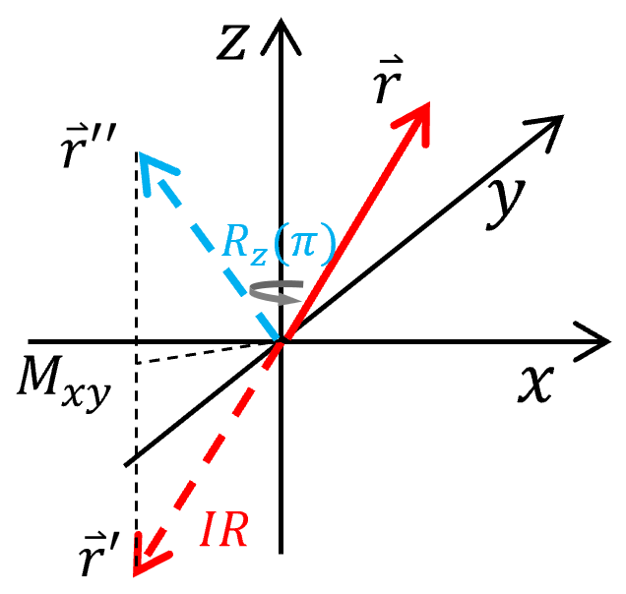
yz-plane: $\left.\left(\begin{aligned}r_{x}^{'} \\ r_{y}^{'} \\ r_{z}^{'}\end{aligned}\right.\right)=\left(\begin{matrix}-1 & 0 & 0 \\ 0 & 1 & 0 \\ 0 & 0 & 1\end{matrix} \right)\left(\begin{aligned}r_{x} \\ r_{y} \\ r_{z}\end{aligned}\right)$ ${\vec{r}}^{'}=M_{yz}\vec{r}$
zx-plane: $\left.\left(\begin{aligned}r_{x}^{'} \\ r_{y}^{'} \\ r_{z}^{'}\end{aligned}\right.\right)=\left(\begin{matrix}1 & 0 & 0 \\ 0 & -1 & 0 \\ 0 & 0 & 1\end{matrix}\right)\left(\begin{aligned}r_{x} \\ r_{y} \\ r_{z}\end{aligned}\right)$ ${\vec{r}}^{'}=M_{zx}\vec{r}$

note: $R_{z}\left(π\right)=\left(\begin{matrix}-1 & 0 & 0 \\ 0 & -1 & 0 \\ 0 & 0 & 1\end{matrix}\right)$, $π-rotation ≠mirror symmetry$
Inversion symmetry= $R_{z}\left(π\right)M_{xy}$
All the transformations which keep $|\vec{r}|$ unchanged can be decomposed into a series of the above operations.
- Concept: Pseudo-vector
$\overset{⃑}{E}:$ electric field is vector, ordinary vector (polar vector), satisfy the above transformations.
$\overset{⃑}{B}:$ pseudo vector (axial vector).
**Under spatial rotation ($R$) , $\overset{⃑}{B}$ transforms as the same as $\overset{⃑}{E}$.
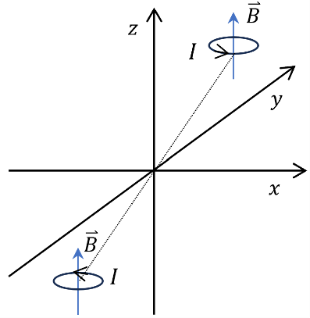
**Under inversion: $\overset{⃑}{E}→ - \overset{⃑}{E}$, but $\overset{⃑}{B}→\overset{⃑}{B}$
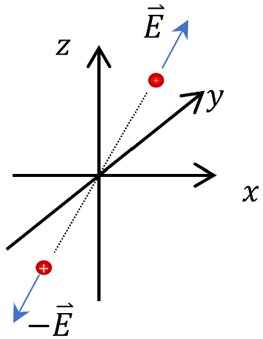
$\overset{⃑}{B}$ is even under spatial inversion, thus is quite different from ordinary vectors- pseudo-vector or axial vector. ($\overset{⃑}{E}$ is also called polar vector).
Note: Any quantity from cross product is a pseudo-vector (e.g., $\overset{⃑}{L}, \overset{⃑}{τ}$) ****homework
*****Extended discussion (homework) how about reflection?
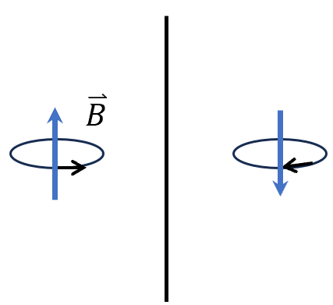
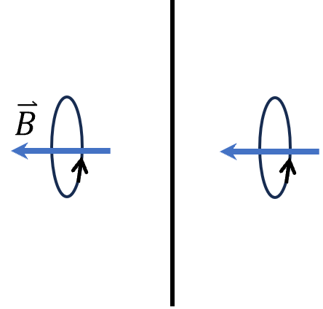
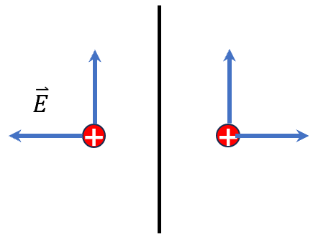

Lecture 2 Differential calculus
- Gradient （梯度）
Consider a scalar function $T(x,y,z)$
$$dT\left(x,y,z\right)=\frac{∂T}{∂x}dx+\frac{∂T}{∂y}dy+\frac{∂T}{∂z}dz$$
$$=\left(\frac{∂T}{∂x}\hat{x}+\frac{∂T}{∂y}\hat{y}+\frac{∂T}{∂y}\hat{z}\right)∙\left(dx\hat{x}+dy\hat{y}+dz\hat{z}\right)=∇T⋅d\vec{r}$$
Where $∇T=\frac{∂T}{∂x}\hat{x}+\frac{∂T}{∂y}\hat{y}+\frac{∂T}{∂z}\hat{z}$
$dT=∣∇T∣∣d\vec{r}∣cosθ$, where $θ$ is the angle between $∇T$ and $d\vec{r}$.
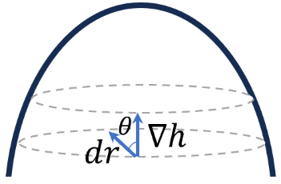
Note: climb a hill $h(x,y,z)$, the direction of $∇h$ is along the steepest direction. The magnitude of $∇h$ is the slope along this steepest direction.

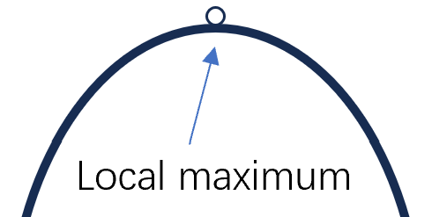

- Stationary point: $∇h=0$ $dh∝0 dr$

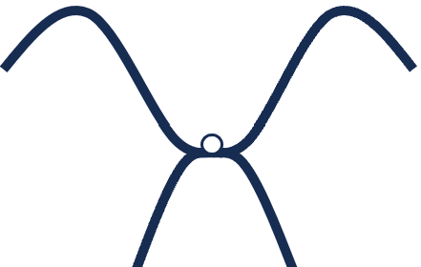
Saddle point: $∇h=0$, maximum along one direction, minimum along another direction.

Example： $r=\sqrt{x^{2}+y^{2}+z^{2}}$
$$\begin{aligned}& \\ &∇r=\frac{∂r}{∂x}\hat{x}+\frac{∂r}{∂y}\hat{y}+\frac{∂r}{∂z}\hat{z}=\frac{1}{\sqrt{x^{2}+y^{2}+z^{2}}}\left(x\hat{x}+y\hat{y}+z\hat{z}\right)=\frac{\vec{r}}{|\vec{r}|}=\hat{r} \\ &\end{aligned}$$
- Nabla (Del) operator: $∇=\hat{x}\frac{∂}{∂x}+\hat{y}\frac{∂}{∂y}+\hat{z}\frac{∂}{∂y}$ (vector operator)
The effect of $∇$ is for any scalar function $f(x,y,z)$ that:
$∇f=\hat{x}\frac{∂f}{∂x}+\hat{y}\frac{∂f}{∂y}+\hat{z}\frac{∂f}{∂z}$
- Divergence （散度）
----applying the $∇$-operator on a vector function: point product.
For a vector field, $\vec{v}=v_{x}\left(x,y,z\right)\hat{x}+v_{y}(x,y,z)\hat{y}+v_{z}(x,y,z)\hat{z}$
Each component is a function of ($x,y,z$)
Example: electric field: $\vec{E}=(E_{x}\left(x,y,z\right),E_{y}\left(x,y,z\right), E_{z}(x,y,z)$)
magnetic filed: $\vec{B}=(B_{x}\left(x,y,z\right),B_{y}\left(x,y,z\right), B_{z}(x,y,z)$)
divergence: $\begin{aligned}&∇∙\vec{v}=(\hat{x}\frac{∂}{∂x}+\hat{y}\frac{∂}{∂y}+\hat{z}\frac{∂}{∂z})(v_{x}\hat{x}+v_{y}\hat{y}+v_{z}\hat{z}) \\ & =\frac{∂}{∂x}v_{x}+\frac{∂}{∂y}v_{y}+\frac{∂}{∂z}v_{z}\end{aligned}$
A scalar function has no divergence.
Physical meaning: $∇∙\vec{v}$ is a measure of the vector $\vec{v}$ spreads out from a point （a source point）.
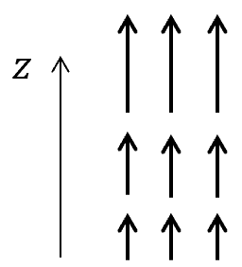
Example 1: $\vec{v}=\left(0,0,v_{z}\left(z\right)\right)→∇∙\vec{v}=\frac{∂}{∂z}v_{z}>0$
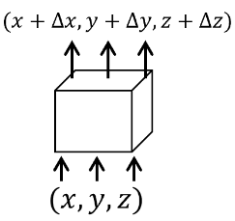
consider a box, the net flow of $\vec{v}$ to outside:
$$v_{z}\left(z+∆z\right)∆x∆y-v_{z}\left(z\right)∆x∆y=\frac{∂}{∂z}v_{z}∆x∆y∆z$$
$$=∇∙\vec{v} ∆x∆y∆z$$
***Think about electric current density.
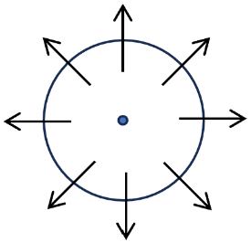
Example 2: $\vec{v}=\left(x,y,z\right)= \vec{r}$consider a small sphere with $∆r$, the flux goes outside:
$$4π(∆r)^{2}⋅Δr=4π(Δr)^{3}=\frac{4}{3}π(∆r)^{3}(∇⋅\vec{r}) =∆V(∇⋅\vec{r})$$
Divergence: net flux per volume. （$\vec{a}∙\vec{b}=a_{i}δ_{ij}b_{j}, 速记符号$）
- Curl （旋度）
$$∇×\vec{v}=\left|\begin{matrix}\hat{x} & \hat{y} & \hat{z} \\ \frac{∂}{∂x} & \frac{∂}{∂y} & \frac{∂}{∂z} \\ v_{x} & v_{y} & v_{z}\end{matrix}\right|\begin{aligned}&=\hat{x}\left(\frac{∂}{∂y}v_{z}-\frac{∂}{∂z}v_{y}\right)+\hat{y}\left(\frac{∂}{∂z}v_{x}-\frac{∂}{∂x}v_{z}\right)+\hat{z}\left(\frac{∂}{∂x}v_{y}-\frac{∂}{∂y}v_{x}\right) \\ &\end{aligned}$$
$∇×\vec{v}$ is a measure of how much $\vec{v}$ “curls around” the point.
The direction of $∇×\vec{v}$ is perpendicular to the circulation plane.
Example: $\vec{v}=(-y,x,0)$
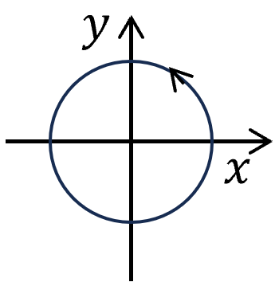
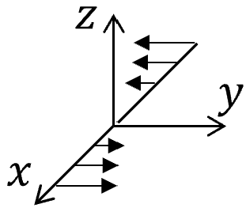
circulation around a circle of radial $∆r$ along the counter-clockwise direction.
$$∆r∙2π∆r=π{\left(∆r\right)}^{2}∙2$$
$∇×\vec{v}=2\hat{z}$
Circulation= $∆S \hat{z}∙(∇×\vec{v})$
（$\vec{a}×\vec{b}=ϵ_{ijk}a_{j}b_{k}, 速记符号 ϵ_{123}=1,ϵ_{132}=-1…$)

- Product rules (结合律)
$\left\{\begin{aligned}&∇(f+g)=∇f+∇g \\ &∇⋅(\vec{A}+\vec{B})=∇⋅\vec{A}+∇⋅\vec{B} \\ &∇×(\vec{A}+\vec{B})=∇×\vec{A}+∇×\vec{B}\end{aligned}\right.$ $\begin{aligned}∇(kf)&=k∇f \\ ∇⋅(k\vec{A})&=k∇⋅\vec{A} \\ ∇×(k\vec{A})&=k∇×\vec{A}\end{aligned}$ $k$: a constant
Linear operator properties
More $\begin{aligned}∇(fg)&=f∇g+∇fg \\ ∇(f/g)&=\frac{1}{g}∇f-\frac{f∇g}{g^{2}} \\ ∇⋅(f\vec{A})&=f(∇⋅\vec{A})+\vec{A}⋅∇f\end{aligned}$
$$\left.\left\{\begin{matrix}∇⋅(\vec{A}×\vec{B})=\vec{B}⋅(∇×\vec{A})-\vec{A}⋅(∇×\vec{B}) & \\ & \\ ∇×(f\vec{A})=f(∇×\vec{A})-\vec{A}×(∇\vec{f}) & \\ & \\ ∇×(\vec{A}×\vec{B})=(\vec{B}⋅∇)\vec{A}-(\vec{A}⋅∇)\vec{B}+\vec{A}(∇⋅\vec{B})-\vec{B}(∇⋅\vec{A}) & \end{matrix}\right.\right.$$
Not required to remember

- Laplacian: divergence of gradient
$$\begin{aligned}∇∙(∇T)&=\frac{∂}{∂x}(∇T)_{x}+\frac{∂}{∂y}(∇T)_{y}+\frac{∂}{∂z}(∇T)_{z} \\ &=\frac{∂^{2}}{∂x^{2}}T+\frac{∂^{2}}{∂y^{2}}T+\frac{∂^{2}}{∂z^{2}}T=∇^{2}T=∆T\end{aligned}$$
- The curl of gradient is zero. (梯度无旋)
$$\begin{aligned}&∇×(∇T)=0 \\ &{\left[∇×(∇T)\right]}_{z}=\frac{∂}{∂x}{\left(∇T\right)}_{y}-\frac{∂}{∂y}{\left(∇T\right)}_{x}=\left(\frac{∂}{∂x}\frac{∂}{∂y}-\frac{∂}{∂y}\frac{∂}{∂x}\right)T=0\end{aligned}$$
Similarly: ${\left[∇×(∇T)\right]}_{x}={\left[∇×(∇T)\right]}_{y}=0$
- The divergence of curl is zero. （旋度无源）
$$∇⋅(∇×\vec{v})=0$$
$$∇⋅(∇×\vec{v})=\frac{∂}{∂x}(∇×\vec{v})_{x}+\frac{∂}{∂y}(∇×\vec{v})_{y}+\frac{∂}{∂z}(∇×\vec{v})_{z}$$
$$\begin{aligned}&=\frac{∂}{∂x}(\frac{∂}{∂y}v_{z}-\frac{∂}{∂z}v_{y})+\frac{∂}{∂y}(\frac{∂}{∂z}v_{x}-\frac{∂}{∂x}v_{z})+\frac{∂}{∂z}(\frac{∂}{∂x}v_{y}-\frac{∂}{∂y}v_{x}) \\ &=(\frac{∂}{∂x}\frac{∂}{∂y}-\frac{∂}{∂y}\frac{∂}{∂x})v_{z}+(\frac{∂}{∂z}\frac{∂}{∂x}-\frac{∂}{∂x}\frac{∂}{∂z})v_{y}+(\frac{∂}{∂y}\frac{∂}{∂z}-\frac{∂}{∂z}\frac{∂}{∂y})v_{x} \\ &=0\end{aligned}$$
- The curl of curl.
$∇×(∇×\vec{v})=∇(∇⋅\vec{v})-∇^{2}\vec{v}$ (leave for exercise)
definition: $∇^{2}\vec{v}=(∇^{2}v_{x},∇^{2}v_{y},∇^{2}v_{z})$

Lecture 3 Integral calculus
Fundamental law of calculus: $\int_{a}^{b}{f^{'}\left(x\right)}dx=f\left(b\right)-f(a)$
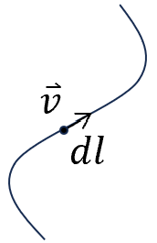
- Line integral--path
$\int_{a p}^{b}{ }\vec{v}⋅d\vec{l}$
If the path forms a loop: ${\text{∮}}_{p}\vec{v}⋅d\vec{l}$
Example: The work done by following a path $W=\int_{a}^{b}{ }\vec{F}⋅d\vec{l}$
Generally speaking, this integral depends on the path.
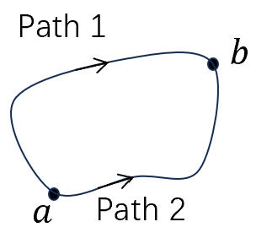
For a special class of vector field, such an integral is path-independent, which means that a close loop: $\oint{\vec{v}⋅d\vec{l}}=0$.
$$\oint{\vec{v}⋅d\vec{l}}=\int_{a p1}^{b}{\vec{v}⋅d\vec{l}}-\int_{a p2}^{b}{\vec{v}⋅d\vec{l}}=0$$
$$→\int_{a p1}^{b}{\vec{v}⋅d\vec{l}}=\int_{a p2}^{b}{\vec{v}⋅d\vec{l}}$$
For the force field satisfying this properties: conservative force (保守力).
e.g. static gravity, electrostatic force, etc.
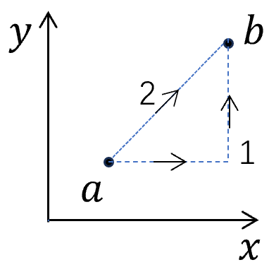
Example: $\vec{v}=y^{2}\hat{x}+2x(y+1)\hat{y}$ $a \left(1,1\right)$ to $b (2,2)$
Path 1: $\begin{aligned}∫\vec{v}⋅d\vec{l}=\int_{\left(1,1\right)→\left(2,1\right)}{ }v_{x}dx+\int_{\left(2,1\right)→\left(2,2\right)}{ }v_{y}dy \\ =\int_{1}^{2}{ }dx+\int_{1}^{2}{ }4(y+1)dy \\ &=1+{\left.(2y^{2}+4y)\right|}_{1}^{2}=1+(16-6)=11\end{aligned}$
Path 2: $∫\vec{v}⋅d\vec{l}=\int_{1}^{2}{ }v_{x}dx+\int_{1}^{2}{ }v_{y}dy$
$=\int_{1}^{2}{ }x^{2}dx+\int_{1}^{2}{ }2y(y+1)dy=\frac{x^{3}}{3}|_{1}^{2}+(\frac{2y^{3}}{3}+y^{2}{)|}_{1}^{2}$
$$=\frac{8-1}{3}+\frac{16-2}{3}+4-1=10$$
$if \vec{v}$ follows P1 and reverse along P2 coming back to a => $\oint{\vec{v}⋅d\vec{l}}=1$
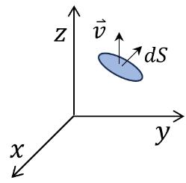
- Surface integral
$\int_{S}{ }\vec{v}⋅d\vec{S}$, $d\vec{S}$ is an infinitesimal area, the direction is along the normal direction.
For a closed surface,
$∯{\vec{v}⋅d\vec{S}}$, the normal direction is from inside to outside.
If $\vec{v}$ describe a flow of a liquid, then $∯{\vec{v}⋅d\vec{S}}$ is the net flux.
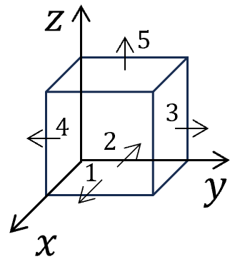
Example: $\vec{v}=2xz\hat{x}+(x+2)\hat{y}+y(z^{2}-3)\hat{z}$
Consider a cube with edge length 2, the 5 surfaces (except for the bottom) form a big surface, calculate $\int_{S}{ }\vec{v}⋅d\vec{S}$:
$$∫\vec{v}⋅d\vec{S}=\int_{1}{ }+\int_{2}{ }+⋯\int_{5}{ }$$
$\int_{1}{ }\vec{v}⋅d\vec{S}=\int{v_{x}dydz}=\int{4zdydz}=\int_{0}^{2}{dy}\int_{0}^{2}{4zdz}=2∙2z^{2}{\left.​\right|}_{0}^{2}=16$
Set $x=2$
$\int_{2}{ }\vec{v}⋅d\vec{S}=-\int{v_{x}dydz}=0 ($Set $x=0)$
$$\int_{3}{ }\vec{v}⋅d\vec{S}=\int{v_{y}dxdz}=\int_{0}^{2}{\left(x+2\right)dx}\int_{0}^{2}{dz=}2\left(\frac{x^{2}}{2}+2x\right){\left.​\right|}_{0}^{2}=12$$
Set $y=2$
$\int_{4}{ }\vec{v}⋅d\vec{S}=-\int{v_{y}dxdz}=-\int_{0}^{2}{\left(x+2\right)dx}\int_{0}^{2}{dz=}-12$ （set $y=0$）
$\int_{5}{ }\vec{v}⋅d\vec{S}=\int{v_{z}dxdy}=\int_{0}^{2}{dx}\int_{0}^{2}{ydy}=2∙\frac{y^{2}}{2}{\left.​\right|}_{0}^{2}=4$ （set $z=2$）
$$⇒\int_{1}{ }+⋯\int_{5}{ }=16+4=20$$
- Volume integral
$\int_{V}{ }Tdτ$ Where $dτ=dxdydz$, $T$ is a scalar function.
Sometimes we also calculate volume integral of vectors:
$∫\vec{v}dτ=(∫v_{x}dτ)\hat{x}+(∫v_{y}dτ)\hat{y}+(∫v_{z}dτ)\hat{z}$
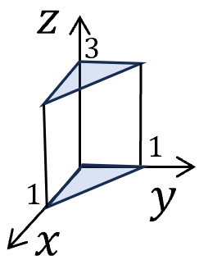
Example: $T=xyz^{2}$, $\int_{V}{ }Tdτ$ for the prism
$$\int_{0}^{3}{ }dz⋅\int_{0}^{1-x}{ }dy\int_{0}^{1}{ dx}⋅xyz^{2}=\int_{0}^{3}{ }z^{2}dz\int_{0}^{1}{ }xdx\int_{0}^{1-x}{ }ydy$$
$$=\frac{z^{3}}{3}|_{0}^{3}⋅\int_{0}^{1}{ }dx⋅x\frac{(1-x)^{2}}{2}=\frac{9}{2}\int_{0}^{1}{ }dx(x-2x^{2}+x^{3})=\frac{9}{2}⋅(\frac{1}{2}-\frac{2}{3}+\frac{1}{4})=3/8$$

Note: ***symmetric $δ_{ij}=\left\{\begin{aligned}1 if i=j \\ 0 if i≠j \end{aligned}\right.$ $\left(\begin{matrix}1 & & \\ & 1 & \\ & & 1\end{matrix}\right)$
***Fully antisymmetric
$$ϵ_{ijk}=\left\{\begin{aligned}0 if any two indexes equal \\ 1 if ϵ_{123}= ϵ_{231}= ϵ_{312} \left(even permutation\right) \\ -1 if ϵ_{213}= ϵ_{132}= ϵ_{321} \left(odd permutation\right)\end{aligned}\right.$$

Lecture 4 Fundamental theorems of vector calculus
- Fundamental theorems: integral of a total derivative is determined by the boundary.
- Calculus: $\int_{a}^{b}{\frac{df}{dx}dx=f(b)}-f\left(a\right) --1D$
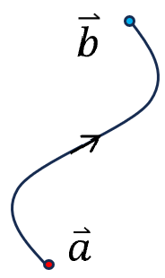
- Curved line $dT=∇T∙d\overset{⃑}{r}$
$$\int_{\overset{⃑}{a}}^{\overset{⃑}{b}}{∇T∙d\overset{⃑}{r}=}\int_{\overset{⃑}{a}}^{\overset{⃑}{b}}{dT}=T\left(\overset{⃑}{b}\right)-T(\overset{⃑}{a})$$
Line integral boundary: two end
This integral is independent of the path from a to b.
$\oint{∇T∙d\overset{⃑}{r}}=0$: only for single valued function $T$.
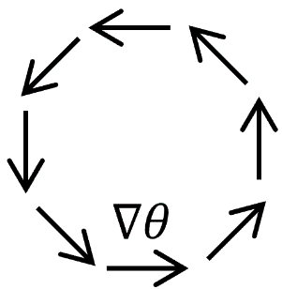
if $T$ is a multi-valued function, say $θ\left(x,y\right),$ the azimuthal angle of the point $(x,y)$, because $θ$ is only uniquely defined up to $2nπ,$ then $\oint{∇θ∙d\overset{⃑}{r}}=2nπ$.

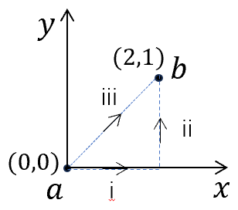
In this class, unless explicitly mentioned, we only consider single-valued function.

Example: $T=xy^{2}$
$$∇T=y^{2}\hat{x}+2xy\hat{y}$$
$$d\overset{⃑}{r}=dx\hat{x}+dy\hat{y}+dz\hat{z}$$
Following i+ii $\int_{i}{∇T∙d\overset{⃑}{r}}+\int_{ii}{∇T∙d\overset{⃑}{r}}=\int_{i}{y^{2}dx}+\int_{ii}{2xydy}=4\int_{0}^{1}{ydy}=2$
Following iii, $y=\frac{x}{2}$ $\int_{iii}{∇T∙d\overset{⃑}{r}}=\int_{iii}{y^{2}dx+2xydy}=\int_{0}^{2}{\frac{x^{2}}{4}dx+\frac{x^{2}}{2}dx}=\frac{x^{3}}{4}{\left.​\right|}_{0}^{2}$
$$=2$$
For both cases $\int{∇T∙d\overset{⃑}{r}}=T\left(2,1\right)-T\left(0,0\right)=2$
$\oint{∇T∙d\overset{⃑}{r}}=0$ For any gradient field, the loop integral is zero.
- Fundamental theorem of divergence-
*** Gauss theorem ${\text{∮}}_{V}\left(∇∙\vec{v}\right)dτ={\text{∮}}_{S}\vec{v}∙\vec{v}d\vec{S}$
within the volume = flow out through the surface.
Explanation: let’s consider a small cube with center (x,y,z) and edge length $∆a$, the flux pass the surface:
Up & down: $\begin{aligned}& \\ &\end{aligned}({\vec{v}}_{z}(x,y,z+\frac{a}{z})-{\vec{v}}_{z}(x,y,z-\frac{a}{z})(Δa)^{2}=(Δa)^{3}∂_{z}{\vec{v}}_{z}$
Front &back $(Δa)^{3}∂_{y}{\vec{v}}_{x}$ Left & right: $(Δa)^{3}∂_{y}{\vec{v}}_{y}$
$${\text{∮}}_{S}\vec{v}.d\vec{S}=∇∙\vec{v} (Δa)^{3}={\text{∮}}_{V}\left(∇∙\vec{v}\right)dτ$$
For a large volume, you can cut the system into a collection of small cubes.
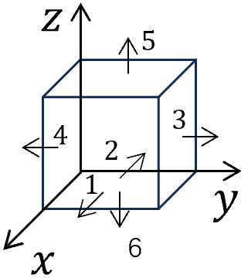
Then apply the above result and add them together.
$\sum{{\text{∮}}_{V}\left(∇∙\vec{v}\right)dτ}={\text{∮}}_{S}\vec{v}∙d\vec{S}$, the sum of external surface, (all the contributions on internal surfaces cancel out.)
Example (see Lect. 3): $\overset{⃑}{v}=y^{2}\hat{x}+\left(2xy+z^{2}\right)\hat{y}+2yz\hat{z}$ with the cube, check the Gauss law:
$∇∙\overset{⃑}{v}=2x+2y$
$$∫∇∙\overset{⃑}{v} dτ=∫dxdydz 2\left(x+y\right)=2∫dz\int_{0}^{1}{ }dxdy\left(x+y\right)=4\int_{0}^{1}{ }dz\int_{0}^{1}{ }dy\int_{0}^{1}{ }xdx=2$$
Flux: $\int_{1}{ }+⋯\int_{6}{ }=\text{∮}d\vec{S}$
$$\int_{1}{ }+\int_{2}{ }=\int_{0}^{1}{ }dydzy^{2}-\int_{0}^{1}{ }dydzy^{2}=0$$
$$x=1 x=0$$
$$\int_{3}{ }+\int_{4}{ }=\int_{0}^{1}{ }dxdz(2xy+z^{2})-\int_{0}^{1}{ }dxdz(2xy+z^{2})=-2\int_{0}^{1}{ }xdxdz=1$$
$y=1 y=0$
$$\int_{5}{ }+\int_{6}{ }=\int_{0}^{1}{ }dxdy(2yz)-\int_{0}^{1}{ }dxdy(2yz)=\int_{0}^{1}{ }2ydxdy=1$$
$z=1 z=0$
$\int_{1}{ }+⋯\int_{6}{ }=2$
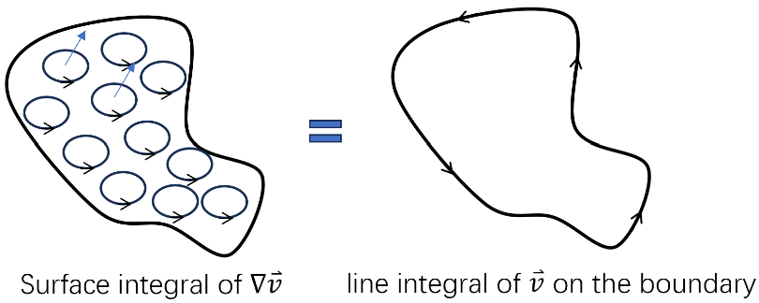
- Fundamental laws of curls – Stoke’s theorem
$$\int_{S}{\left(∇×\vec{v}\right)∙}d\vec{S}=\oint{\overset{⃑}{v}}∙d\overset{⃑}{l}$$
Surface boundary

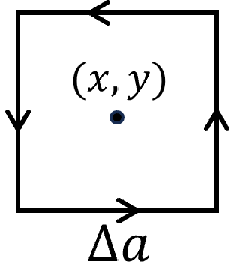
Example: Check for a planer version $\int_{s}{ }(\frac{∂}{∂x}v_{y}-\frac{∂}{∂y}v_{x})dxdy=\text{∮}\vec{v}⋅d\vec{l}$
$$\begin{aligned}\text{∮}\vec{v}⋅d\overset{⃑}{l}=\left[-v_{y}(x-\frac{∆a}{2},y)+v_{y}(x+\frac{∆a}{2},y)+v_{x}(x,y-\frac{∆a}{2})-v_{x}(x,y+\frac{∆a}{2})\right]∆a\end{aligned}$$
$=\left(\frac{∂}{∂x}v_{y}-\frac{∂}{∂y}v_{x}\right){\left(Δa\right)}^{2} = \int_{S}{\left(∇×\vec{v}\right)∙}d\vec{S}$
Note: $\int_{S}{\left(∇×\vec{v}\right)∙}d\vec{S}$ only depend on the boundary, but not the surface. A close area in 3D does not uniquely determine a surface. All the surface share the same boundary yield the same result.

For a close surface (e.g. a sphere): $\oint_{S}{\left(∇×\vec{v}\right)}∙d\vec{S}=\oint{\overset{⃑}{v}}∙d\overset{⃑}{l}=0$
Contract the boundary curve to a point.
$\oint_{S}{\left(∇×\vec{v}\right)}∙d\vec{S}=\int{∇∙\left(∇×\vec{v}\right)}dτ=0$ (a curl has no source)
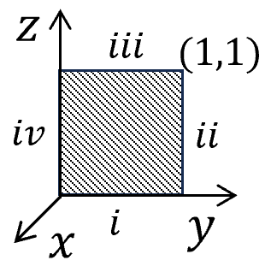
Example: $\vec{v}=(2xz+3y^{2})\hat{y}+4yz^{2}\hat{z}$, consider square surface
$$∇×\vec{v}=\left(\frac{∂v_{z}}{∂y}-\frac{∂v_{y}}{∂z}\right)\hat{x}+\left(\frac{∂v_{x}}{∂z}-\frac{∂v_{z}}{∂x}\right)\hat{y}+\left(\frac{∂v_{y}}{∂x}-\frac{∂v_{x}}{∂y}\right)\hat{z}=\left(4z^{2}-2x\right)\hat{x}+2z\hat{z}$$
$$∫∇×\vec{v}d\vec{S}=∫(4z^{2}-2x)dydz=4\int_{0}^{1}{ }dy\int_{0}^{1}{ }z^{2}dz=\frac{4}{3}$$
$$x=0$$
$$\text{∮}\vec{v}⋅d\overset{⃑}{l}=\int_{i}{ }+⋯\int_{iv}{ } ⇒\int_{i}{ }+\int_{iii}{ }=\int_{i}{ }dy\left(2xz+3y^{2}\right)-\int_{iii}{ }dy\left(2xz+3y^{2}\right)=\int_{0}^{1}{dy \left(3y^{2}-3y^{2}\right)=}0 x=z=0 x=0,z=1$$
$\int_{ii}{ }+\int_{iv}{ }=\int_{0}^{1}{ }dz 4yz^{2}-\int_{0}^{1}{ }dz 4yz^{2}=4\int_{0}^{1}{ }dz z^{2}=\frac{4}{3}$
$$x=0,y=1 x=y=0$$
$$⇒\text{∮}\vec{v}⋅d\vec{l}=\frac{4}{3}=∫∇×\vec{v} d\vec{S}$$
- Integral by parts
$$\begin{aligned}∇⋅(f\vec{A})&=f(∇⋅\vec{A})+\vec{A}⋅∇f \\ ⇒\int_{V}{ }f\left(∇⋅\vec{A}\right)dτ&=\int_{V}{ }\left[∇⋅\left(f\vec{A}\right)-\vec{A}⋅∇f\right]dτ\end{aligned}$$
$$=\text{∮}f\vec{A}⋅d\vec{S}-\int_{V}{ }\vec{A}⋅∇fdτ$$
Note: In some situations, we can take the surface to infinity. If $f\vec{A}$ decays very quickly, the surface integral often vanishes.

Lecture 5: curvilinear coordinates
- $\overset{⃑}{r}=x{\hat{e}}_{x}+y{\hat{e}}_{y}+z{\hat{e}}_{z}=\overset{⃑}{r}(x,y,z)$ Cartesian coordinate
The grid of orthogonal: $x=const_{1}, y=const_{2}, z=const_{3}.$
Unit vectors: ${\hat{e}}_{x}=\frac{∂\overset{⃑}{r}}{∂x}$ , ${\hat{e}}_{y}=\frac{∂\overset{⃑}{r}}{∂y}$, ${\hat{e}}_{z}=\frac{∂\overset{⃑}{r}}{∂z}$
- For many applications, we need curvilinear coordinates
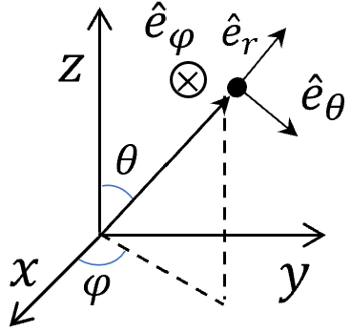
Example: the surface of the earth
$\overset{⃑}{r}(u^{1},u^{2},u^{3}$), the curves of surfaces $u^{1},u^{2},u^{3}=consts$
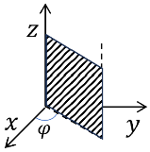
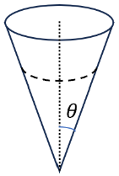
Say for the spherical coordinates: $\overset{⃑}{r}(r,θ,φ$),
$r=const_{1}$, specifies a spherical surface.
$θ=const_{2}$, specifies a cone surface.
$φ=const_{3}$, specifies a half plane.

Unit vectors: ${\hat{e}}_{r}=\frac{∂\vec{r}}{∂r}/|\frac{d\vec{r}}{dr}|, {\hat{e}}_{θ}=\frac{∂\vec{r}}{∂θ}/|\frac{d\vec{r}}{dθ}|,{\hat{e}}_{φ}=\frac{∂\vec{r}}{∂φ}/|\frac{d\vec{r}}{dφ}|$
Transformations $\left.\left\{\begin{aligned}x=r sinθ cosϕ \\ y=r sinθ sinϕ \\ z=r\cos{θ} \end{aligned}\right.\right.$
$$d\vec{r}=\frac{∂\vec{r}}{∂r}⋅dr+\frac{∂\vec{r}}{∂θ}dθ+\frac{∂\vec{r}}{∂φ}dφ$$
Or from cartesian:
$$d\vec{r}=dx{\hat{e}}_{x}+dy{\hat{e}}_{y}+dz{\hat{e}}_{z}$$
$$={\hat{e}}_{x}\left(\frac{∂x}{∂r}dr+\frac{∂x}{∂θ}dθ+\frac{∂x}{∂φ}dϕ\right)+{\hat{e}}_{y}\left(\frac{∂y}{∂r}dr+\frac{∂y}{∂θ}dθ+\frac{∂y}{∂φ}dφ\right)+{\hat{e}}_{z}\left(\frac{∂z}{∂r}dr+\frac{∂z}{∂θ}dθ+\frac{∂z}{∂φ}dφ\right)$$
$$=\left[{\hat{e}}_{x}\frac{∂x}{∂r}+{\hat{e}}_{y}\frac{∂y}{∂r}+{\hat{e}}_{y}\frac{∂z}{∂r}\right]dr+\left[{\hat{e}}_{x}\frac{∂x}{∂θ}+{\hat{e}}_{y}\frac{∂y}{∂θ}+{\hat{e}}_{z}\frac{∂z}{∂θ}\right]dθ+\left[{\hat{e}}_{r}\frac{∂x}{∂φ}+{\hat{e}}_{y}\frac{∂y}{∂φ}+{\hat{e}}_{z}\frac{∂z}{∂φ}\right]dφ$$
$$\begin{aligned}⇒ &\frac{∂\vec{r}}{∂r}=sinθ cosϕ{\hat{e}}_{x}+sinθsinϕ{\hat{e}}_{y}+cosθ{\hat{e}}_{z}={\hat{e}}_{r} \\ \frac{∂\vec{r}}{∂θ}&=r(cosθcosϕ{\hat{e}}_{x}+cosθsinϕ{\hat{e}}_{y}-sinθ{\hat{e}}_{z})=r{\hat{e}}_{θ }\end{aligned}$$
$$\frac{∂\vec{r}}{∂φ}=rsinθ[-sinϕ{\hat{e}}_{x}+cosϕ{\hat{e}}_{y}]=r\sin{θ}{\hat{e}}_{φ}$$
$⇒({\hat{e}}_{r},{\hat{e}}_{θ},{\hat{e}}_{φ})=({\hat{e}}_{x},{\hat{e}}_{y},{\hat{e}}_{z})\left(\begin{matrix}sinθcosϕ & cosθcosϕ & -sinϕ \\ sinθsinϕ & cosθsinϕ & cosϕ \\ cosθ & -sinθ & 0\end{matrix}\right)$ SO(3), matrix
Det=1, S; special, O: orthogonal
Or: $({\hat{e}}_{x},{\hat{e}}_{y},{\hat{e}}_{z})=({\hat{e}}_{r},{\hat{e}}_{θ},{\hat{e}}_{φ})\left(\begin{matrix}sinθcosϕ & sinθsinϕ & cosθ \\ cosθcosϕ & cosθsinϕ & -sinϕ \\ -sinϕ & cosϕ & 0\end{matrix}\right)$
$$d\overset{⃑}{r}={\hat{e}}_{r}dr + r{\hat{e}}_{θ}dθ+rsinθ{\hat{e}}_{ϕ}dϕ$$

Lecture 6 $δ$-function and others
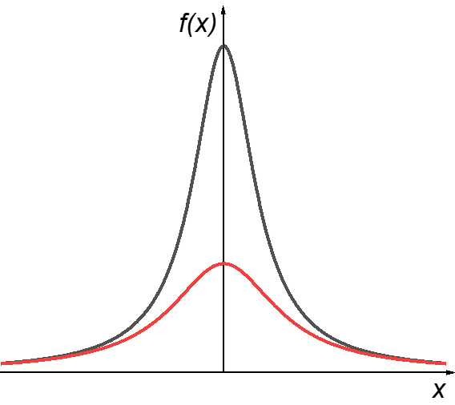
- Definition: $δ$-function is a limit of distribution function
$$f\left(x\right)=\frac{a}{x^{2}+a^{2}}\frac{1}{π}$$
$$\int_{-∞}^{+∞}{ }dxf\left(x\right)=\frac{1}{π}\int_{-∞}^{+∞}{ }\frac{1}{(\frac{x}{a})^{2}+1}=\frac{1}{π}arctg\left(\frac{x}{a}\right)|_{-∞}^{+∞}=1$$
Take the limit of $a→0$, then $\int_{-∞}^{+∞}{ }dxf\left(x\right)=1$ doesn’t change.
But $\lim_{a→0}{f(x)}=\left\{\begin{aligned}0 x≠0 \\ +∞ x=0\end{aligned}\right.$.
We define $δ\left(x\right)=$ $\lim_{a→0}{\frac{a}{x^{2}+a^{2}}\frac{1}{π}}$ then $\int_{-∞}^{+∞}{ }δ\left(x\right)dx=1$
Note: there are many other ways to define $δ\left(x\right)$ through distribution functions.
Example: point charge at $x_{1},x_{2},x_{3}…$,
the charge density: $ρ=δ\left(x-x_{1}\right)+δ\left(x-x_{2}\right)+δ\left(x-x_{3}\right)+…$

- $\frac{1}{x±iδ}=P\left(\frac{1}{x}\right)∓iπδ(x)$ $P:$ principal value
Proof: $\frac{1}{x±ia}=\frac{x∓ia}{x^{2}+a^{2}}=\frac{x}{x^{2}+a^{2}}∓i\frac{a}{x^{2}+a^{2}}$
$$\lim_{a→0}{\frac{1}{x±ia}}=P(\frac{1}{x}) ∓iπδ(x)$$

Properties
- $f\left(x\right)δ\left(x\right)=f\left(0\right)δ(x)$
$$\int_{-∞}^{+∞}{f\left(x\right)δ(x)dx}=f\left(0\right)\int_{-∞}^{+∞}{δ\left(x\right)dx}=f(0)$$
$$\int_{-∞}^{+∞}{f\left(x\right)δ(x-a)dx}=f\left(a\right)$$

- $δ\left(2x\right)=δ\left(-2x\right)=\frac{1}{2}δ\left(x\right)$
$$δ\left(ax\right)=δ\left(-ax\right)=\frac{1}{|a|}δ\left(x\right)$$
$$δ\left(ax+b\right)=\frac{1}{|a|}δ\left(x+\frac{b}{a}\right)$$

- $δ(f(x))=\sum_{a}{ }\frac{δ(x-x_{a})}{|f^{'}(x)|_{x=x_{a}}}$, where $x_{a}$ is for the zero of $f\left(x\right).$
Proof: around each zero $x_{a}$, $f\left(x\right)=f^{'}\left(x_{a}\right)\left(x-x_{a}\right)$ Talor expansion
For any function $g(x)$
$$\int_{x_{a}-ϵ}^{x_{a}+ϵ}{ }dxδ(f(x))g(x)=\int_{x_{a}-ϵ}^{x_{a}+ϵ}{ }dxδ[f^{'}(x_{a})(x-x_{a})]g(x)$$
Set $x^{'}=|f^{'}\left(x_{a}\right)|(x-x_{a})$
Then: $=\int_{-{|f}^{'}(x_{a})ϵ|}^{|f^{'}\left(x_{a}\right)ϵ|}{\frac{dx^{'}}{\left|f^{'}\left(x_{a}\right)\right|}δ\left(x^{'}\right)g\left(\frac{x^{'}}{\left|f^{'}\left(x_{a}\right)\right|}+x_{a}\right)=g(x_{a})/\left|f^{'}\left(x_{a}\right)\right|}$
Sum over all the zeros: $\int_{-∞}^{+∞}{ }dxδ\left(f\left(x\right)\right)g\left(x\right)=\sum_{a}{g(x_{a})/\left|f^{'}\left(x_{a}\right)\right|}$

- 3D-$δ$ functions
$$\left\{\begin{aligned}&δ^{(3)}(\vec{r})=δ(x)δ(y)δ(z) \\ &∫f(\vec{r})δ^{(3)}(\vec{r})d\vec{r}=f(0)\end{aligned}\right.$$
- Example: $∇⋅(\frac{\hat{r}}{r^{2}})=?$
For any $\overset{⃑}{r}≠0,$
$$∇⋅\left(\frac{\hat{r}}{r^{2}}\right)=∂_{x}\left(\frac{x}{(x^{2}+y^{2}+z^{2})^{\frac{3}{2}}}\right)+∂_{y}\left(\frac{y}{(x^{2}+y^{2}+z^{2})^{\frac{3}{2}}}\right)+∂_{z}\left(\frac{z}{(x^{2}+y^{2}+z^{2})^{3/2}}\right)$$
$$\begin{aligned}& \\ &=-\frac{3}{2}\frac{2(x^{2}+y^{2}+z^{2})}{r^{5/2}}+\frac{3}{r^{3/2}}=\frac{-3+3}{r^{3/2}}=0\end{aligned}$$
However $\oint_{R}{\frac{\hat{r}}{r^{2}}}d\overset{⃑}{S}=\frac{4πR^{2}}{R^{2}}=4π$, which independent on $R$.
- This will be consistent if we set $∇⋅\left(\frac{\hat{r}}{r^{2}}\right)=4πδ^{(3)}(\vec{r})$
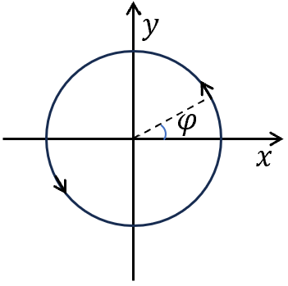
- Example $∇×∇φ(x,y)=?$
$φ$: azimuthal angle, multi-valued
We know that at any point except $r=0$, $φ(x,y)$ is regular $∇×∇φ\left(x,y\right)=0 (r≠0)$ check?
$$\int{∇×∇φ\left(x,y\right)d\overset{⃑}{S}=\oint{∇φ\left(x,y\right)dl}=?}$$
$φ\left(x,y\right)=arctg\frac{y}{x}$$∇φ\left(x,y\right)=\frac{-\frac{y}{x^{2}}}{1+(y/x)^{2}}\hat{x}+\frac{\frac{1}{x}}{1+(y/x)^{2}}\hat{y}=\frac{-y\hat{x}+x\hat{y}}{x^{2}+y^{2}}=\frac{1}{r}{\hat{e}}_{φ}$
$∮∇φ(x,y)dl=2πr\frac{1}{r}=2π$
- This will be consistent with $∇×∇φ\left(x,y\right)=2πδ^{(2)}(\vec{r})$
Note: $arctg^{'}x=\frac{1}{x^{2}+1}$

