Lecture 10 Magnetostatics
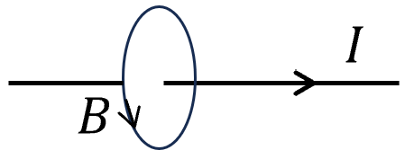
- Ampere’s law
$\oint{\overset{⃑}{B}∙d\overset{⃑}{l}}=μ_{0}I$ ---- $SI$
$\oint{\overset{⃑}{B}∙d\overset{⃑}{l}}=\frac{4π}{c}I$ ---- $CGS$
We start from this formula to derive Biot-Savart’s law.
$\text{∮}\vec{B}⋅d\vec{l}=∬\left(∇×\vec{B}\right)⋅d\vec{S}=μ_{0}∬\vec{j}⋅d\vec{S}$ Stoke’s theorem
$∇×\vec{B}=μ_{0}\vec{j}$ ---- $SI$ ($∇×\vec{B}=\frac{4π}{c}\vec{j}$ ---- $CGS$)
Clearly Ampere’s law only applies to steady current:
$∇∙\left(∇×\vec{B}\right)= μ_{0}∇∙\vec{j}=0$ ⟹ $\frac{∂ρ}{∂t}=0$
How about the divergence of $\overset{⃑}{B}$. The fact is that so far no magnetic monopole is discovered. For any closed surface, the mangeic flux is zero $∯{\overset{⃑}{B}∙}d\vec{S}=0 ⟹ \iiint{∇∙\overset{⃑}{B} dV}=0$
$⟹ ∇∙\overset{⃑}{B}=0$ Magnetic field has no source.
- Vector potentia
$∇∙\overset{⃑}{B}=0$ ⟹ $\overset{⃑}{B}=∇×\vec{A}=\left|\begin{matrix}\hat{x} & \hat{y} & \hat{z} \\ \frac{∂}{∂x} & \frac{∂}{∂y} & \frac{∂}{∂z} \\ A_{x} & A_{y} & {vA}_{z}\end{matrix}\right|$ , $\vec{A}$ is well defined up to $\vec{A}+∇f$.
$$∇×\vec{B}=∇×\left(∇×\vec{A}\right)=μ_{0}\vec{j}$$
⟹ $∇×\left(∇×\vec{A}\right)=∇\left(∇∙\overset{⃑}{A}\right)-∇^{2}\vec{A}=μ_{0}\vec{j}$
We further impose the condition $∇∙\overset{⃑}{A}=0$ (Coulomb gauge):
⟹ $\begin{matrix}∇∙\overset{⃑}{A}=0 \\ ∇^{2}\vec{A}=-μ_{0}\vec{j}\end{matrix}$
Assuming $\vec{j}$ goes to zero at infinity, we can read off from the solution of Poisson equation:
$\vec{A}(\vec{r})=\frac{μ_{0}}{4π}\iiint{\frac{\vec{j}\left({\vec{r}}^{'}\right)d^{3}\overset{⃑}{r}'}{|\vec{r}-{\vec{r}}^{'}|}}$ ---- $SI$
$\vec{A}(\vec{r})=\frac{1}{c}\iiint{\frac{\vec{j}\left({\vec{r}}^{'}\right)d^{3}\overset{⃑}{r}'}{|\vec{r}-{\vec{r}}^{'}|}}$ ---- $CGS$
Check $∇∙\overset{⃑}{A}\left(\overset{⃑}{r}\right)=0$ $⟹$ $∇∙\overset{⃑}{A}\left(\overset{⃑}{r}\right)=\frac{μ_{0}}{4π}\iiint{\vec{j}\left({\vec{r}}^{'}\right) ∇_{r}\frac{1}{\left|\vec{r}-{\vec{r}}^{'}\right|}} d^{3}{\overset{⃑}{r}}^{'}=\frac{μ_{0}}{4π}\iiint{\vec{j}\left({\vec{r}}^{'}\right) ∇_{r^{'}}\frac{1}{\left|\vec{r}-{\vec{r}}^{'}\right|} d^{3}{\overset{⃑}{r}}^{'}}$
$$=\frac{μ_{0}}{4π}\iiint{∇_{r^{'}}∙\left( \frac{\vec{j}\left({\vec{r}}^{'}\right)}{\left|\vec{r}-{\vec{r}}^{'}\right|}\right)-[∇_{r^{'}}∙\vec{j}\left({\vec{r}}^{'}\right)] \frac{1}{\left|\vec{r}-{\vec{r}}^{'}\right|} }d^{3}\overset{⃑}{r}'$$
$$∇∙\overset{⃑}{A}\left(\overset{⃑}{r}\right)=\frac{μ_{0}}{4π}\iiint{∇_{r^{'}}∙\left( \frac{\vec{j}\left({\vec{r}}^{'}\right)}{\left|\vec{r}-{\vec{r}}^{'}\right|}\right) }d^{3}{\overset{⃑}{r}}^{'}=\frac{μ_{0}}{4π}∯{ \frac{\vec{j}\left({\vec{r}}^{'}\right)}{\left|\vec{r}-{\vec{r}}^{'}\right|}∙d\overset{⃑}{S}}=0$$
Assuming $j\left(r\right)→0$ at $r→ +∞$ boundary.
Example: 2D, $E \& B$ duality
Assume an 2D distribution $j_{z}(x,y)$, which does not depend on $z$. We cannot use the above formula, because $j_{z}(x,y)$ extends to $z=±∞$.
$B$ only has in-plane component, define $\overset{⃑}{A}=φ(x,y)\hat{z}$ and ${\overset{⃑}{E}}^{*}=\overset{⃑}{B}×\hat{z}$
⟹ $\overset{⃑}{B}=∇×\vec{A}=∇×\left(φ\left(x,y\right)\hat{z}\right)=∇φ\left(x,y\right)×\hat{z}$
$(∇φ\left(x,y\right)×\hat{z})×\hat{z}=\overset{⃑}{B}×\hat{z}$ $⟹$ $-∇φ={\overset{⃑}{E}}^{*}$ ⟹ $-∇^{2}φ=∇∙\left(\overset{⃑}{B}×\hat{z} \right)=\left(∇×\vec{B}\right)∙\hat{z}=μ_{0}j_{z}$
(Compare with$-∇^{2}φ=ρ/ϵ_{0}$ ---- Gauss equation)
($∇×(f\vec{A})=f(∇×\vec{A})-\vec{A}×(∇\vec{f})$, $∇⋅(\vec{A}×\vec{B})=\vec{B}⋅(∇×\vec{A})-\vec{A}⋅(∇×\vec{B})$Lec*. 2 )
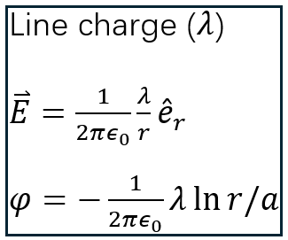
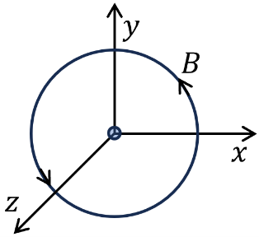
So we transform it to an electro-static problem. Say
$$\overset{⃑}{B}=\frac{μ_{0}I}{2πr}{\hat{e}}_{φ}$$
⟹ ${\overset{⃑}{E}}^{*}=\overset{⃑}{B}×\hat{z}=\frac{μ_{0}I}{2π}\frac{\hat{r}}{r}$ ⟹ $-∇φ=\frac{μ_{0}I}{2π}\frac{\hat{r}}{r}$
$$\int_{a}^{r}{∇φdr}=φ\left(r\right)-φ\left(a\right)=-\frac{μ_{0}I}{2π}\ln{r}{\left.​\right|}_{a}^{r}$$
⟹ $φ\left(r\right)-φ\left(a\right)=-\frac{μ_{0}I}{2π}\left(\ln{r}-\ln{a}\right)=-\frac{μ_{0}I}{4π}\ln{\frac{x^{2}+y^{2}}{a^{2}}}$
short range cutoff
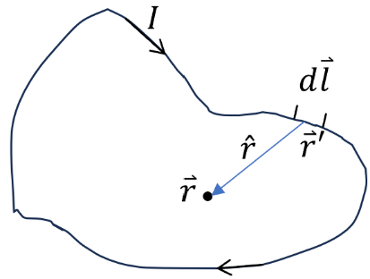
- Magnetic fields from a general shape of wire
$j=I/a$ $a:$ cross section of wire
⟹ $\overset{⃑}{j}d^{3}r^{'}$= $Id\overset{⃑}{l}$ ($d^{3}r^{'}=adl )$
⟹ $\vec{A}(\vec{r})=\frac{μ_{0}I}{4π} \int{\frac{d\overset{⃑}{l}}{|\vec{r}-{\vec{r}}^{'}|}}$ $⟹$ Biot-Savart law
$$d\vec{A}(\vec{r})=\frac{μ_{0}I}{4π} \frac{d\overset{⃑}{l}}{|\vec{r}-{\vec{r}}^{'}|}$$
The contribution to $\vec{B}$ from this line segment is
$$d\vec{B}(r)=∇×d\vec{A}(\vec{r})=\frac{μ_{0}I}{4π}∇_{r}×(\frac{d\overset{⃑}{l}}{\left|\vec{r}-{\vec{r}}^{'}\right|})=\frac{μ_{0}I}{4π}(-d\vec{l}×∇_{r}\frac{1}{|\vec{r}-{\vec{r}}^{'}|})$$
$d\vec{l}$ is constant vector with respect to $∇_{r}.$
⟹ $d\vec{B}\left(r\right)=-\frac{μ_{0}I}{4π}d\vec{l}×∇_{r}\frac{1}{\left|\vec{r}-{\vec{r}}^{'}\right|}=-\frac{μ_{0}I}{4π}d\vec{l}×(-\frac{\vec{r}-{\vec{r}}^{'}}{{\left|\vec{r}-{\vec{r}}^{'}\right|}^{3}})$ ($∇_{r}\left|\vec{r}-{\vec{r}}^{'}\right|=\hat{r}$ Lec* 2 )
⟹ $d\vec{B}\left(r\right)=\frac{μ_{0}I}{4π}\frac{1}{r^{2}} d\vec{l}×\hat{r}$, where $\hat{r}=\frac{\vec{r}-{\vec{r}}^{'}}{\left|\vec{r}-{\vec{r}}^{'}\right|}$
⟹ $\vec{B}\left(r\right)$=$\frac{μ_{0}I}{4π}\oint{ \frac{d\vec{l}×\hat{r}}{r^{2}}}$ Biot-Savart law
- Magneto-static boundary condition
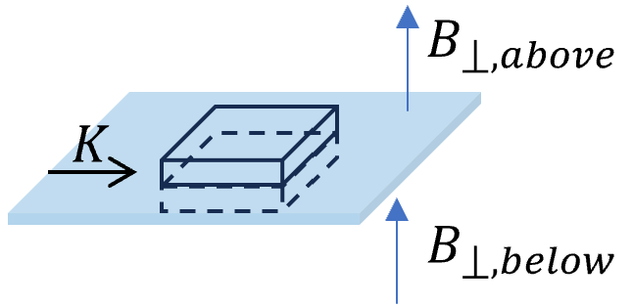
When there is surface current $K$, magnetic fields can be discontinuous. But the normal component remains continuous:
$∯{\overset{⃑}{B}∙}d\vec{S}=0$ ⟹ $\left(B_{⟘{above}}-B_{⟘{below}}\right)S=0$
⟹ $B_{⟘{above}}=B_{⟘{below}}$
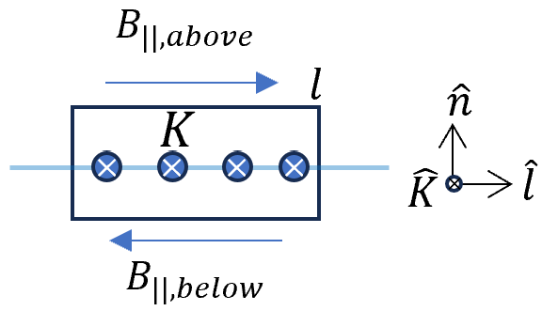
$\oint{\overset{⃑}{B}∙d\overset{⃑}{l}}=μ_{0}I=μ_{0}KΔl$ $K:$ surface current density
⟹ $B_{||,above}-B_{||, below}$=$μ_{0}K$ cross configuration

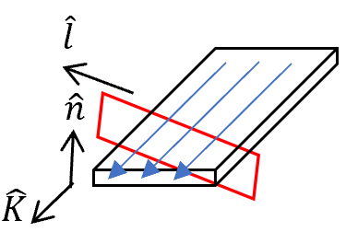
For arbitrary loop and field direction:
$$\oint{\overset{⃑}{B}∙d\overset{⃑}{l}}=μ_{0}I= μ_{0}\overset{⃑}{K}∙(\hat{n}×∆\overset{⃑}{l})$$
⟹ $({\overset{⃑}{B}}_{||,above}-{\overset{⃑}{B}}_{||, below} )∙∆\overset{⃑}{l}=μ_{0}\overset{⃑}{K}∙(\hat{n}×∆\overset{⃑}{l})$
$${\overset{⃑}{B}}_{||,above}-{\overset{⃑}{B}}_{||,below}=μ_{0}\overset{⃑}{K}×\hat{n}$$

(vector algebra: $\vec{A}⋅\left(\vec{B}×\vec{C}\right)=\vec{B}⋅(\vec{C}×\vec{A})=\vec{C}⋅(\vec{A}×\vec{B})$ see Lec* 1)
- We may also need boundary conditions for vector potential $\overset{⃑}{A}$. Since $\overset{⃑}{A}$ satisfies 2nd-order differential equation, $\overset{⃑}{A}$ itself is continuous and the discontinuity may appear at its derivative.
$∇∙\overset{⃑}{A}=0$ ⟹ the normal component of $A$ is continuous.
$\oint{\overset{⃑}{A}}∙d\overset{⃑}{l}=B\left(∆l∆h\right)→0$ as the thickness of $∆h→0.$ The parallel component of $A$ is continuous.
Set the frame $e_{\hat{n}}, e_{\hat{k}}$ and $e_{\hat{n}×\hat{k}}$
$$\vec{B}⋅e_{\hat{k}×\hat{n}}=∂_{\hat{k}}A_{\hat{n}}-∂_{\hat{n}}A_{\hat{k}}$$
Only this component of $\vec{B}$ is discontinuous. We don’t expect discontinuity of $∂_{\hat{k}}A_{\hat{n}}$, because $A_{\hat{n}}$ is continuous and $\hat{k}$ is parallel to the boundary. The discontinuity comes from $∂_{\hat{n}}A_{\hat{k}}$.

$${\left(∂_{\hat{n}}A_{\hat{k}}\right)}_{above}-{\left(∂_{\hat{n}}A_{\hat{k}}\right)}_{below}=-μ_{0}K$$
Or
$${\left(∂_{\hat{n}}\overset{⃑}{A}\right)}_{above}-{\left(∂_{\hat{n}}\overset{⃑}{A}\right)}_{below}=-μ_{0}\overset{⃑}{K}$$
In comparison: boundary conditions for electric surface charge
$$({\vec{E}}_{||})_{above}=({\vec{E}}_{||})_{below}$$
$$(\vec{E}⋅\hat{n})_{above}-(\vec{E}⋅\hat{n})_{below}=σ/ϵ_{0}$$
$$(\frac{∂φ}{∂n})_{above}-(\frac{∂φ}{∂n})_{below}=-σ/ϵ_{0}$$
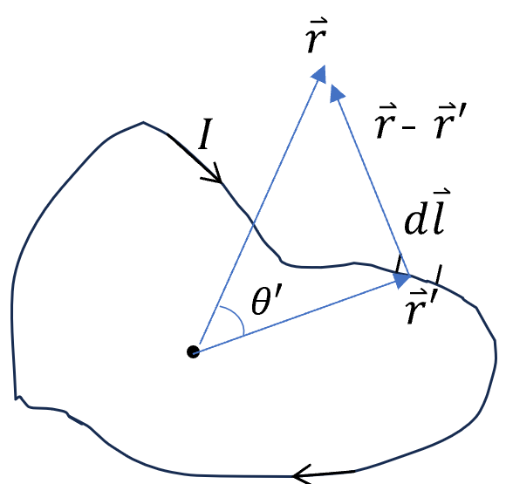
- Multiple expansion of vector potential
We need to use
$$\frac{1}{|\overset{⃑}{r}-{\overset{⃑}{r}}^{'}|}=\frac{1}{\sqrt{r^{2}+r^{'2}-2rr^{'}cos⁡θ^{'}}}=\frac{1}{r}\sum_{n=0}^{∞}{ }(\frac{r^{'}}{r})^{n}P_{n}(\cos{θ'})$$
$***P_{n}\left(x\right)$: Legendre polynomials (see the end)
$$\vec{A}\left(\vec{r}\right)=\frac{μ_{0}I}{4π}\text{∮}\frac{d{\overset{⃑}{l}}^{'}}{\left|\vec{r}-{\vec{r}}^{'}\right|}=\frac{μ_{0}I}{4π}\sum_{n=0}^{∞}{ }\frac{1}{r^{n+1}}\oint{r^{'n}P_{n}\left(\cos{θ^{'}}\right)d{\vec{l}}^{'}}$$
$$=\frac{μ_{0}I}{4π}\left\{\frac{1}{r}\oint{d{\vec{l}}^{'}}+\frac{1}{r^{2}}\oint{r^{'}\cos{θ^{'}}d{\vec{l}}^{'}}+\frac{1}{r^{3}}\oint{r^{'2}\left(\frac{3}{2}\cos^{2}{θ^{'}}-\frac{1}{2}\right)d{\vec{l}}^{'}}+…\right\}$$
monopole dipole quadrupole
- Magnetic dipole component
${\vec{A}}_{dip}\left(\vec{r}\right)$=$\frac{μ_{0}I}{4π}\frac{1}{r^{2}}\oint{r^{'}\cos{θ^{'}}d{\vec{l}}^{'}}=\frac{μ_{0}I}{4π}\frac{1}{r^{2}}\oint{(\hat{r}∙{\overset{⃑}{r}}^{'})d{\vec{l}}^{'}}$
Using the identity $\oint{\left(\overset{⃑}{c}∙\overset{⃑}{r}\right)d\overset{⃑}{l}}=\overset{⃑}{a}×\overset{⃑}{c}$, $\overset{⃑}{c}$ is a constant vector and $\overset{⃑}{a}=\frac{1}{2}\oint{\overset{⃑}{r}×d\overset{⃑}{l}}$.
$$\text{∮}(\hat{r}⋅{\vec{r}}^{'})d{\vec{l}}^{'}=\vec{a}×\hat{r}=(\frac{1}{2}\oint{{\vec{r}}^{'}×d{\vec{l}}^{'} })×\hat{r}$$
⟹ ${\vec{A}}_{dip}(\vec{r})=\frac{μ_{0}}{4π}\frac{\vec{m}×\hat{r}}{r^{2}}$ where $\vec{m}=\frac{I}{2}\text{∮}{\vec{r}}^{'}×d{\vec{l}}^{'}$ magnetic moment
$\overset{⃑}{a}=\frac{1}{2}\text{∮}{\vec{r}}^{'}×d{\vec{l}}^{'}$ is the area of a surface, which is enclosed by the boundary (c.f. Prob. 1.61).
- Field from a dipole
$${\vec{B}}_{dip}\left(\vec{r}\right)=∇×{\vec{A}}_{dip}(\vec{r})=\frac{μ_{0}}{4π}∇×(\frac{\vec{m}×\hat{r}}{r^{2}})$$
(Using $∇×(\vec{A}×\vec{B})=(\vec{B}⋅∇)\vec{A}-(\vec{A}⋅∇)\vec{B}+\vec{A}(∇⋅\vec{B})-\vec{B}(∇⋅\vec{A})$ Lec*. 3)
⟹ $∇×\left(\frac{\vec{m}×\hat{r}}{r^{2}}\right)=-\left(\vec{m}∙∇\right)\frac{\hat{r}}{r^{2}}+\vec{m}(∇∙\frac{\hat{r}}{r^{2}})$ $∇∙\frac{\hat{r}}{r^{2}}=4πδ(\vec{r})$ Lec*6.
Neglected only singular point at origin
Given $∇(\vec{A}⋅\vec{B})=\vec{A}×(∇×\vec{B})+\vec{B}×(∇×\vec{A})+(\vec{A}⋅∇)\vec{B}+(\vec{B}⋅∇)\vec{A}$ ($∇\frac{1}{r}=\frac{\hat{r}}{r^{2}}$)
⟹ $∇(\frac{\vec{m}∙\hat{r}}{r^{2}})=(\vec{m}∙∇)\frac{\hat{r}}{r^{2}}$
⟹ $∇×\left(\vec{m}×\frac{\hat{r}}{r^{2}}\right)=-∇\left(\frac{\vec{m}⋅\hat{r}}{r^{2}}\right)=-∇\left(\frac{\vec{m}⋅\overset{⃑}{r}}{r^{3}}\right)=-(\vec{m}⋅\vec{r})∇\frac{1}{r^{3}}-∇(\vec{m}⋅\vec{r})\frac{1}{r^{3}}$
$∇\frac{1}{r^{3}}=\frac{-3\hat{r}}{r^{4}}, ∇(\vec{m}⋅\vec{r})=\vec{m}$ see notebook
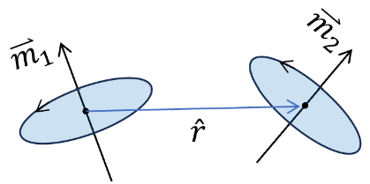
⟹ $∇×(\vec{m}×\hat{r}/r^{2})=\frac{3(\vec{m}∙\hat{r})\hat{r}}{r^{3}}-\frac{\vec{m}}{r^{3}}$
⟹ ${\vec{B}}_{dip}(\vec{r})=\frac{μ_{0}}{4π}⋅(\frac{3(\vec{m}⋅\hat{r})\hat{r}-\vec{m}}{r^{3}})$
- Interaction between two magnetic dipoles
Magnetic energy of a moment under external field: $U=-\overset{⃑}{B}∙\overset{⃑}{m}$
Interaction between two dipoles:
$U=-{\vec{B}}_{12}∙{\overset{⃑}{m}}_{2}$=$\frac{μ_{0}}{4π}\frac{1}{r^{3}}\left[{\overset{⃑}{m}}_{1}∙{\overset{⃑}{m}}_{2}-3({\overset{⃑}{m}}_{1}∙\hat{r})({\overset{⃑}{m}}_{2}∙\hat{r})\right]= -{\vec{B}}_{21}∙{\overset{⃑}{m}}_{1}$

***Legendre polynomials： $P_{n}(x)$
Definition: $\frac{1}{\sqrt{1-2xt+t^{2}}}=\sum_{0}^{∞}{t^{n}P_{n}(x)}$
$P_{0}(x)=1, P_{1}(x)=x$, $P_{2}\left(x\right)=\frac{3}{2}x^{2}-\frac{1}{2}$, $P_{3}\left(x\right)=\frac{5}{2}x^{3}-\frac{3}{2}x$
$$\left(n+1\right)P_{n+1}\left(x\right)=\left(2n+1\right)xP_{n}\left(x\right)-nP_{n-1 }(x)$$

