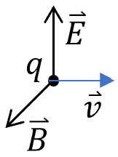
Lecture 11 examples of magnetic fields
- Cycloid motion of charge under $E\&B.$ Griffiths p213, Ex. 5.2:
Related to the classic picture of quantum Hall edge.
Recall: equilibrium case of a charge:
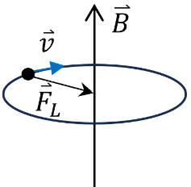
$F_{E}=F_{L} ⟹qE=qvB ⟹$ $v=E/B$
- Cyclotron motion of a charge under $B$ without $E$:
${\overset{⃑}{F}}_{L}=qv_{⟘}B=\frac{mv_{⟘}^{2}}{r}$ （centripetal force 向心力）
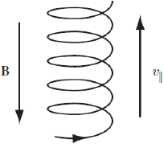
⟹ cyclotron radius $r=\frac{mv_{⟘}}{qB}$ and frequency $ω=\frac{v_{⟘}}{r}=\frac{qB}{m}$.
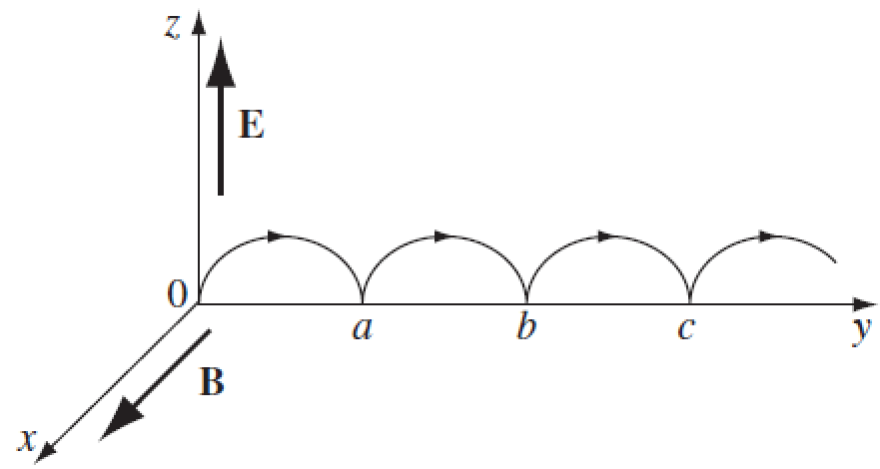
For the existence of $v_{||}$, spiral motion
- General case: cycloid motion of charge under $E \& B.$
Solution: no force in the x-direction. The motion is in the yz-plane.
$$\overset{⃑}{r}\left(t\right)=\left(0,y\left(t\right),z\left(t\right)\right)$$
${\overset{⃑}{F}}_{L}=q\overset{⃑}{v}×\overset{⃑}{B}=qB(\dot{z}\hat{y}-\dot{y}\hat{z})$, ${\overset{⃑}{F}}_{E}=qE\hat{z}$ (see $\overset{⃑}{A}×\overset{⃑}{B}=ϵ_{ijk}{\hat{e}}_{i}A_{j}B_{k}$)
$\overset{⃑}{F}={\overset{⃑}{F}}_{L}+{\overset{⃑}{F}}_{E}$ $⟹$ $q\left(E-B\dot{y}\right)\hat{z}+qB\dot{z}\hat{y}=m\overset{⃑}{a}=m(\ddot{y}\hat{y}+\ddot{z}\hat{z})$
$⟹$ $\left\{\begin{aligned}qB\dot{z}=m\ddot{y} \\ q\left(E-B\dot{y}\right)=m\ddot{z}\end{aligned}\right.$ define $ω=\frac{qB}{m}$ cyclotron frequency
$⟹ \left\{\begin{aligned}\ddot{y}=ω\dot{z} \\ \ddot{z}=ω\left(\frac{E}{B}-\dot{y}\right)\end{aligned}\right.$ ⟹ $\overset{⃛}{z}=-ω\ddot{y}=-ω^{2}\dot{z}$
(comparison: $\ddot{x}+\frac{K}{m}x=0$ with $ω=\sqrt{K/m}$ harmonic function)
⟹ $\dot{z}=A\cos{ωt}+B\sin{ωt} (=C_{2}ω\cos{ωt}-C_{1}ω\sin{ωt})$
⟹ $z=C_{1}\cos{ωt}+C_{2}\sin{ωt}+C_{3}$
⟹ $\ddot{z}=-ω^{2}\left(C_{1}\cos{ωt}+C_{2}\sin{ωt}\right)$
⟹ $\dot{y}=-\frac{\ddot{z}}{ω}+\frac{E}{B}=ω\left(C_{1}\cos{ωt}+C_{2}\sin{ωt}\right)+\frac{E}{B}$
⟹ $y=C_{1}\sin{ωt}- C_{2} \cos{ωt}+\frac{E}{B}t+C_{4}$

Given the initial condition: $y\left(0\right)=z\left(0\right)=\dot{y}\left(0\right)=\dot{z}\left(0\right)=0$
⟹ $\left\{\begin{aligned}C_{4}-C_{2}=0 \\ C_{1}+C_{3}=0 \\ ωC_{1}+E/B=0 \\ ωC_{2}=0\end{aligned}\right.$ ⟹ $\left\{\begin{aligned}C_{1}=-C_{3}=-E/ωB \\ C_{2}=C_{4}=0\end{aligned}\right.$
⟹ $\left\{\begin{aligned}y\left(t\right)=-\frac{E}{ωB}\sin{ωt}+\frac{E}{B}t=\frac{E}{ωB}(ωt-\sin{ωt}) \\ z(t)=-\frac{E}{ωB}\cos{ωt}+\frac{E}{ωB}=\frac{E}{ωB}(1-\cos{ωt})\end{aligned}\right.$
Define： $R=\frac{E}{ωB}$ radius
⟹ ${\left(y-Rωt\right)}^{2}+{\left(z-R\right)}^{2}=R^{2}$
$vt$ Cycloid velcoity $v=Rω=E/B$
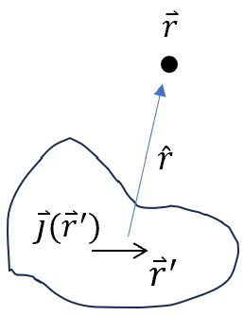
- Start from Biot-Savart law to prove $∇∙\overset{⃑}{B}=0$.
$$\vec{A}\left(\vec{r}\right)=\frac{μ_{0}}{4π}\iiint{\frac{\vec{j}\left({\vec{r}}^{'}\right)d^{3}\overset{⃑}{r}'}{\left|\vec{r}-{\vec{r}}^{'}\right|}}$$
$$\vec{B}\left(\vec{r}\right)=∇×\vec{A}\left(\vec{r}\right)=\frac{μ_{0}}{4π}\iiint{∇_{r}×\left(\frac{\vec{j}\left({\vec{r}}^{'}\right)}{\left|\vec{r}-{\vec{r}}^{'}\right|}\right) d^{3}\overset{⃑}{r}'}=\frac{μ_{0}}{4π}\iiint{\vec{j}\left({\vec{r}}^{'}\right)×∇_{r}\frac{1}{\left|\vec{r}-{\vec{r}}^{'}\right|} d^{3}\overset{⃑}{r}'}\frac{μ_{0}}{4π}\iiint{\frac{\vec{j}\left({\vec{r}}^{'}\right)×{\hat{r}}_{r-r'}}{{\left|\vec{r}-{\vec{r}}^{'}\right|}^{2}}d^{3}\overset{⃑}{r}'}$$
(See $∇×(f\vec{A})=f(∇×\vec{A})-\vec{A}×(∇\vec{f})$)
$$∇∙\vec{B}\left(\vec{r}\right)=\frac{μ_{0}}{4π}\iiint{∇_{r}∙\left[\frac{\vec{j}\left({\vec{r}}^{'}\right)×\left(\vec{r}-{\vec{r}}^{'}\right)}{{\left|\vec{r}-{\vec{r}}^{'}\right|}^{3}}\right]d^{3}{\overset{⃑}{r}}^{'}}=\frac{μ_{0}}{4π}\iiint{\vec{j}\left({\vec{r}}^{'}\right)∙\left[∇_{r}×\frac{\vec{r}-{\vec{r}}^{'}}{{\left|\vec{r}-{\vec{r}}^{'}\right|}^{3}}\right]d^{3}{\overset{⃑}{r}}^{'}=0}$$
(See $∇⋅(\vec{A}×\vec{B})=\vec{B}⋅(∇×\vec{A})-\vec{A}⋅(∇×\vec{B})$ and $∇\frac{1}{r}=\frac{\hat{r}}{r^{2}}$)
$$∇×\vec{B}\left(\vec{r}\right)=\frac{μ_{0}}{4π}\iiint{∇_{r}×\left[\frac{\vec{j}\left({\vec{r}}^{'}\right)×\left(\vec{r}-{\vec{r}}^{'}\right)}{{\left|\vec{r}-{\vec{r}}^{'}\right|}^{3}}\right]d^{3}{\overset{⃑}{r}}^{'}}$$
$∇_{r}×\left[\frac{\vec{j}\left({\vec{r}}^{'}\right)×\left(\vec{r}-{\vec{r}}^{'}\right)}{{\left|\vec{r}-{\vec{r}}^{'}\right|}^{3}}\right]=\vec{j}\left({\vec{r}}^{'}\right)(∇_{r}∙\frac{\vec{r}-{\vec{r}}^{'}}{{\left|\vec{r}-{\vec{r}}^{'}\right|}^{3}})$-$(\vec{j}\left({\vec{r}}^{'}\right)∙∇_{r})\frac{\vec{r}-{\vec{r}}^{'}}{{\left|\vec{r}-{\vec{r}}^{'}\right|}^{3}}$
(See $∇×(\vec{A}×\vec{B})=(\vec{B}⋅∇)\vec{A}-(\vec{A}⋅∇)\vec{B}+\vec{A}(∇⋅\vec{B})-\vec{B}(∇⋅\vec{A})$)
The second term
$$\left(\vec{j}\left({\vec{r}}^{'}\right)∙∇_{r}\right)\frac{\vec{r}-{\vec{r}}^{'}}{{\left|\vec{r}-{\vec{r}}^{'}\right|}^{3}}=\left(\vec{j}\left({\vec{r}}^{'}\right)∙∇_{r^{'}}\right)\frac{\vec{r}-{\vec{r}}^{'}}{{\left|\vec{r}-{\vec{r}}^{'}\right|}^{3}}=∇_{r^{'}}\left[\vec{j}\left({\vec{r}}^{'}\right)∙\frac{\vec{r}-{\vec{r}}^{'}}{{\left|\vec{r}-{\vec{r}}^{'}\right|}^{3}}\right]- \frac{\vec{r}-{\vec{r}}^{'}}{{\left|\vec{r}-{\vec{r}}^{'}\right|}^{3}}∇_{r^{'}}∙\vec{j}\left({\vec{r}}^{'}\right)$$
$=0$
(See $∇(\vec{A}⋅\vec{B})=\vec{A}×(∇×\vec{B})+\vec{B}×(∇×\vec{A})+(\vec{A}⋅∇)\vec{B}+(\vec{B}⋅∇)\vec{A}$)
The second term vanishes after volume integral.
$⟹$ $∇×\vec{B}\left(\vec{r}\right)=\frac{μ_{0}}{4π}\iiint{\vec{j}\left({\vec{r}}^{'}\right)(∇_{r}∙\frac{\vec{r}-{\vec{r}}^{'}}{{\left|\vec{r}-{\vec{r}}^{'}\right|}^{3}})d^{3}{\overset{⃑}{r}}^{'}}=μ_{0}\iiint{\vec{j}\left({\vec{r}}^{'}\right)δ^{(3)}(\vec{r}-{\vec{r}}^{'}) d^{3}{\overset{⃑}{r}}^{'}}=μ_{0}\vec{j}\left(\vec{r}\right)$
(See $∇\frac{\hat{r}}{r^{2}}=4πδ^{(3)}(\vec{r}-{\vec{r}}^{'})$)
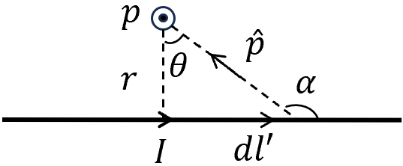
- Application of Biot-Savart law
- B-field from a long straight line:
$d{\overset{⃑}{l}}^{'}×\hat{p}$ point out of page, with the magnitude $dl^{'}\sin{α}= dl^{'}\cos{θ}$
$l^{'}=r\tan{θ} ⟹dl^{'}=r\sec^{2}{θ}dθ$ $(\sec{θ}=1/\cos{θ})$
$$p^{2}=\frac{r^{2}}{\cos^{2}{θ}} ⟹ \overset{⃑}{B}=\frac{μ_{0}I}{4π}\int{\frac{d{\overset{⃑}{l}}^{'}×\hat{p}}{p^{2}}}$$
$⟹B=\frac{μ_{0}I}{4π}\int_{-\frac{π}{2}}^{\frac{π}{2}}{\frac{{r sec}^{2}{θ}\cos{θ}dθ}{\frac{r^{2}}{\cos^{2}{θ}}}}=\frac{μ_{0}I}{4πr}\int_{-\frac{π}{2}}^{\frac{π}{2}}{\cos{θ}dθ}=\frac{μ_{0}I}{4πr}\sin{θ}{\left.​\right|}_{-\frac{π}{2}}^{\frac{π}{2}}=\frac{μ_{0}I}{2πr}$ ----Ampere’s law
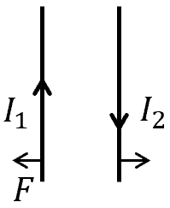
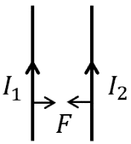
The force between two parallel wires
$\overset{⃑}{F}=\int{\overset{⃑}{v}}×\overset{⃑}{B}dq=\int{\overset{⃑}{v}}×\overset{⃑}{B} λdl$ $λ:$ line charge density
$⟹$ $\overset{⃑}{F}=\int{\overset{⃑}{I}}×\overset{⃑}{B}dl$ $⟹$ $\frac{F}{l}=\frac{μ_{0}I_{1}I_{2}}{2πr}$

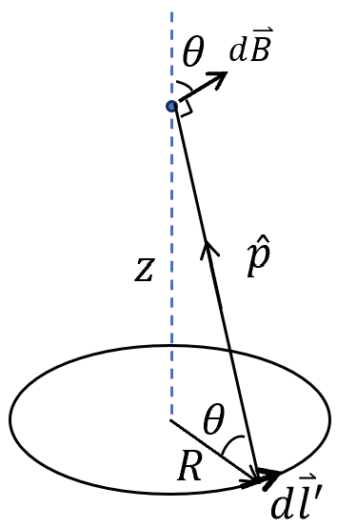
- B-field at distance $z$ above the center of a circular loop of radius $R$ with a steady current $I$
$d{\overset{⃑}{l}}^{'}×\hat{p}$ has the magnitude of $dl^{'}$ with the direction of a polar angle $θ$ with respect to the $z$-axis as plotted.
$\overset{⃑}{B}=\frac{μ_{0}I}{4π}\int{\frac{d{\overset{⃑}{l}}^{'}×\hat{p}}{p^{2}}}$⟹
$B_{z}=\frac{μ_{0}I}{4π}\int{\frac{\cos{θ}dl^{'}}{p^{2}}}=\frac{μ_{0}I}{4πp^{2}}2πR\cos{θ}=\frac{μ_{0}I}{2}\frac{R^{2}}{p^{3}}=\frac{μ_{0}I}{2}\frac{R^{2}}{{(R^{2}+z^{2})}^{3/2}}$
or $B_{z}=\frac{μ_{0}I}{2R}\cos^{3}{θ}$
Other components average to zero owning to rotation symmetry.
- B-field at axis of a wound solenoid
Suppose that the left and right ends span the polar angles of $α_{L}$ and $α_{R}$, respectively.
$dB=\frac{μ_{0}λdl}{2R}\sin^{3}{α}=\frac{μ_{0}λ}{2R}R\sin{α}dα$ ($α=\frac{π}{2}-θ$)
where $λ=nI$ and $n$ is the number of turns per length.
$$B=\int_{α_{L}}^{α_{R}}{\frac{μ_{0}λ}{2}\sin{α}dα}=-\frac{μ_{0}λ}{2}\cos{α}{\left.​\right|}_{α_{L}}^{α_{R}}=\frac{μ_{0}λ}{2}(\cos{α_{L}}-\cos{α_{R}})$$
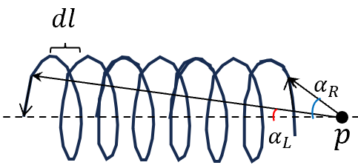
Suppose for an infinitely long solenoid,
$α_{L}=0$, $α_{R}=π$ ⟹ $B=μ_{0}λ=μ_{0}nI$
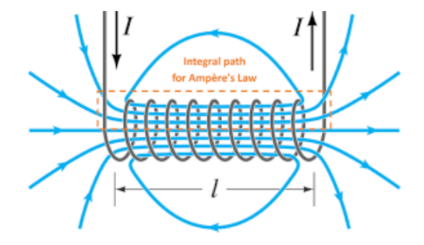

$B$-field of a solenoid

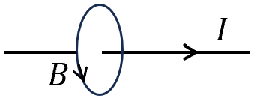
- Application of Ampere’s law + symmetric analysis (Other than Biot-Savart law)
- $B$ can only be along “circumferential” direction.
$\oint{\overset{⃑}{B}∙d\overset{⃑}{l}=μ_{0}I}$ ⟹ $B∙2πr=μ_{0}I$ ⟹ $B=μ_{0}I/2πr$
- $B$ from a sheet current
$B$ should have translational symmetry, i.e. $B$ is uniform along xy-direction.
- Q: Can $B$ has a z-component?
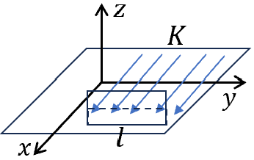
A: No. The system has the symmetry of combine time-reversal and rotation along z-axis by ${180}^{o}$. This operation flips the direction of $B_{z}$. So $B$ only have the in-plane component.
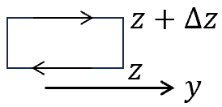
- The system has the symmetry of combined time-reversal and reflectional symmetry with respect to zy-plane.
$B$ is an axial (pseudo) vector $⟹$ $B_{x}\underset{→}{TR}-B_{x}\underset{→}{RF_{zy}}-B_{x}$ ⟹ $B_{x}=0$
- $B$ can only be along y-direction.
Let us choose a loop at $z>0$ ⟹ $B_{y}\left(z\right)=B_{y}(z+∆z)$
$B_{y}$ should not depend on $z$ for $z>0$.
- For a loop crossing the current sheet.
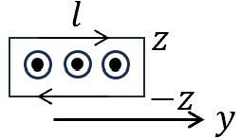
The system has rotation symmetry around x-axis by ${180}^{o}$.
⟹ $B_{y }\left(z\right)=-B_{y}\left(-z\right)$.
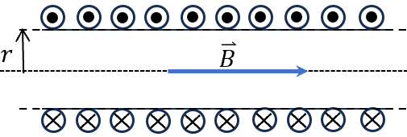
⟹ $-2lB_{y }\left(z\right)=μ_{0}Kl$ ⟹ $B_{y}\left(z\right)=\left\{\begin{aligned}-\frac{μ_{0}}{2}K for z>0 \\ \frac{μ_{0}}{2}K for z<0\end{aligned}\right.$

- $B$-field from an infinitely long solenoid
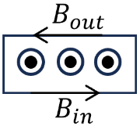
The system has rotational symmetry around the axis.
- $B$ cannot have radial component, otherwise $∯{\overset{⃑}{B}d\overset{⃑}{S}}≠0$.
- $B$ cannot have “circumferential” component, otherwise $\oint{\overset{⃑}{B}d\overset{⃑}{l}}≠0$.
- $B$ can only be along the axial. It can also be proved that $B$ is uniform inside the solenoid, and outside.
$$\left(B_{in}-B_{out}\right)l=μ_{0}IN$$
- If we set $r→0$ (limit case), $B_{out}=0$ ⟹
$B_{in}=μ_{0}nI$ along axial axis. $n$: the number of turns per unit length.
- A toroidal coil of a circular ring. The winding is uniform. What’s the distribution of $B$-field? There are two ways:
- Application of Biot-Savart law
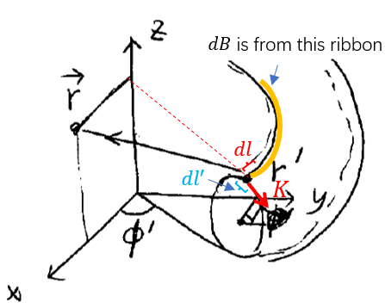
Our system has rotational symmetry around $z$-axis, without loss of generality, let us consider a point $r$ in the xz-plan with $\overset{⃑}{r}=(x,0,z)$.
The coordinate of $r^{'}$ on the toroidal coil: ${\overset{⃑}{r}}^{'}=\left(s^{'}\cos{ϕ^{'}},s^{'}\sin{ϕ^{'}},z^{'}\right), ϕ^{'}:$ azimuthal angle.
The current density $K=nI$ has no $ϕ$ dependence.
$d\vec{B}\left(r\right)=\oint{[\frac{μ_{0}}{4π}\frac{\overset{⃑}{K}×\left(\overset{⃑}{r}-{\overset{⃑}{r}}^{'}\right)}{|{\overset{⃑}{r}-{\overset{⃑}{r}}^{'}|}^{3}}dl'}]dl$ Integral over $dl$
$\overset{⃑}{K}=(K_{s}\cos{ϕ^{'}},K_{s}\sin{ϕ^{'}},K_{z})$
$\overset{⃑}{K}×\left(\overset{⃑}{r}-{\overset{⃑}{r}}^{'}\right)=\left|\begin{matrix}\hat{x} & \hat{y} & \hat{z} \\ K_{s}\cos{ϕ'} & K_{s}\sin{ϕ'} & K_{z} \\ x-s^{'}\cos{ϕ'} & -s^{'}\sin{ϕ^{'}} & z-z^{'}\end{matrix}\right|$
$$=\sin{ϕ'}\left[K_{s}\left(z-z^{'}\right)+s^{'}K_{z}\right]\hat{x}+\left[K_{z}\left(x-s^{'}\cos{ϕ^{'}}\right)-K_{s}\cos{ϕ^{'}}\left(z-z^{'}\right)\right]\hat{y}-K_{s}x\sin{ϕ'}\hat{z}$$
The contribution to $\hat{x}$ and $\hat{z}$ are odd function of $ϕ'$ ⟹ vanishes after integration.
⟹ $d\overset{⃑}{B}$ only along the $\hat{y}$-direction thus $\overset{⃑}{B}$.
Similar calculation for the point yz-plane, $\overset{⃑}{B}$ is along $\hat{x}$-direction.
These imply that $\overset{⃑}{B}$ is a “circumferential” field.
- Application of symmetry analysis.
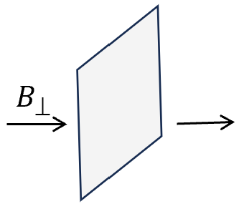
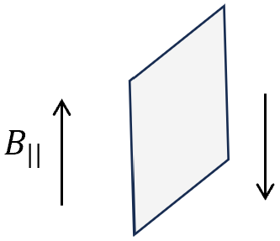
$\overset{⃑}{B}$ is an axial-vector. It has different properties under reflection operation.

Can you explain why?

- Our system has reflection symmetry respect to any vertical-radial plane.
⟹ $B$ cannot be parallel to that plane. $B$ can only be perpendicular to the vertical -radial plane.
⟹ $B$ is circumferential.
Then the results are straightforward. For point $\overset{⃑}{r}$ inside the torus with radius $r$ to the z-axis: $B\left(\overset{⃑}{r}\right)=\frac{μ_{0}I}{2πr}N$, $N$: total turns, otherwise $B\left(r\right)=0$.

- $B$-field of a rotation spherical shell
The charged shell circulates around z-axis, let’s calculate $\overset{⃑}{B}$ at $\overset{⃑}{r}$. $\overset{⃑}{r}$ is at xz-plane with $ψ$ with respect to z-axis
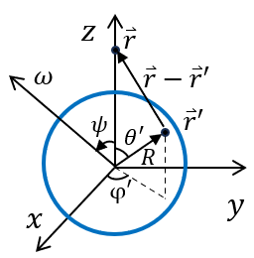
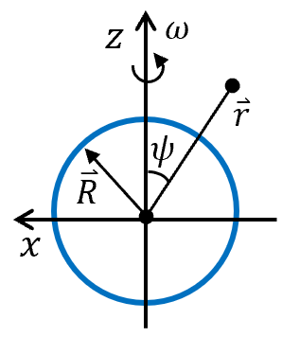

rotate

To calculate, we first rotate $\overset{⃑}{r}$ to the z-axis and $\overset{⃑}{ω}$ to the xz plane.
$\overset{⃑}{r}'$ is on the sphere with $\left(θ^{'},φ^{'}\right).$(spherical coordinate)
$$\vec{A}(\vec{r})=\frac{μ_{0}}{4π}\iiint{\frac{\vec{j}\left({\vec{r}}^{'}\right)d^{3}\overset{⃑}{r}'}{|\vec{r}-{\vec{r}}^{'}|}}=\frac{μ_{0}}{4π} \iint{\frac{\overset{⃑}{K}({\vec{r}}^{'})}{|\vec{r}-{\vec{r}}^{'}|}}dS'$$
where $\overset{⃑}{K}\left({\vec{r}}^{'}\right)=σ\overset{⃑}{v}$ surface current density,
Here: $\left|\vec{r}-{\vec{r}}^{'}\right|=\sqrt{R^{2}+r^{2}-2Rr\cos{θ^{'}} }$, $dS^{'}=R^{2}dΩ=R^{2}\sin{θ^{'}}dθ^{'}dφ^{'}$
$$\overset{⃑}{v}=\overset{⃑}{ω}×{\overset{⃑}{r}}^{'}=\left.\left|\begin{matrix}\hat{x} & \hat{y} & \hat{z} \\ ω\sin{ψ}⁡ & 0 & ωcos ψ \\ Rsinθ^{'}\cos{φ^{'}} & Rsinθ^{'}sinφ^{'} & Rcosθ^{'}\end{matrix}\right.\right|$$
$$=Rω\left[-\cos{ψ}sinθ^{'}sinφ^{'} \hat{x}+\left(\cos{ψ}sinθ^{'}\cos{φ^{'}}-\sin{ψ}cosθ^{'}\right) \hat{y}+\sin{ψ}sinθ^{'}sinφ^{'} \hat{z}\right]⁡$$
Those terms contain $\cos{φ^{'}} \&$ $sinφ^{'}$ goes to zero after average over $φ'$
⟹ only $A_{y}\left(\overset{⃑}{r}\right)≠0$. along $-\hat{y}$ = the direction of $\overset{⃑}{ω}×\overset{⃑}{r}$.

$$\vec{A}\left(\vec{r}\right)=-\frac{μ_{0}}{2}R^{3}σω\int_{0}^{π}{ }\frac{\sin{ψ}cosθ^{'}sinθ^{'}}{\sqrt{R^{2}+r^{2}-2Rrcosθ^{'}}}dθ^{'}\hat{y} =\frac{μ_{0}}{2}R^{3}σω\sin{ψ}\int_{0}^{π}{ }\frac{cosθ^{'}dcosθ^{'}}{\sqrt{R^{2}+r^{2}-2Rrcosθ^{'}}}\hat{y}$$
One have $\int_{-1}^{1}{ }\frac{udu}{\sqrt{R^{2}+r^{2}-2Rru}}=-\frac{R^{2}+r^{2}+Rru}{3R^{2}r^{2}}\sqrt{R^{2}+r^{2}-2Rru}{\left.​\right|}_{-1}^{1}$
$$=-\frac{1}{3R^{2}r^{2}}[(R^{2}+r^{2}+Rr)|R-r|-(R^{2}+r^{2}-Rr)(R+r)$$
$=\left\{\begin{aligned}2r/3R^{2} (r≤R) \\ 2R/3r^{2} (r≥R)\end{aligned}\right.$
$\vec{A}\left(\vec{r}\right)=\left\{\begin{aligned}-\frac{μ_{0}}{3}Rωσr\sin{ψ}\hat{y} (r≤R) \\ -\frac{μ_{0}}{3}\frac{R^{4}}{r^{2}}ωσ\sin{ψ}\hat{y} (r≥R)\end{aligned}\right.$
Remember $\overset{⃑}{ω}×\overset{⃑}{r}=-ωr\sin{ψ}\hat{y}$:
$$\vec{A}\left(\vec{r}\right)=\left\{\begin{aligned}\frac{μ_{0}}{3}Rσ\left(\overset{⃑}{ω}×\overset{⃑}{r}\right) \left(r≤R\right) \\ \frac{μ_{0}}{3}\frac{R^{4}}{r^{3}}σ\left(\overset{⃑}{ω}×\overset{⃑}{r}\right) \left(r≥R\right)\end{aligned}\right.$$
This expression is independent on the chosen of frame.

If set back $\overset{⃑}{ω}$ along z-axis
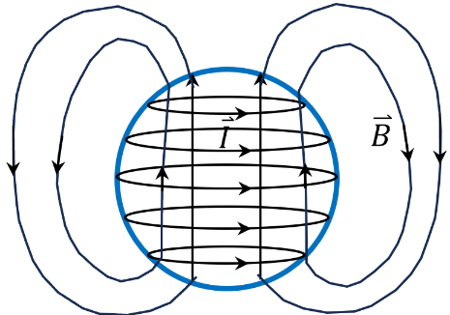
⟹ $A\left(r,θ,φ\right)=\left\{\begin{aligned}\frac{μ_{0}}{3}Rωσr\sin{ψ}{\hat{e}}_{φ} (r≤R) \\ \frac{μ_{0}}{3}\frac{R^{4}}{r^{2}}ωσ\sin{ψ}{\hat{e}}_{φ} (r≥R)\end{aligned} \right.$ along the azimuthal direction.
$\vec{B}=∇×\vec{A}\left(\vec{r}\right)$
- i. For $r≤R$,
$∇×\left(\overset{⃑}{ω}×\overset{⃑}{r}\right)=-\left(\overset{⃑}{ω}∙∇\right)\vec{r}+\overset{⃑}{ω}\left(∇∙\vec{r}\right)=2\overset{⃑}{ω}$
(see $∇×(\vec{A}×\vec{B})=(\vec{B}⋅∇)\vec{A}-(\vec{A}⋅∇)\vec{B}+\vec{A}(∇⋅\vec{B})-\vec{B}(∇⋅\vec{A})$ $\left(\overset{⃑}{ω}∙∇\right)\vec{r}=\overset{⃑}{ω}$, $\overset{⃑}{ω}\left(∇∙\vec{r}\right)=3\overset{⃑}{ω}$)
⟹ ${\overset{⃑}{B}}_{inside}=\frac{2}{3}μ_{0}Rσ\overset{⃑}{ω}$
- For $r≥R$, $∇×\left(\overset{⃑}{ω}×\frac{\hat{r}}{r^{2}}\right)=-\left(\overset{⃑}{ω}∙∇\right)\left(\frac{\hat{r}}{r^{2}}\right)+\overset{⃑}{ω}\left(∇∙\frac{\hat{r}}{r^{2}}\right)=-∇\left(\frac{\overset{⃑}{ω}∙\hat{r}}{r^{2}}\right)+\overset{⃑}{ω}4πδ^{(3)}(\vec{r})$
(see $∇∙\frac{\hat{r}}{r^{2}}=4πδ^{(3)}(\vec{r})$ Lec*. 6 and $\left(\overset{⃑}{m}∙∇\right)\left(\frac{\hat{r}}{r^{2}}\right)=∇\left(\frac{\overset{⃑}{m}∙\hat{r}}{r^{2}}\right)$ Lec. 10)
Since $\overset{⃑}{ω}4πδ\left(\vec{r}\right)→0$, because $\left|\overset{⃑}{r}\right|>R$.
$∇\left(\frac{\overset{⃑}{ω}∙\overset{⃑}{r}}{r^{3}}\right)=\left(\overset{⃑}{ω}∙\overset{⃑}{r}\right)∇\frac{1}{r^{3}}+∇\left(\overset{⃑}{ω}∙\overset{⃑}{r}\right)∙\frac{1}{r^{3}}$
$∇×\left(\overset{⃑}{ω}×\frac{\hat{r}}{r^{2}}\right)=\frac{3\left(\overset{⃑}{ω}∙\hat{r}\right)}{r^{3}}\hat{r}-\frac{\overset{⃑}{ω}}{r^{3}}$ ($∇\left(\overset{⃑}{ω}∙\overset{⃑}{r}\right)=\left(\overset{⃑}{ω}∙∇\right)\vec{r}=\overset{⃑}{ω}$,)
${\overset{⃑}{B}}_{outside}=\frac{μ_{0}}{3}R^{4}σ[3\left(\overset{⃑}{ω}∙\hat{r}\right)\hat{r}-\overset{⃑}{ω}]/r^{3}$ ---- SI-unit
Compare with dipole field ${\vec{B}}_{dip}(\vec{r})=\frac{μ_{0}}{4π}⋅(\frac{3(\vec{m}⋅\hat{r})\hat{r}-\vec{m}}{r^{3}})$
We can derive the magnetic moment: $\overset{⃑}{m}=\frac{μ_{0}}{3}R^{4}σ\overset{⃑}{ω}$
Or ${\overset{⃑}{B}}_{outside}=\frac{4π}{3c}R^{4}σ[3\left(\overset{⃑}{ω}∙\hat{r}\right)\hat{r}-\overset{⃑}{ω}]/r^{3}$ and $\overset{⃑}{m}=\frac{4π}{3c}R^{4}σ\overset{⃑}{ω}$ ---- CGS-unit

