Lecture-17 AC Circuit – I
- Impedance （阻抗）and admittance （导纳） (lumped element 集总元件)
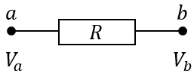
- Resistance -$R$
$$u\left(T\right)=V_{a}-V_{b}=u_{0}e^{iωt}$$
$I\left(t\right)=\frac{u\left(t\right)}{R}=I_{0}e^{iωt}$ with $I_{0}=u_{0}/R$ or $R=u_{0}/I_{0}$
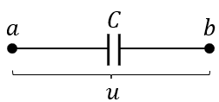
- Capacitance -$C$
$$u\left(t\right)=Q(t)/C$$
$\dot{u}\left(t\right)=\frac{\dot{Q}\left(t\right)}{C}=I(t)/C$ $iωu=I/C$
$I=iωCu_{0}e^{iωt}=I_{0}e^{iωt}$
$\frac{u_{0}}{I_{0}}=\frac{1}{iωC}=Z_{c}$
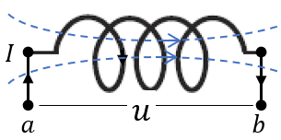
- Inductance – $L$
$$\oint{\overset{⃑}{E}∙d\overset{⃑}{l}}=\int_{a_{coil}}^{b}{\overset{⃑}{E}∙d\overset{⃑}{l}}+\int_{b}^{a}{\overset{⃑}{E}∙d\overset{⃑}{l}}=E$$
$$emf: E=-\frac{dΦ}{dt}=-L\frac{dI}{dt}$$
Inside the coil, there’s no $E$-field ($ρ$0) in metal,
$u\left(t\right)=V_{a}-V_{b}=-\int_{b}^{a}{\overset{⃑}{E}∙d\overset{⃑}{l}}=-E= L\frac{dI}{dt}=iωLI_{0}e^{iωt}$
$\frac{u_{0}}{I_{0}}= iωL=Z_{L}$
Now let’s define impedance: $Z=R+\frac{1}{iωC}+iωL$ with $Z=u_{0}/I_{0}$

- $emf$ (electric motive force 电动势) from non-electrostatic force
Consider a loop, the total force that a charge $q$ feels is denoted as $\overset{⃑}{F}=q\overset{⃑}{E}+{\overset{⃑}{F}}_{other}$
$\oint{\overset{⃑}{F}/q∙d\overset{⃑}{l}}=E$, where $E$ is the electric motive force.
Since $E=-\oint{∇φ}∙d\overset{⃑}{l}=0$, if $E≠0$, there must be something beyond electrostatics.
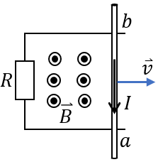
Case 1: Faraday’s Law $\oint{\overset{⃑}{F}/q∙d\overset{⃑}{l}}=\int_{b}^{a}{\overset{⃑}{E}∙d\overset{⃑}{l}}=-\frac{dΦ}{dt}= E$ (induce $emf$）
Case 2: Lorenz force （motion-induce $emf$）
$E$=$\oint{\frac{\overset{⃑}{F}}{q}∙d\overset{⃑}{l}}=\int_{a_{R}}^{b}{\overset{⃑}{E}∙d\overset{⃑}{l}}+\int_{b_{rod}}^{a}{\left(\overset{⃑}{E}+\overset{⃑}{v}×\overset{⃑}{B}\right)∙d\overset{⃑}{l}}$
$=\oint{\overset{⃑}{E}∙d\overset{⃑}{l}}+\int_{b_{rod}}^{a}{(\overset{⃑}{v}×\overset{⃑}{B})∙d\overset{⃑}{l}}=\int_{b_{rod}}^{a}{(\overset{⃑}{v}×\overset{⃑}{B})∙d\overset{⃑}{l}}$
since $\oint{\overset{⃑}{E}∙d\overset{⃑}{l}}=0$ for static field.
On the other hand, inside metal $\overset{⃑}{E}+\overset{⃑}{v}×\overset{⃑}{B}=0$ (no resistance)
$$E=\int_{a_{R}}^{b}{\overset{⃑}{E}∙d\overset{⃑}{l}}=V_{a}-V_{b}=-\int_{b_{rod}}^{a}{\overset{⃑}{E}∙d\overset{⃑}{l}}=\int_{b_{rod}}^{a}{(\overset{⃑}{v}×\overset{⃑}{B})∙d\overset{⃑}{l}}$$
Everything is consistent!

Case 3: Chemical battery
$E$=$\oint{\frac{\overset{⃑}{F}}{q}∙d\overset{⃑}{l}}=\int_{a_{R}}^{b}{\overset{⃑}{E}∙d\overset{⃑}{l}}+\int_{b_{battery}}^{a}{\left(\overset{⃑}{E}+{\overset{⃑}{F}}_{ch}/q\right)∙d\overset{⃑}{l}}=\oint{\overset{⃑}{E}∙d\overset{⃑}{l}}+\frac{1}{q}\int_{b_{battery}}^{a}{{\overset{⃑}{F}}_{ch}∙d\overset{⃑}{l}}$
$E$=$\frac{1}{q}\int_{b_{battery}}^{a}{{\overset{⃑}{F}}_{ch}∙d\overset{⃑}{l}}$
Inside battery: ${\overset{⃑}{F}}_{ch}+q\overset{⃑}{E}+\overset{⃑}{f}=0$ $\overset{⃑}{f}:$ friction
$V_{a}-V_{b}=-\int_{b_{R}}^{a}{\overset{⃑}{E}∙d\overset{⃑}{l}}=-\int_{b_{battery}}^{a}{\overset{⃑}{E}∙d\overset{⃑}{l}}=\frac{1}{q}\int_{b_{battery}}^{a}{{\overset{⃑}{F}}_{ch}∙d\overset{⃑}{l}}+\frac{1}{q}\int_{b_{battery}}^{a}{\overset{⃑}{f}∙d\overset{⃑}{l}}$
(effect of internal resistance)
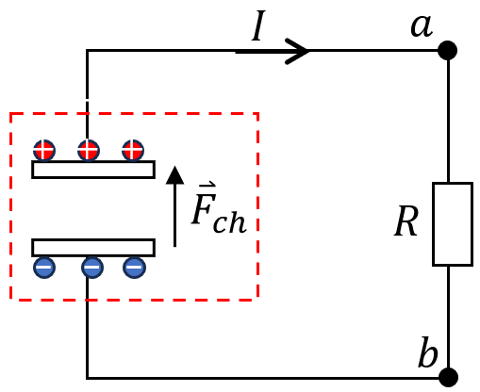
Since $\overset{⃑}{f}∝\overset{⃑}{v}$ , $\frac{1}{q}\int_{b_{battery}}^{a}{\overset{⃑}{f}∙d\overset{⃑}{l}}=-\frac{.B}{q^{2}}I$
Here $B$ is a constant. Then $\frac{B}{q^{2}}$ can be view as internal resistance $R_{in}$.
$$V_{a}-V_{b}=E-IR_{in}=IR$$
$I=\frac{E}{R+R_{in}}$ $V_{a}-V_{b}=\frac{R}{R+R_{in}}E$
- Kirchhoff’s rule
- Kirchhoff loop condition: Consider a loop consisting of a generator and a few lumped elements. We assume no magnetic leaking outside the elements.
$$0=\oint{\overset{⃑}{E}∙d\overset{⃑}{l}}=\int_{a}^{b}{\overset{⃑}{E}∙d\overset{⃑}{l}}+\int_{b}^{c}{\overset{⃑}{E}∙d\overset{⃑}{l}}+\int_{c}^{d}{\overset{⃑}{E}∙d\overset{⃑}{l}}+\int_{d}^{a}{\overset{⃑}{E}∙d\overset{⃑}{l}}$$
The integration path is along the dashed lines. $\sum{u_{i}}=0$
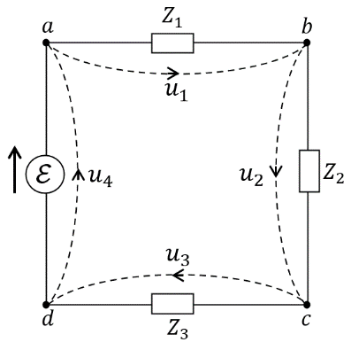
Check the loop $d→$ generator $a→$ dashed lines $→ d$
$$E=\int_{d}^{a}{\left(\frac{1}{q}{\overset{⃑}{F}}_{other}+\overset{⃑}{E}\right)∙d\overset{⃑}{l}}+\int_{a}^{d}{\overset{⃑}{E}∙d\overset{⃑}{l}}$$
If neglecting internal resistance of the generator:
$$\frac{1}{q}{\overset{⃑}{F}}_{other}+\overset{⃑}{E}=0$$
$$E=-\int_{d}^{a}{\overset{⃑}{E}∙d\overset{⃑}{l}}=-u_{4}$$
$$u_{1}+u_{2}+u_{3}- E=0$$

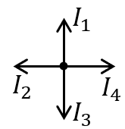
- Kirchhoff node condition: For each node, the total current sum should be zero.
$\sum_{i}{I_{i}}=0$, pay attention to the positive position.
***Example:
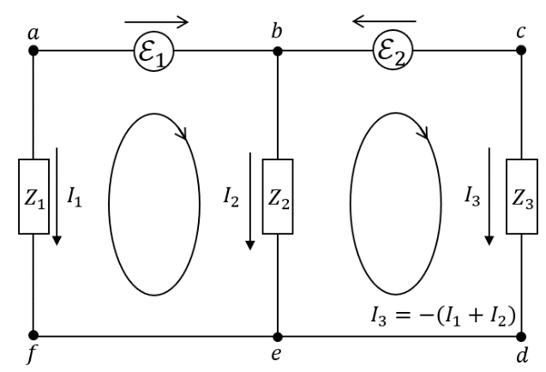
Consider the left loop:
$u_{1}+u_{2}- E_{1}=0$ $-I_{1}Z_{1}+I_{2}Z_{2}-E_{1}=0$
Right loop:
$u_{2}+u_{3}+ E_{2}=0$ $-I_{2}Z_{2}+I_{3}Z_{3}+E_{2}=0$
Node condition: $I_{1}+I_{2}+I_{3}=0$
$E_{2} -I_{2}Z_{2}-\left(I_{1}+I_{2}\right)Z_{3}=0$
$\left\{\begin{aligned} I_{1}=\frac{Z_{2}E_{2}-(Z_{2}+Z_{3})E_{1}}{z_{1}\left(z_{2}+z_{3}\right)+z_{2}z_{3}} \\ I_{2}=\frac{Z_{1}E_{2}+Z_{3}E_{1}}{z_{1}\left(z_{2}+z_{3}\right)+z_{2}z_{3}}\end{aligned}\right.$
Generally speaking, Kirchhoff Law applies when the wave feature of $E\&M$ is not prominent. i.e. if the wave length $λ≫l$, where $l$ is the circuit size.
For $ν=50 Hz$, $λ=\frac{c}{ν}=6×{10}^{6} m$
$ν=100 MHz$, $λ=3m$
$ν=1 GHz$, $λ=0.3m$ radio frequency
$ν=1 THz$, $λ=0.3 mm$
$ν=400-800 THz$, $λ=400-700 nm$ visible light

*** In addition, we use the approximation of lumped circuit. We have neglected that circuit itself may carry inductance and capacitance, which we call distributed impedance.

Condition for Kirchhoff’s Rule
- Consider the scale of the entire circuit:
$$\oint{\overset{⃑}{E}∙d\overset{⃑}{l}}=-\frac{∂}{∂t}\iint{\overset{⃑}{B}∙d\overset{⃑}{s}}$$
Estimate the contribution from RHS, which is $Bl^{2}/T$ with $T=1/ν$ the period.
The RHS can be neglected if $\frac{Bl^{2}}{T}≪u$, where $u$ is a typical voltage drop across an element. Plug in $B\sim μ_{0}I/l$:
$u≫\frac{μ_{0}Il}{T}$ $\frac{u}{I}≫\frac{μ_{0}l}{T}=\frac{h}{e^{2}} \frac{1}{4πϵ_{0}}\frac{e^{2}}{ℏc} 2ϵ_{0}μ_{0}c\frac{l}{T}$
Here $\frac{h}{e^{2}}≈26kΩ$quantum resistance.
$\frac{1}{4πϵ_{0}}\frac{e^{2}}{ℏc}=α=\frac{1}{137}(=\frac{v_{e}}{c} )$ fine-structure constant. – SI
$\frac{u}{I}=Z≫2α\frac{l}{cT}\frac{h}{e^{2}}$
② The charge accumulation on a node is at the order of $(\sum_{i}{I_{i}})T$, which cannot exceed the order of $CE$ with $C$ the effective capacitance of the entire circuit.
Since $C$=$ϵ_{0}S/l≈ϵ_{0}l$ $\left(\sum_{i}{I_{i}}\right)\sim \frac{ϵ_{0}lE}{T}$
$\sum_{i}{I_{i}}$ is negligible, if $\frac{\left(\sum_{i}{I_{i}}\right)}{I}\sim \frac{E}{I}\frac{ϵ_{0}l}{T}≪1$, where $I$ is a typical current.
It means $Z≪\frac{T}{ϵ_{0}l}=\frac{T}{ϵ_{0}l}$ $\frac{h}{e^{2}} \frac{1}{4πϵ_{0}}\frac{e^{2}}{ℏc}2ϵ_{0}c=2α\frac{cT}{l} \frac{h}{e^{2}}$
$$Z≪2α\frac{λ}{l} \frac{h}{e^{2}}$$
Since $\frac{h}{e^{2}}≈26kΩ$ and $2α=2/137,$ define $R_{0}=2α\frac{h}{e^{2}}≈380 Ω$
Kirchhoff’s Law is applicable under the condition:
$\frac{l}{λ}≪\frac{Z}{R_{0}}≪\frac{λ}{l}$
Example:
***For a daily life circuit ($50 Hz$), $λ=cT=6×{10}^{6} m$, $l\sim 1 m$
We have $\frac{λ}{l}=6×{10}^{6}$, there should be no problem.
***But if consider a power system at $l\sim 1km$, even that $\frac{λ}{l}\sim {10}^{4}≫1$, but the typical resistance/impedance: ${10}^{-4}≪\frac{Z}{R_{0}}≪{10}^{4}$ this is an importance constraint.
*** For a typical FM radio frequency circuit $100 MHz$, $λ=3m$
A typical radio size $L\sim 0.1m$ $\frac{λ}{l}≈30$.
The application of Kirchhoff’s Law requires $1/30≪\frac{Z}{R_{0}}≪30$

