Lecture 3 – Gauss’s law
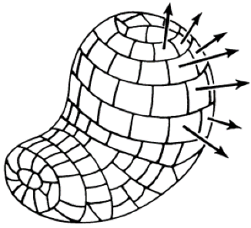
- Electric flux
Consider an irregular surface, for each patch $d{\overset{⃐}{a}}_{i}$, with the direction outward-pointing normal to the surface.
- Definition of flux: $dΦ=\overset{⃑}{E}∙d{\overset{⃑}{a}}_{i}$
(i.e. consider a water flow)
Note: this definition of flux is applicable to any vector function, whatever physical variable it may represent.
Then the total flux: $Φ=∯{\overset{⃑}{E}∙d\overset{⃑}{a}}$
- Gauss’s law
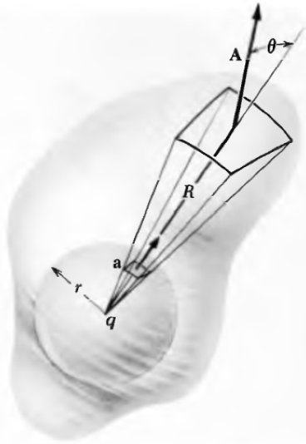
- For Static charge in a sphere with radius $r_{0}$
Flux: $Φ=\frac{1}{4πϵ_{0}}\frac{q}{r_{0}^{2}}4πr_{0}^{2}=\frac{q}{ϵ_{0}}$ $\left(=4πq --CGS\right)$
Consider an element of solid angle $dΩ=da/r^{2}$. It cut the sphere into an area of $d\overset{⃑}{a}$. Flux penetrating this area:
$dΦ=\frac{1}{4πϵ_{0}}\frac{q}{r_{0}^{2}}da=\frac{q}{ϵ_{0}}\frac{dΩ}{4π}$ ($\frac{q}{r_{0}^{2}}da=qdΩ$ --CGS)
*** Solid angle (立体角Ω): a measure of the amount of 3D angle that a given object covers from a particular point.
If there is an irregular surface, enclosing the small sphere. Then the solid angle $dΩ$ corresponds to an new area $d\overset{⃑}{A}$ at the irregular surface.
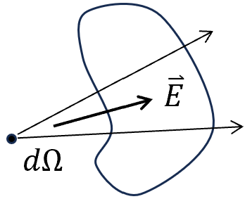
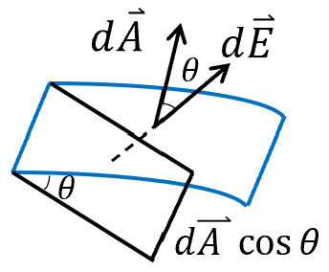
As for $d\overset{⃑}{A}$, its projection to the direction of $\overset{⃑}{E}$ is
$$dA cosθ=dS=dΩ R^{2}$$
$$-→ dΦ^{'}=\overset{⃑}{E}∙d\overset{⃑}{A}=E∙dA cosθ=\frac{1}{4πϵ_{0}}\frac{q}{R^{2}}∙dΩ R^{2}$$
$=\frac{q}{ϵ_{0}}\frac{dΩ}{4π} -→$ $dΦ=dΦ^{'}$
$-→ Φ=\int{dΦ}=\frac{q}{ϵ_{0}}\int{\frac{dΩ}{4π}}=\frac{q}{ϵ_{0}}$ ($=4πq--CGS$)
- Discussion:
1) For a closed surface outside the charge, $Φ=0$.
2) For a many-charge system, the superposition law:
$$Φ=∯{\overset{⃑}{E}∙d\overset{⃑}{a}}=∯{\left({\overset{⃑}{E}}_{1}+{\overset{⃑}{E}}_{2}+…+{\overset{⃑}{E}}_{n}\right)∙d\overset{⃑}{a}}=\frac{1}{ϵ_{0}}\sum_{i=1}^{n}{q_{i}}=\frac{Q}{ϵ_{0}}$$
$=\frac{1}{ϵ_{0}}\iiint_{V}{ρ dτ}$ consider a continuous distribution of charge.
In a large scale, one can generalize from point charges to continuous charge distributions with charge density $ρ.$

$∯{\overset{⃑}{E}∙d\overset{⃑}{a}}=\frac{1}{ϵ_{0}}\iiint_{V}{ρ dτ}$ Gauss’s Law ---SI
$∯{\overset{⃑}{E}∙d\overset{⃑}{a}}=4π\iiint_{V}{ρ dτ}$ ---CGS
3) Gauss's law and Coulomb's law are not two independent physical laws, but the same law expressed in different ways. Gauss’s law is considered an inverse version of Coulomb’s law.
If $E∝\frac{q}{r^{3}}$, $Φ∝\frac{q}{r^{3}}∙4πR^{2}∝\frac{q}{r}$. $Φ$ would depend on $r$ and $Φ→0$ as $r→+∞$.
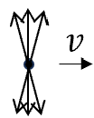
4) Gauss’s law is more general than Coulomb’s law. They are equivalent for electrostatics. But a field that is inverse-square in $r$, but not spherically symmetrical can satisfy Gauss' law. In other words, Gauss' law alone does not imply the symmetry of the field of a point source which is implicit in Coulomb's law. E.g. for a moving charge, its electric field line exhibits as follows, but Gauss’s law remains.
5) The proof of Gauss’s law hings on the inverse square nature of the interaction and of course on the additivity of interactions. Therefore, the Gauss-like law can be applicable to any inverse-square field in physics, for instance, to the gravitational field.
- Gauss’s law in differential form
Gauss’s theorem: $∯{\overset{⃑}{E}∙d\overset{⃑}{a}}=\iiint_{V}{∇∙\overset{⃑}{E} dτ}=\frac{1}{ϵ_{0}}\iiint_{V}{ρ dτ}$
- Gauss’s Law $∇∙\overset{⃑}{E}=\frac{ρ}{ϵ_{0}}$ -- SI in differential form
$∇∙\overset{⃑}{E}=4πρ$ --CGS
- Applications: Gauss’s law is a powerful method to derive the electric field distribution when combined with symmetry analysis.
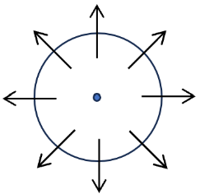
- Point charge: For a spherical symmetry, $\overset{⃑}{E}$ is only along the radial direction, and exhibit the same strength at the same distance.
$$Φ=∯{\overset{⃑}{E}∙d\overset{⃑}{a}}=\frac{q}{ϵ_{0}} -→ E∙4πr^{2}=\frac{q}{ϵ_{0}} -→ E=\frac{1}{4πϵ_{0}}\frac{1}{r^{2}}$$
or $\overset{⃑}{E}=\frac{1}{4πϵ_{0}}\frac{1}{r^{2}}\hat{r}$
2）Spherically symmetric charge distribution
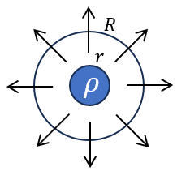
The analysis above only involves the spherical symmetry. Hence it is also applicable to a spherically symmetric charge distribution with $r$.
$$E∙4πR^{2}=\frac{1}{ϵ_{0}}\int_{0}^{r}{\oint_{Ω}{ρ(r')r^{'2}dr^{'}}dΩ}=\frac{1}{ϵ_{0}}\int_{0}^{r}{4πr^{'2}dr^{'}ρ(r')}$$
For $R≥r,$ $E=\frac{1}{4πϵ_{0}}\frac{1}{R^{2}} \int_{0}^{r}{4πr^{'2}dr^{'}ρ(r')}=\frac{1}{4πϵ_{0}}\frac{Q}{R^{2}}$
For $R≤r$, $E=\frac{1}{4πϵ_{0}}\frac{1}{R^{2}} \int_{0}^{R}{4πr^{'2}dr^{'}ρ(r')}=\frac{1}{4πϵ_{0}}\frac{Q(R)}{R^{2}}$

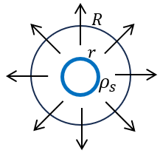
- For a hollow spherical charged shell with $r$,
$$E∙4πR^{2}=\frac{1}{ϵ_{0}}∯{r^{2}dΩ ρ_{s}}$$
For $R≥r,$ $E=\frac{1}{4πϵ_{0}}\frac{1}{R^{2}} ∯{r^{2}dΩ ρ_{s}}=\frac{1}{4πϵ_{0}}\frac{Q}{R^{2}}$
For $R<r$, $E=0$
For electric field outside the shell, it looks as if the charge is concentrated in the center.
- Field of a long line charge
Suppose the line charge density of $λ$. Consider a point with distance of $r$ to the line. By reflection symmetry with respect to x-axis, $\overset{⃑}{E}$ is along y-direction.
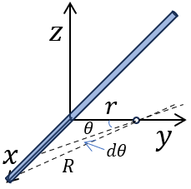
Method 1: Coulomb’ law
$$d\overset{⃑}{E}=\frac{1}{4πϵ_{0}}\frac{dq}{R^{2}}\hat{R}=\frac{1}{4πϵ_{0}}\frac{λdx}{R^{2}}\hat{R}$$
$$-→ dE_{y}=d\overset{⃑}{E}\cos{θ}=\frac{1}{4πϵ_{0}}\frac{λdx}{R^{2}}\cos{θ}$$
The total: $E_{y}=\int{dE_{y}}=\frac{1}{4πϵ_{0}}\int{\frac{λ}{R^{2}}\cos{θ}}dx$
Since $R=\frac{r}{\cos{θ}}$ and $dx=\frac{Rdθ}{\cos{θ}}$, the integral transformed to
$$E_{y}=\frac{1}{4πϵ_{0}}\int_{-π/2 }^{π/2}{\frac{λ\cos{θ}}{r}dθ}=\frac{1}{4πϵ_{0}}\frac{λ}{r}\int_{-π/2 }^{π/2}{\cos{θ}dθ}=\frac{1}{4πϵ_{0}}\frac{2λ}{r}$$
Method 2: Gauss’s law, which leads directly to the same result.
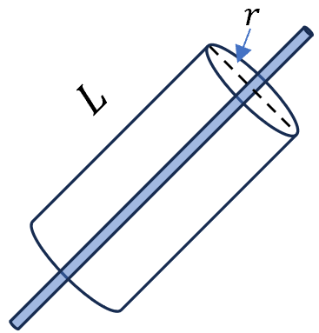
Consider a segment of line charge enclosed by a closed cylinder of length $L$. Since the field is radial $E_{r}∙2πrL=\frac{λL}{ϵ_{0}} -→ E_{r}=\frac{1}{4πϵ_{0}}\frac{2λ}{r}$
$$\overset{⃑}{E}=\frac{1}{4πϵ_{0}}\frac{2λ}{r}{\hat{e}}_{ρ}$$
- Field of planar charge (infinite)
$\overset{⃑}{E}$-field at $\overset{⃑}{r}$ of a distance $d$ above the plane
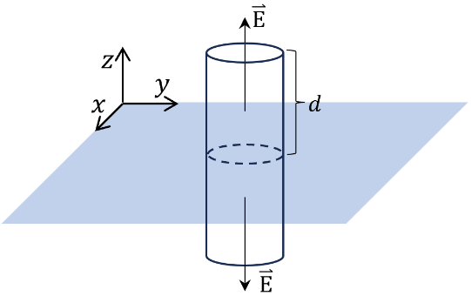
Symmetry analysis:
- Rotation symmetry around z-axis.
$\overset{⃑}{E}=E\hat{z}$，if $\overset{⃑}{E}$ has $\hat{x} or \hat{y}$ components, the $\overset{⃑}{E}$-field will not be unique.
- Reflection symmetry
Construct a cylinder with a cross section $A$, and symmetric to the plane. The system has the reflection symmetry with respect to the plane. Hence, at the other side of the cylinder, $\overset{⃑}{E}=-E\hat{z}$ (the same magnitude but opposite direction).
Applying Gauss’s law, $E∙2A=Aσ/ϵ_{0}$, with $σ$ the surface charge density.
Then $E=σ/2ϵ_{0}$ independent of $r$

$E$of point charge is proportional to the inverse $r^{2}$.
$E$of line charge is proportional to the inverse $r$.
$E$of plane charge is independent of $r$.

