Lecture 4 Electric potential
- For the static electric field of a point charge, along any closed loop $\oint{\overset{⃑}{E}∙d\overset{⃑}{l}=0}$ $∇×\overset{⃑}{E}=0$
Applying to Stoke’s theorem
Since electrostatic field can be viewed as superposition of point charges,
We have $∇×\overset{⃑}{E}=0$ for any electrostatic field. Therefore, $\overset{⃑}{E}$ can be expressed as the gradient of a scalar field, since $∇×∇φ=0$.
$\overset{⃑}{E}=-∇φ$ $φ:$ electric potential (a scalar field)
$φ\left({\overset{⃑}{r}}_{2}\right)-φ\left({\overset{⃑}{r}}_{1}\right)=-\int_{{\overset{⃑}{r}}_{1}}^{{\overset{⃑}{r}}_{2}}{\overset{⃑}{E}∙d\overset{⃑}{r}}$ potential difference between ${\overset{⃑}{r}}_{2}$ and ${\overset{⃑}{r}}_{1}$
Since $\oint{\overset{⃑}{E}∙d\overset{⃑}{l}=0}$, the integral above is path independent (See Lect. vector algebra).
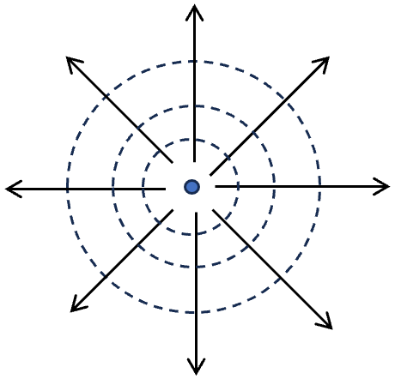
- Electric potential of a point charge
$φ\left(\overset{⃑}{r}\right)=\frac{1}{4πϵ_{0}}\frac{Q}{r}$ $\overset{⃑}{E}=-∇φ=\frac{1}{4πϵ_{0}}\frac{Q}{r^{2}}\hat{r}$
For a charge distribution $ρ(x,y,z)$ and $\overset{⃑}{r}=(x,y,z)$
The potential $φ\left(x,y,z\right)=\frac{1}{4πϵ_{0}}\iiint{dx^{'}dy'dz'\frac{ρ\left(x^{'},y^{'},z^{'}\right)}{|\overset{⃑}{r}-\overset{⃑}{r}'|}}$
$\overset{⃑}{E}=-∇φ=\frac{1}{4πϵ_{0}}\iiint{dx^{'}dy^{'}dz^{'}}\frac{ρ\left(x^{'},y^{'},z^{'}\right)}{{\left|\overset{⃑}{r}-{\overset{⃑}{r}}^{'}\right|}^{3}}(\overset{⃑}{r}-\overset{⃑}{r}')$
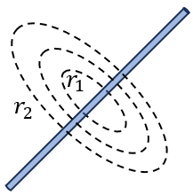
- Potential for an infinite charge line with charge density $λ$
Potential difference:
$φ\left({\overset{⃑}{r}}_{2}\right)-φ\left({\overset{⃑}{r}}_{1}\right)=-\frac{1}{4πϵ_{0}}\int_{r_{1}}^{r_{2}}{\frac{2λ}{r}∙dr}=-\frac{1}{4πϵ_{0}}2λ\ln{r_{2}/r_{1}}$
Potential: $φ=\frac{1}{4πϵ_{0}}2λ\ln{a/r}$, where $a$ is constant, representing a reference point at which $φ$ is at zero.

- Potential for a uniformly charged disk
- Potential along the high symmetric z-axis

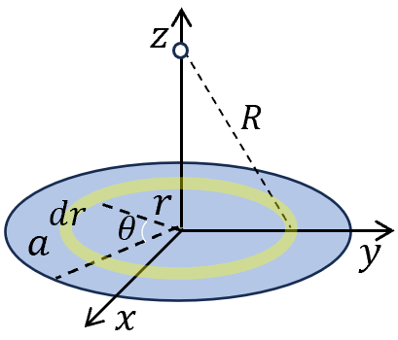
$φ\left(0,0,z\right)=\frac{1}{4πϵ_{0}}\iint{\frac{rdrdθ σ}{R}}=\frac{σ}{2ϵ_{0}}\int_{0}^{a}{\frac{rdr}{\sqrt{r^{2}+z^{2}}}}$
$$=\frac{σ}{4ϵ_{0}}\int_{0}^{a}{\frac{dr^{2}}{\sqrt{r^{2}+z^{2}}}}=\frac{σ}{2ϵ_{0}}\sqrt{r^{2}+z^{2}}{\left.​\right|}_{0}^{a^{2}}=\frac{σ}{2ϵ_{0}}(\sqrt{a^{2}+z^{2}}-|z|)$$
- $\left|z\right|≪a$, $φ\left(0,0,z\right)≈\frac{σ}{2ϵ_{0}}\left(a(1+\frac{z^{2}}{2a^{2}})-\left|z\right|\right)≈\frac{σ}{2ϵ_{0}}(a-|z|)$
- $\left|z\right|≫a$, $φ\left(0,0,z\right)≈\frac{σ}{2ϵ_{0}}\left( \left|z\right|\left(1+\frac{a^{2}}{2{\left|z\right|}^{2}}\right)-\left|z\right|\right)≈\frac{σ}{4ϵ_{0}}\frac{a^{2}}{\left|z\right|}=\frac{1}{4πϵ_{0}}\frac{Q}{\left|z\right|}$
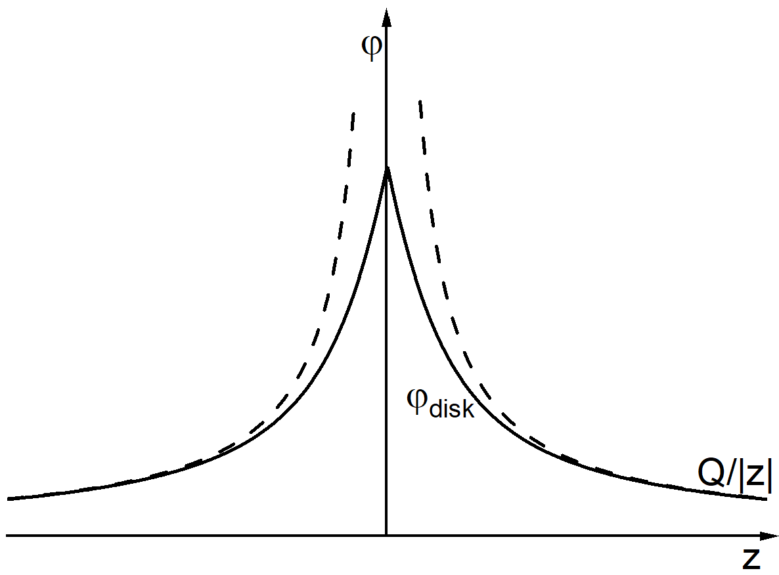
At the large distance, the expression of potential reduces to that of a point charge. As we should expect, at a considerable distance from the disk (relative to its diameter), it doesn’t matter much how the charge is shaped; only the total charge matters, in first approximation.
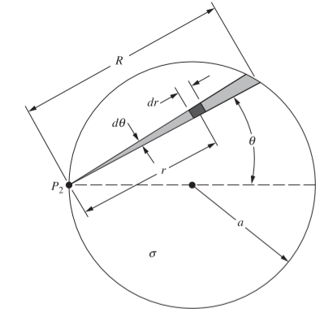
- Potential on the rim
Calculate the potential at $P_{2}$ from the thin wedge
Small element of the wedge $dq=σrdθdr$
Contribution to $φ$: $\frac{dq}{4πϵ_{0}r}=\frac{σdθdr}{4πϵ_{0}}$
From the wedge: $\frac{σdθ}{4πϵ_{0}}\int_{0}^{R}{dr}=\frac{σRdθ}{4πϵ_{0}}$
In total: $φ=\frac{σ}{4πϵ_{0}}\int_{-π/2}^{π/2}{Rdθ}$
Substituting $R=2a\cos{θ}$ $φ=\frac{σa}{2πϵ_{0}}\int_{-π/2}^{π/2}{\cos{θ}dθ}$=$\frac{σa}{πϵ_{0}}$
***Comparing this with the potential at the center of the disk, $σa/2ϵ_{0}$,we see that, as we should expect, the potential falls off from the center to the edge of the disk. The electric field, therefore, must have an outward component in the plane of the disk. The uniformly charged disk is not a surface of constant potential. That is why we remarked earlier that the charge, if free to move, would redistribute itself toward the rim.

- Electric Field
$\overset{⃑}{E}=-∇φ\left(0,0,z\right)=E_{z}\hat{z}$ $E_{z}=\left\{\begin{aligned}\frac{σ}{2ϵ_{0}}\left(1-\left|z\right|/\sqrt{a^{2}+z^{2}}\right) at \left|z\right|>0 \\ -\frac{σ}{2ϵ_{0}}\left(1-\left|z\right|/\sqrt{a^{2}+z^{2}}\right) at \left|z\right|<0\end{aligned}\right.$

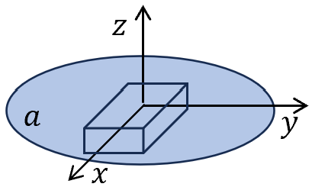
Actually, if we sufficiently approach $z=0$, even away from z-axis, the plate looks as if infinitely large. We choose a small box,
$A\left(E_{z}\left(x,y,0^{+}\right)-E_{z}\left(x,y,0^{-}\right)\right)=\frac{Aσ}{ϵ_{0}}$
$E_{z}\left(x,y,0^{+}\right)-E_{z}\left(x,y,0^{-}\right)=\frac{σ}{ϵ_{0}}$
the discontinuity of the normal component of the electric field.
Since the system is reflection symmetric with respect to xy-plane,
$$E_{z}\left(x,y,0^{+}\right)=-E_{z}\left(x,y,0^{-}\right)=\frac{σ}{2ϵ_{0}}$$
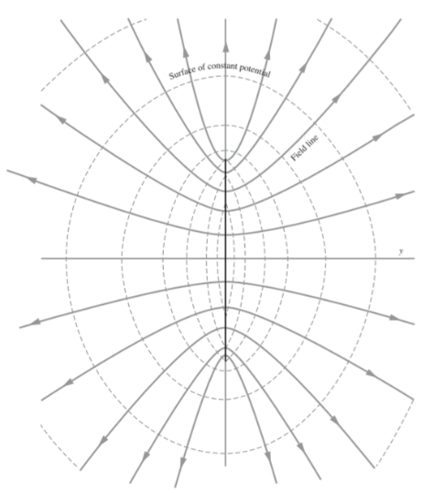
*** The calculation for the potential and $\overset{⃑}{E}$ away from the axis in the general case is complicate. We illustrate the equal potential surface and electric field lines below. Near the center of the disk these are lens-like surfaces, while at distances much greater than $a$, they approach the spherical form of equipotential surfaces around a point charge.

$\overset{⃑}{E}$-field lines are perpendicular to the equal potential surface. It’s not a hyperbola (See $\overset{⃑}{E}$ in a conducing disk later).
Note: We shall often meet surface charge distributions in the future, especially on metallic conductors. However, the object just described is not a conductor; if it were, as we shall soon see, the charge could not remain uniformly distributed but would redistribute itself, crowding more toward the rim of the disk.
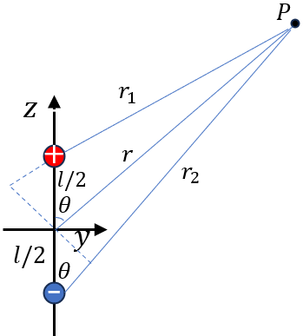
- Electric potential of a dipole
$$φ\left(P\right)=\frac{q}{4πϵ_{0}}(\frac{1}{r_{1}}-\frac{1}{r_{2}})$$
Using spherical coordinates: $P(r,θ,φ)$
By rotation symmetry along $z$-axis, $φ$ doesn’t play $P(r,θ)$
In long-distance limit $r≫l$
- $r_{1}=r-\frac{l}{2}\cos{θ}$ and $r_{2}=r+\frac{l}{2}\cos{θ}$
- $=\frac{q}{4πϵ_{0}}\left(\frac{1}{r_{1}}-\frac{1}{r_{2}}\right)=\frac{q}{4πϵ_{0}}\left(\frac{1}{r-\frac{l}{2}\cos{θ}}-\frac{1}{r+\frac{l}{2}\cos{θ}}\right)=\frac{1}{4πϵ_{0}}\frac{q}{r}\left(\frac{1}{1-\frac{l}{2r}\cos{θ}}-\frac{1}{1+\frac{l}{2r}\cos{θ}}\right)$
$$≈\frac{1}{4πϵ_{0}}\frac{q}{r}\left(\left(1+\frac{l}{2r}\cos{θ}\right)-\left(1-\frac{l}{2r}\cos{θ}\right)\right)=\frac{1}{4πϵ_{0}}\frac{ql\cos{θ}}{r^{2}}$$
*** Define: $\overset{⃑}{p}≡q\overset{⃑}{l}$ the dipole moment, pointing from negative to positive.
- $φ\left(P\right)=\frac{1}{4πϵ_{0}}\frac{p\cos{θ}}{r^{2}}$
- Electric field $\overset{⃑}{E}=-∇φ$
$$\overset{⃑}{E}\left(r,θ\right)=-\hat{r}\frac{∂}{∂r}\left(\frac{1}{4πϵ_{0}}\frac{p\cos{θ}}{r^{2}}\right)-\hat{θ}\frac{1}{r} \frac{∂}{∂θ}\left(\frac{1}{4πϵ_{0}}\frac{p\cos{θ}}{r^{2}}\right)$$
$$=\frac{1}{4πϵ_{0}}\frac{p}{r^{3}} (2\cos{θ}\hat{r}+\sin{θ}\hat{θ})$$
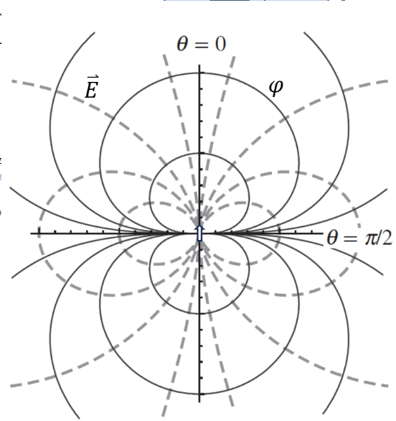
*** Key points for dipoles:
- $φ$ and $\overset{⃑}{E}$ depend on $q$ and $l$ only through the product $p$.
- $φ\sim \frac{1}{r^{2}}$ and $\overset{⃑}{E}\sim \frac{1}{r^{3}}$, in contrast with $φ\sim \frac{1}{r}$ and $\overset{⃑}{E}\sim \frac{1}{r^{2}}$ of point charge.
- $φ\left(r,θ\right)$ and $\overset{⃑}{E}\left(r,θ\right)$ is angle dependent, since the dipole has a preferred direction along the joint line.

- Potential of monopole, dipole, quadrupole and Octupole
$φ\sim q/r$ $φ\sim ql/r^{2}$

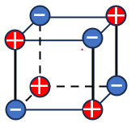
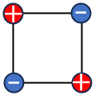
$φ\sim ql^{2}/r^{3}$ $φ\sim ql^{3}/r^{4}$

- Force on the surface charge
We know that for a uniformly charged sphere, right at the surface $E(r=R^{+})=σ$/$ϵ_{0}$ and $E(r=R^{-})=0$. There is a discontinuity. If we ask which value should be used to calculate the force to the surface charge, we need to consider more.
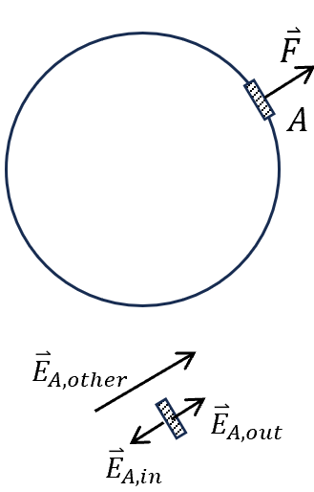
The force on a small area $A$ should be due to the electric field generated from other charges, not by the field by $A$ itself.
The field generated by $A$ : $E_{A,out}={-E}_{A,in}.$
And the field generated by other part should smooth across the shell.
$\left.⟹\left\{\begin{aligned}{\vec{E}}_{A,out}+{\vec{E}}_{other}=\vec{E}\left(R^{+}\right) \\ {\vec{E}}_{A,in}+{\vec{E}}_{other}=\vec{E}\left(R^{-}\right)\end{aligned}\right.\right. ⇒ {\vec{E}}_{other}=\frac{1}{2}\left(\vec{E}({\vec{R}}^{+})+\vec{E}({\vec{R}}^{-})\right)$
$$\vec{F}=Aσ{\vec{E}}_{other}=\frac{Aσ^{2}}{2ϵ_{0}} → \frac{dF}{dA}=\frac{σ^{2}}{2ϵ_{0}}$$

- Energy stored in the field
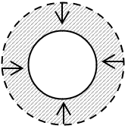
Suppose the bulb uniformly charged with $Q$ and is compressed slightly from initial $R$ to $R-δR$. This requires that work be done against the repulsive force between the charge. The force required is $\overset{⃑}{F}=-{\overset{⃑}{F}}_{st}$
$$dW=FδR=Q\frac{σ}{2ϵ_{0 }}δR=\frac{1}{8πϵ_{0 }}\frac{Q^{2}}{R^{2}}δR$$
On the other hand, the only difference of before and after the compression is the change of electric field in shadowed region.
$E=\frac{1}{4πϵ_{0 }}\frac{Q}{R^{2}}$ $dW=\frac{ϵ_{0 }}{2}E^{2}∙4πR^{2}δR=\frac{ϵ_{0 }}{2}E^{2}δV$
This means the work done by the mechanical force is switched to (stored as) the electric potential energy in the varied volume of bulb.
Energy density: $u=\frac{ϵ_{0 }}{2}E^{2}$
Theorem: The electric potential energy $U$ stored in a charge system can be expressed as $U=\frac{ϵ_{0 }}{2}\iiint_{V}{E^{2}dτ}$------------eq. 1
*** Comparison: Energy stored by $n-q$ system
$$U=\frac{1}{2}\sum_{j=1}^{n}{q_{j}\sum_{i≠j}{\frac{1}{4πϵ_{0}}\frac{q_{i}}{r_{ij}}}}$$
- $U=\frac{1}{2}\iiint_{V}{ρφdτ}$ in view of charge
*** The above two forms are two different aspects of the same thing.
$$\vec{E}=-∇φ ⇒ ∇⋅\vec{E}=-∇^{2}φ ⇒ U=\frac{ϵ_{0 }}{2}\iiint_{V}{E^{2}dτ}=\frac{ϵ_{0 }}{2}\iiint_{V}{{\left(∇φ\right)}^{2}dτ}$$
$$(∇φ)∙\left(∇φ\right)=∇⋅\left(φ∇φ\right)-φ∇^{2}φ$$
Gauss’s Law $∇⋅\vec{E}=-∇^{2}φ=ρ/ϵ_{0 }$ Poisson Equation
$⇒$ $U=\frac{ϵ_{0 }}{2}\iiint_{V}{∇⋅\left(φ∇φ\right)dτ}+\frac{1}{2}\iiint_{V}{ρφdτ}=\frac{ϵ_{0 }}{2}∯{φ∇φ} d\overset{⃑}{s}+\frac{1}{2}\iiint_{V}{ρφdτ}$
$φ\sim \frac{1}{R}, ∇φ\sim \frac{1}{R^{2}},$ hence $φ∇φ\sim \frac{1}{R^{3}}$,
As we set $R→ +∞$, then the surface term $→0$
Then $U=\frac{1}{2}\iiint{ρφ }dV$ for an electrostatic system ---eq.2
One may think of this energy as “stored” in the field. The system being conservative, that amount of energy can of course be recovered by allowing the charges to go apart. Therefore, it is nice to think of the energy as “being somewhere” meanwhile. There is no harm in this, but in fact we have no way of identifying, quite independently of anything else, the energy stored in a particular cubic meter of space.

Only the total energy is physically measurable: the work required to bring the charge into some configuration, starting from some other configuration. Just as the concept of electric field serves in place of Coulomb’s law to explain the behavior of electric charges, so when we use Eq. 2 rather than Eq. 1 to express the total potential energy of an electrostatic system, we are merely using a different kind of bookkeeping. Sometimes a change in viewpoint, even if it is a first only a change in bookkeeping, can stimulate new ideas and deeper understanding. The notion of the electric field as an independent entity will take form when we study the dynamical behavior of charged matter and electromagnetic radiation.

Supporting information for Lecture-4 Electric potential
Potential for a uniformly charged disk
What we have is an insulating disk, like a sheet of plastic, upon which charge has been “sprayed” so that every square meter of the disk has received, and holds fixed, the same amount of charge.

We shall often meet surface charge distributions in the future, especially on metallic conductors. However, the object just described is not a conductor; if it were, as we shall soon see, the charge could not remain uniformly distributed but would redistribute itself, crowding more toward the rim of the disk.

