Lecture 5 Electric field around conductors
Insulator: bound electrons. Under an external $\overset{⃑}{E}$ field, electrons can be displaced and acquire a new equilibrium. No current!
Conductor: electrons acquire a finite velocity in $\overset{⃑}{E}$ field, developing a current. Electron can travel to a finite distance within a finite time!
The crucial difference between insulators and conductors can only be explained by quantum mechanics.
Common good conductors like ordinary metals differ in their electrical conductivity from common insulators like glass and plastics by factors on the order of 10²⁰.
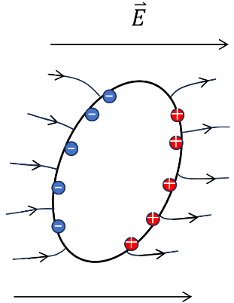
- Conductors under $\overset{⃑}{E}−$ field
Imaging applying ${\overset{⃑}{E}}_{ext}$ to an conductor. Electrons are driven to redistribute resulting in a counter-electric field ${\overset{⃑}{E}}_{ct}$. Only when $\overset{⃑}{E}$ inside of metal become zero, electrons stop moving. Otherwise, more electrons redistribute to cancel $\overset{⃑}{E}$. Finally, $\overset{⃑}{E}$ becomes zero. --Electric shielding
Note: here we do not consider emf.
- $∇∙\overset{⃑}{E}=\frac{ρ}{ϵ_{0}}=0$ $ρ=0$
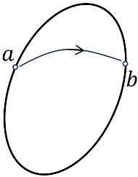
- Then the body and surface of metal becomes iso-potential:
$$φ_{b}−φ_{a}=−\int_{a}^{b}{d\overset{⃑}{r}}∙\overset{⃑}{E}=0$$
- $\overset{⃑}{E}$-field perpendicular to the surface $⟸$
$\overset{⃑}{E}=−∇φ$ $⟹$ $\overset{⃑}{E}⟘$ metal surface
Gauss’s law: $E_{n,out}−E_{n,in}=σ/ϵ_{0}$ $⟹$ $E_{n,out}=σ/ϵ_{0}$
$E_{n,out}\left\{\begin{aligned}>0, if \overset{⃑}{E} outward \\ <0, if \overset{⃑}{E} inward\end{aligned} \right.$
- Hence, the total charge of the metal:
$Q=∯{σdS=ϵ_{0}∯{\overset{⃑}{E}}d\overset{⃑}{S}}$
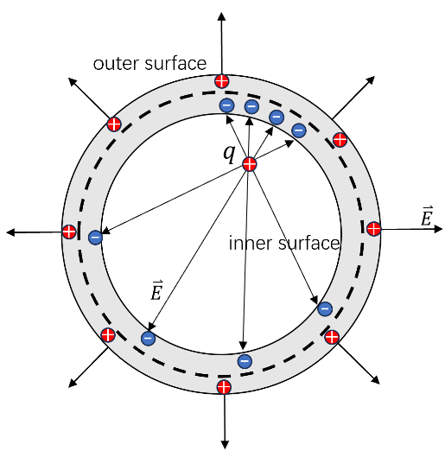
Example:
A point charge $q$ is located at an arbitrary position inside a neutral conducting spherical shell. What is the distribution of $\overset{⃑}{E}$ outside the shell.
- $\overset{⃑}{E}$is zero inside the conductor. If we draw a Gaussian surface that lies entirely inside the material (the dashed line), there is zero flux, so it must enclose zero charge. The charge on $S_{in}$is therefore $−q$. This leaves $q$ for $S_{out}$ The charge $−q$ on $S_{in}$won’t be uniformly distributed unless the point charge $q$ is located at the center.
- The question is how $q$ is distributed over $S_{out}$. Imagine that we have removed this $q$ charge, we have only the point charge $q$ and $−q$ on $S_{in}$. Their combination produces zero $\overset{⃑}{E}$ in the conductor and also produces zero field outside.
- If we gradually add back $q$ on $S_{out}$, it will distribute itself in a spherically symmetric manner, because $\overset{⃑}{E}$ is zero. Due to this spherical symmetry, the outer-surface charge will produce no field inside $S_{out}$.
- Hence, the external field is due only to the spherically symmetric $q$ on $S_{out}$. By Gauss’s law, the external field is therefore radial (with respect to the center of the shell and not the point charge q) and has magnitude $q/4πϵ_{0}r^{2}$.
The electric field outside the shell is the same as the spherically symmetric field due to a charge q located at the center of the shell
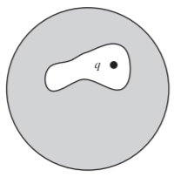
*** The shape of the inner surface was irrelevant.

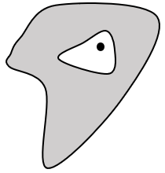
+*** For arbitrary shape of conductors, the external field is not spherically symmetric. But the external field is independent of the location of the point charge inside. Whatever the location, the external field equals the field in a system without the point charge q, where we instead dump $q$ on the shell (which will distribute itself in a particular manner).

- Uniqueness of electrostatic problem
Suppose there exist a few metallic surfaces with the electric potential $φ_{1}, φ_{2}…φ_{n}$, respectively, $φ$ approaches to zero at infinite distance or on a conductor enclosing this system. Then the distribution of electric potential is uniquely determined. (There is no other charge in space.)
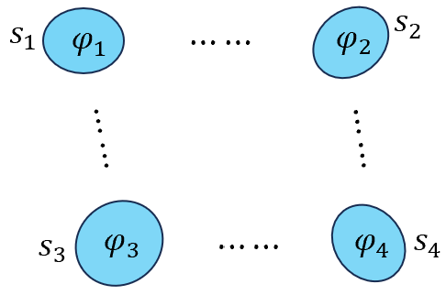
Physically, not mathematically, the existence of a solution is out of question.

Below, we focus on the uniqueness (This boundary-value problem has no more than one solution).

The solution of the electric potential $φ$ satisfies:
$$\frac{ρ}{ϵ_{0}}=∇∙\overset{⃑}{E}=−∇∙\left(∇φ\right)=−∇^{2}φ$$
We only consider the case without free charges, then the electric potential satisfies the Laplace’s equation!
$$\left\{\begin{aligned}∇^{2}φ=0, with the boundary condition \\ φ{\left.​\right|}_{s_{i}}=φ_{i}, for i=1,…, n \end{aligned}\right.$$
Suppose there exist two different solutions $φ$ and $ψ$. Then define $W= φ−ψ$, such that $\left\{\begin{aligned}∇^{2}W=0 \\ W{\left.​\right|}_{s_{i}}=0, for i=1,…, n\end{aligned}\right.$.
Then $∫{\left(∇W\right)}^{2}d^{3}\vec{r}=∫\left(∇⋅\left(W∇W\right)−W∇^{2}W\right)d^{3}\vec{r}=∫∇⋅\left(W∇W\right)d^{3}\vec{r}=∯{W⋅∇Wd\vec{S}}=0$ (integral at the boundary of $s$)
$∇W=0$ $\left\{\begin{aligned}φ−ψ=const \\ W{\left.​\right|}_{s_{i}}=0\end{aligned}\right.$ $φ=ψ$
- Corollary: For a hollow conductor with any shape, if there is no charge inside, the $\overset{⃑}{E}$ inside the conductor equal zero.
Proof: The potential function inside the conductor $φ(x, y, z)$, must satisfy Laplace’s equation. The entire boundary of this region, namely the conductor, is an equipotential, so we have $φ =φ_{0}$ everywhere on the boundary. One solution is obviously $φ =φ_{0}$throughout the volume. But there can be only one solution, according to the uniqueness theorem, so this is it. And then “$φ =constant$” implies $E=0$.
The absence of $\overset{⃑}{E}$ inside a conducting enclosure is useful. It is the basis for electrical shielding. For most practical purposes, the enclosure does not need to be completely tight. If the walls are perforated with small holes, or made of metallic screen, the field inside will be extremely weak except in the immediate vicinity of a hole. A metal pipe with open ends (a few diameters long) will very effectively shield the space inside (not close to either end). We are considering only static fields of course, but for slowly varying electric fields these remarks still hold.

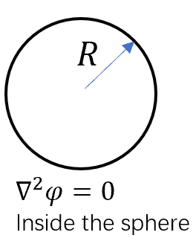
- An important property of harmonic function $∇^{2}φ=0$. Draw a sphere with a finite radius $R$, then the average of $φ(\overset{⃑}{r})$ on the sphere equals the value of $φ$ located at the center of the sphere, if there is no extra charge inside.
$\int{dS∙φ=4πR^{2}φ(\overset{⃑}{r}=0)}$
Proof: We design a charge density distribution $ρ(\overset{⃑}{r})=σδ(r−R)$. Then the charge distribution on the surface with total charge $Q=\int{4πr^{2}dr ρ}=4πR^{2}σ$.
Assume the potential generated by $ρ(\overset{⃑}{r})$ as $Ψ$, i.e. $∇^{2}Ψ=−ρ(\overset{⃑}{r})/ϵ_{0}$. We calculate the electric potential energy:
$$\int{ρφ}d^{3}\overset{⃑}{r}=−ϵ_{0}\int{∇^{2}Ψ\left(\overset{⃑}{r}\right)}φ(\overset{⃑}{r}) d^{3}\overset{⃑}{r}$$
According to ${ ∇}^{2}Ψ(\overset{⃑}{r})φ=∇(∇Ψ⋅φ)−∇Ψ⋅∇φ=∇∙(∇Ψ⋅φ−Ψ⋅∇φ)+Ψ∇^{2}φ$
$∫ρφ\left(\vec{r}\right)d^{3}\vec{r}=−ϵ_{0}∯_{boundary}{\left(∇Ψ⋅φ−Ψ⋅∇φ\right)}d\overset{⃑}{S}−ϵ_{0}∫d^{3}\vec{r} Ψ∇^{2}φ$
Here the surface integral over boundaries, which are outside the sphere we are interesting. $∇^{2}φ=−ρ'(\overset{⃑}{r})/ϵ_{0}$, where $ρ'(\overset{⃑}{r})$ also distribute outside the sphere. Hence, the contribution to the RHS are determined by $Ψ$ outside the sphere of $R$.
${\left.4πR^{2}σ〈φ〉​\right|}_{surf}$
$$=−ϵ_{0}∯_{boundary outside sphere}{\left(∇Ψ⋅φ−Ψ⋅∇φ\right)}⋅d\overset{⃑}{S}+\int_{outside sphere}{d^{3}\overset{⃑}{r} Ψρ'(\overset{⃑}{r})}$$
We know that $Ψ$is generated by $ρ=σδ(r−R)$. Its distribution outside the sphere is the same as all the charge concentrates to the center according to Gauss’s law. Therefore, we assume that this charge is concentrated at the center of the sphere, and carrying out the same derivation as above, we obtain:
$${\left.Q φ\right|}_{center}=−ϵ_{0}∯_{boundary outside sphere}{\left(∇Ψ⋅φ−Ψ⋅∇φ\right)}⋅d\overset{⃑}{S}+\int_{outside sphere}{d^{3}\overset{⃑}{r} Ψρ'(\overset{⃑}{r})}$$
And the RHS is the same as the RHS of ${\left.4πR^{2}σ〈φ〉\right|}_{surf}$ , i.e.
$4πR^{2}σ〈φ〉{\left.​\right|}_{surf}=Q φ(\overset{⃑}{r}=center)$
$〈φ〉{\left.​\right|}_{surf}=φ(\overset{⃑}{r}=center)$
- Application of the uniqueness theorem
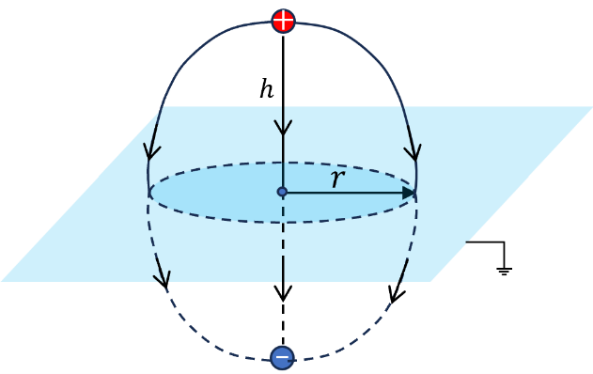
- Consider a positive charge $+q$ put above a grounded conductivity plate. According to the uniqueness theorem, we can design an equivalent system (but much simpler) which provides the same boundary condition.
Then we replace the grounded plates by a negative charge$−q$, then the bisector plane is the zero potential plane.
Consider a point on the plate with distance $r$ from the projection of the $+q−−q$ line. Then the field is along the z-axis:
$$E_{z}=−\frac{2}{4πϵ_{0}}\frac{q}{r^{2}+h^{2}}\frac{h}{\sqrt{r^{2}+h^{2}}}=−\frac{1}{2πϵ_{0}} \frac{hq}{{\left(r^{2}+h^{2}\right)}^{3/2}}$$
Hence $σ_{z}=ϵ_{0}E_{z}=−\frac{1}{2π} \frac{hq}{{\left(r^{2}+h^{2}\right)}^{3/2}}$ charge density at the plate.
Then the total charge
$Q=\int{σ_{z}rdrdθ}=−q\int_{0}^{∞}{r^{2}dr\frac{h}{{\left(r^{2}+h^{2}\right)}^{\frac{3}{2}}}}=−q$ $\int_{0}^{∞}{\frac{r}{h}\frac{d\left(\frac{r}{h}\right)}{{\left({\left(\frac{r}{h}\right)}^{2}+1\right)}^{\frac{3}{2}}} }$
$$=−q\int_{0}^{∞}{\frac{xdx}{{\left(x^{2}+1\right)}^{\frac{3}{2}}}=} −q$$
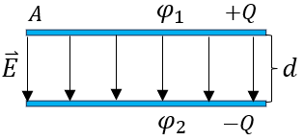
- Capacitors
Define: capacitance $C=Q/u$
$u$=$φ_{1}−φ_{2}$ : voltage
For a two-plate capacitor:
$EA=Q/ϵ_{0}$ $E=σ/ϵ_{0}$ $u=Ed=σd/ϵ_{0}$
$C=\frac{Q}{σd/ϵ_{0}}=ϵ_{0}A/d$ -- SI
Unit of $C$: $F$ farad $\left[F\right]=\left[C\right]/[V]$.
$C=A/4πd$ -- CGS with unit of $cm$.
- Energy stored in capacitors
- From the view of charging: Suppose we increase the charge from $Q$ to $Q+dQ$ by transporting a positive charge $dQ$ from the negative to the positive plate, working against the potential difference $u$.
$ℰ=\int_{0}^{Q_{f}}{uIdt}=\int_{0}^{Q_{f}}{udQ}=\frac{1}{C}\int_{0}^{Q_{f}}{QdQ}=\frac{Q_{f}^{2}}{2C}$
Or $ℰ=\frac{{\left(Cu\right)}^{2}}{2C}=\frac{1}{2}Cu^{2}=\frac{1}{2}uQ_{f}$
- For the force point of view, force, say on the upper one,
$\overset{⃑}{F}=\frac{\left({\overset{⃑}{E}}_{in}+{\overset{⃑}{E}}_{out}\right)}{2}Q=\frac{σ}{2ϵ_{0}}Q$
$\left\{\begin{aligned}ℰ=F∙d=\frac{1}{2ϵ_{0}}\frac{Q^{2}}{A}d \\ C=ϵ_{0}A/d \end{aligned}\right.$ $ℰ=Q^{2}/2C$
The later method is consistent with $\frac{ℰ}{V}=\frac{ϵ_{0}}{2}E^{2}$, the energy stored in the electric field.
*** Considering a charge sphere, it and the infinity consist of a capacitor.
We know that $φ=Q/4πϵ_{0}R$ $C=4πϵ_{0}R$.
Given $R≈6400 km$ the size of the earth, $C= 7 × {10}^{−4} F$
The farad happens to be a gigantic unit.
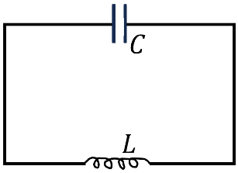
- L-C circuit - may not be introduced this time
$ℰ=\frac{Q^{2}}{2C}+\frac{1}{2}L{\left(\frac{dQ}{dt}\right)}^{2}=\frac{Q^{2}}{2C}+\frac{Φ^{2}}{2L}, where Φ=LI=LdQ/dt$
Analog to a mechanical oscillator, $ℰ=\frac{1}{2}mω^{2}x^{2}+\frac{1}{2}m{\left(\frac{dx}{dt}\right)}^{2}$
$L→m, C^{−1}→mω^{2}$ $=>ω=\sqrt{1/LC}$
- Capacitance of a group of conductors/charges
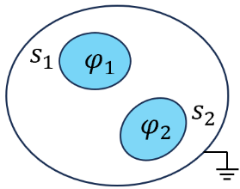
Two metallic balls, $S_{1}$ and $S_{2}$ with the electric potential $φ_{1}$ and $φ_{2}$, with the outer shell grounded. The relation between $Q_{1,2}$ and $φ_{1,2}$ are
$\left(\frac{Q_{1}}{Q_{2}}\right)$=$\left(\begin{matrix}C_{11} & C_{12} \\ C_{21} & C_{22}\end{matrix}\right)\left(\frac{ φ_{1}}{ φ_{2}}\right)$
Here the capacitance depends on the shape and arrangement of the conducting bodies.
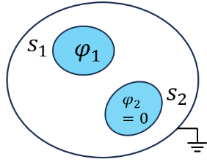
The above relation can be derived via the superposition principle.
$Case I φ_{2}=0 −→$ $\begin{matrix}Q_{1}^{I}=C_{11}φ_{1} \\ Q_{2}^{I}=C_{21}φ_{1}\end{matrix}$

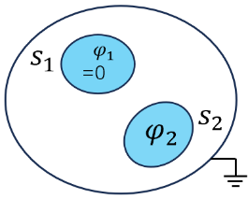
$$Case II φ_{1}=0 −→ \begin{matrix}Q_{1}^{II}=C_{12}φ_{2} \\ Q_{2}^{II}=C_{22}φ_{2}\end{matrix}$$
$Case I+Case II$ $\left\{\begin{aligned}Q_{1}=C_{11}φ_{1}+C_{12}φ_{2} \\ Q_{2}=C_{21}φ_{1}+C_{22}φ_{2}\end{aligned}\right.$
Proof:
$Case I$: $\left\{\begin{aligned}∇^{2}φ_{I}=0 \\ φ_{I}=φ_{1}{\left.​\right|}_{S_{1}} \\ =0|s_{2} \\ =0|outshel\end{aligned}\right.$ $Case II$: $\left\{\begin{aligned}∇^{2}φ_{II}=0 \\ φ_{II}=0{\left.​\right|}_{S_{1}} \\ =φ_{2}|s_{2} \\ =0|outshell\end{aligned}\right.$
Superposition: $\left\{\begin{aligned}∇^{2}(φ_{I}+φ_{II})=0 \\ φ_{I}+φ_{II}=φ_{1}{\left.​\right|}_{S_{1}} \\ =φ_{2}|s_{2} \\ =0|outshel\end{aligned}\right.$
$\begin{matrix}Q_{1}=Q_{1}^{I}+Q_{1}^{II} \\ Q_{2}=Q_{2}^{I}+Q_{2}^{II}\end{matrix}$ $\left(\frac{Q_{1}}{Q_{2}}\right)$=$\left(\begin{matrix}C_{11} & C_{12} \\ C_{21} & C_{22}\end{matrix}\right)\left(\frac{ φ_{1}}{ φ_{2}}\right)$
This superposition law can be applied to arbitrary amounts of conductors.
Applications：
A lightning rod: providing an alternative path for the lightning’s current on its way to ground, instead of the building itself. The field generated by the tip is larger, meaning that the lightning is more likely to hit the rod than some other point on the building. Should the tip of the rod be pointed or rounded? sphere). It isn’t obvious which of these effects wins, but experiments suggest that a somewhat rounded tip has a better chance of being struck.

Capacitors:
Store energy, slow discharge or fast discharge. In the slow case, the capacitor acts effectively like a battery: shake flashlights (手摇手电筒) and power adapters (电源适配器). For the fast case, capacitors have the ability to release their energy very quickly (unlike a normal battery): flashbulbs (闪光灯), stun guns (电击枪), defibrillators (除颤器), and the National Ignition Facility (NIF), whose goal is to create sustained fusion (核聚变). The capacitor for a flashbulb might store 10 J of energy, while the huge capacitor bank at the NIF can store 4*10⁸J.

Dynamic random access memory (DRAM): works by storing charge on billions of tiny capacitors. Each capacitor represents a bit of information; uncharged is 0, charged is 1. The capacitors are leaky, so their charges must be refreshed many times each second (64ms is a common refresh time); hence the adjective “dynamic.” The memory is lost when the power is shut off. The permanent memory on the hard disk must therefore use a different method – the orientation of tiny magnetic domains.

Condenser microphone: makes use of the fact that the capacitance of a parallel-plate capacitor depends on the plate separation. (“Condenser” is simply another name for a capacitor.) A small capacitor consists of a fixed plate and a movable diaphragm (隔膜). The pressure from the sound
waves in the air moves the diaphragm back and forth, changing the separation and hence the capacitance. This movement is extremely small but is large enough to affect a circuit and generate an electric signal that can be sent to a speaker.

Basic element of electronic circuits: $R, L, C$ in radios, cell phones, wireless computer connections The resonant frequency of a circuit depends on the inductance and capacitance. If the resonant frequency equals the frequency of the desired signal (transmitted by an electromagnetic wave), the electromagnetic wave could be detected by the circuit.

