Lecture 7 relativity I
Feynman’s Lect. 1 Chap. 15 and Lect. 2 Chap. 25-26
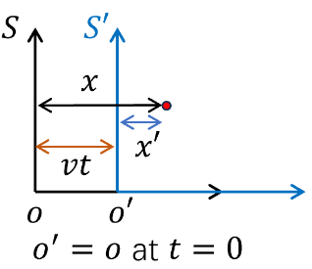
- Galilean Relativity: the Newton’s laws hold the same form in all the inertial frames. – A moving large boat with closed window at a constant velocity, the passengers cannot notice its motion as stated by Galileo to defend for Copernicus’s sun-centered solar system.

$$\left.\left\{\begin{aligned}x^{'}=-vt \\ &y^{'}=y,z^{'}=z,t^{'}=t\end{aligned}\right.\right.$$

Velocity-addition: ${\dot{x}}^{'}=\dot{x}-v$
Acceleration: ${\ddot{x}}^{'}=\ddot{x} → m{\overset{⃑}{a}}^{'}=m\overset{⃑}{a}→ {\overset{⃑}{F}}^{'}=\overset{⃑}{F}$
Newton’ space-time view. $↑$
- However, Maxwell’s equation does not obey this Galilean relativity.
$\left\{\begin{aligned}∇∙\overset{⃑}{E}=\frac{ρ}{ε_{0}} --Gauss^{'}s Law \\ ∇∙\overset{⃑}{B}=0 \\ ∇×\overset{⃑}{E}=-\frac{∂\overset{⃑}{B}}{∂t} --Farady^{'}s ’Law’ \\ ∇×\overset{⃑}{B}=μ_{0}\left(\overset{⃑}{J}+ε_{0}\frac{∂\overset{⃑}{E}}{∂t}\right) --Ampere^{'}s rule+displacement current\end{aligned}\right.$
For a vacuum, $ρ=0 and \overset{⃑}{J}=0$:
$\left\{\begin{aligned}∇∙\overset{⃑}{E}=0 \\ ∇∙\overset{⃑}{B}=0 \\ ∇×\overset{⃑}{E}=-\frac{∂\overset{⃑}{B}}{∂t} \\ ∇×\overset{⃑}{B}=μ_{0}ϵ_{0}\frac{∂\overset{⃑}{E}}{∂t}\end{aligned}\right.$
- Wave function
$\left\{\begin{aligned}∇×\left(∇×\vec{E}\right)=∇\left(∇∙\vec{E}\right)-∇^{2}\vec{E}=-∇^{2}\vec{E} \\ || \\ -\frac{∂}{∂t}∇×\vec{B}=-μ_{0}ϵ_{0}\frac{∂^{2}}{∂t^{2}}\vec{E}\end{aligned}\right.⟹\left\{\begin{aligned}∇^{2}\vec{E}=μ_{0}ϵ_{0}\frac{∂^{2}}{∂t^{2}}\vec{E} \\ c=\frac{1}{\sqrt{μ_{0}ϵ_{0}}}=3×{10}^{8} m/s\end{aligned}\right.$ (wave)
Solution：$E=E_{0}e^{i(kx-ckt)}$ a wave function. It looks that Maxwell’s Equations are only valid in a special frame in which $c=1/\sqrt{μ_{0}ϵ_{0}}$. Mechanical waves (e.g. water wave or sound wave) need media. The wave equation is respect to the frame in which the media is at rest! What’s the media of the E-M wave? In 19th century, it’s considered as ether. At that time, people thought Maxwell’s Equations are only valid in frame of ether (vacuum).
Einstein’s Gedanken experiment of chasing light: Since his childhood, Einstein thought over this question: suppose a person travels at the speed of $c$, what will be see? Then the E-M wave is at rest with respect to him and becomes electro-static problem. This is incompatible with the Maxwell equation. We know that $∇×\vec{E}≠0$ for a E-M wave configuration，which is incompatible with electro-statics.
In other words, that meant in a general frame, Maxwell’s equation will be an ugly form. Einstein did not agree with this! Einstein felt that Maxwell’s equations are so beautiful, it should be valid in any frame! What’s needed is not to change Maxwell’s equations, but to change Galileo’s relativity!
If one insists Maxwell’s equations are correct, the only solution is no one can travel at the speed of light! Light speed in any frame is “$c$”.
Michelson-Morley experiment: aim at detecting the relative motion of the earth with respect to ether, by using optics interferometry experiments (光学干涉实验), but got negative results. The relative speed of earth with respect to ether is zero? What’s the specialty of earth? Interestingly, Eistein did not know this experiment before his theory was published.
2. Postulates of special relativity
1) Every inertial frame is equivalent to each other. All the physics laws are the same, we cannot distinguish different inertial frame y looking at the form of physical laws. no preferred frame!!!
2) There is an finite upper limit for the velocity of signal propagation, which is “$c$”. This upper limit must be the same for all the inertial frames, otherwise we can distinguish these frames by measuring them. light speed is the same!
3. Time dilation (时间膨胀)
We need to change our understanding of time. What is time? This another profound question-time is related to the fact we become older and dying. But now we only consider how to measure time.
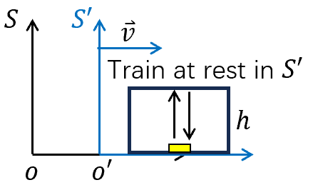
Event ‘1’: a light pulse emitted from the floor.
Event ‘2’, the light pulse comes back to the floor

Measure in $S'$ (rest frame), the time interval $∆t^{'}=2h/c$. （Proper time – 原时）
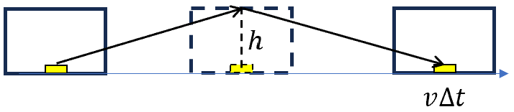
Measure in $S$
（observer frame）

$$∆t=2\sqrt{h^{2}+{\left(v∆t/2\right)}^{2}}/c$$
⟹ $∆t=\sqrt{ ∆{t^{'}}^{2}+{\left(v∆t/c\right)}^{2}}=\sqrt{ ∆{t^{'}}^{2}+β^{2}∆t^{2}}$ with $β=\frac{v}{c}$
$∆t^{2}=\frac{∆{t^{'}}^{2}}{1-β^{2}}$ $∆t=\frac{∆t^{'}}{\sqrt{1-β^{2}}}$
Define $τ=∆t^{'}$ as proper time (原时)， $∆t=\frac{τ}{\sqrt{1-β^{2}}}$.
Set $γ=\frac{1}{\sqrt{1-β^{2}}}$, $∆t=γτ$.
$τ$ is measured at the rest frame, called proper time. Proper time is the shortest!!! The co-moving clock with train is observed run slower.
Example:
- Muon-decay ($μ$-decay): $τ$ in the rest frame is $1.5 μs$.
From the cosmic ray, say $γ=\frac{1}{\sqrt{1-β^{2}}}=1.67$ with $β=0.8$ ⟹ $t=2.5 μs$
(Muon is a lepton, an elementary particle similar to the electron, with an electric charge of −1 e and a spin of 1/2, but with a much greater mass.)
2） Atomic clock in the airplane
3) GPS (The global positioning system)

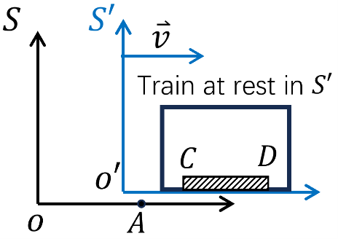
3. Length contraction (尺缩)

event ‘1’: the end “D” passes “o”.
event ‘2’: the end “C” passes “o”.

The time interval between “1” and “2” in $S^{'}$ frame $∆t'$ and $S$ frame $∆t$.
⟹ $∆t^{'}=∆t/\sqrt{1-β^{2}}$ ($∆t$ is proper time, because the events 1, 2 occurs at the same location.)
The length of ruler CD measured in $S$, $l=v∆t$
in $S^{'}$, $l^{'}=v∆t'$
⟹ $\frac{l}{l^{'}}=\frac{∆t}{∆t^{'}}=\sqrt{1-β^{2}}≤1$: length contraction
$l'$ is the length measured at the rest frame – proper length(原长) is the longest!!!
3. Lorenz transformation
A rotation of space-time ⇔ c.f. rotation in 3D space.
$\left(\begin{matrix}Δx^{'} \\ c∆t^{'}\end{matrix}\right)=(\begin{matrix}a_{1} & a_{2} \\ a_{3} & a_{4}\end{matrix})\left({Δx \atop c∆t}\right)$
we need to determine the 4-real coefficient.
$Δx$, $∆t$ ($Δx'$, $∆t'$) are the spatial and temporal interval between two events measured in $S.$ ($S'$)

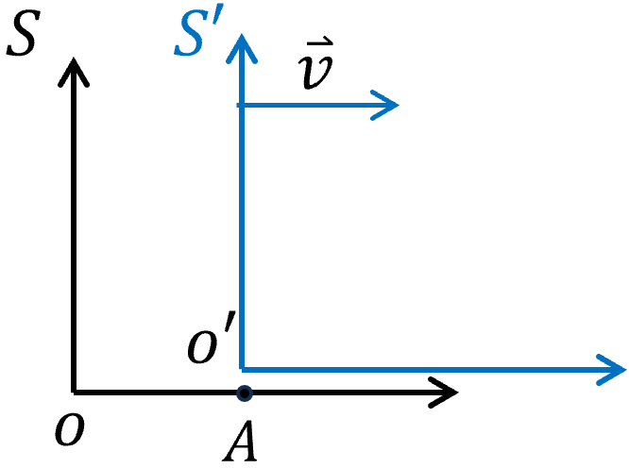
event ‘1’ $o^{'}$ and $o$ coincide
event ‘2’: $o'$ and $A$ coincide

In frame $S$, $∆x=v∆t$
In frame $S'$, $∆x'=0$, $∆t^{'}=∆t\sqrt{1-β^{2}}$
$⟹$ $a_{1}∆x+a_{2}c∆t=0$ $⟹$ $\frac{a_{2}}{a_{1}}=-\frac{∆x}{c∆t}=-\frac{v}{c}=-β$
$⟹$ $c∆t^{'}=a_{3}∆x+a_{4}c∆t=\left(a_{3}v+a_{4}c\right)∆t=c∆t\sqrt{1-β^{2}}$
$⟹$ $a_{3}β+a_{4}=\sqrt{1-β^{2}}$
i.e. $\left(\begin{matrix}0 \\ \sqrt{1-β^{2}}\end{matrix}\right)=(\begin{matrix}a_{1} & a_{2} \\ a_{3} & a_{4}\end{matrix})\left({β \atop 1}\right)$
Then let us switch the role of $S$ and $S'$
With respect to $S'$, $S$ is moving along -$\hat{x}$ axis with $v$, repeat the above argument, we can have a space-time interval:
In frame $S$, $∆x=0$, $∆t=∆t'\sqrt{1-β^{2}}$ $\begin{matrix}∆x \\ ∆t \\ v\end{matrix}⇔\begin{matrix}∆x' \\ ∆t' \\ -v\end{matrix}$
In frame $S'$, $∆x^{'}=-v∆t'$,
$$({-v∆t^{'} \atop c∆t^{'}})=\left(\begin{matrix}a_{1} & a_{2} \\ a_{3} & a_{4}\end{matrix}\right)\left({0 \atop c\sqrt{1-β^{2}}∆t^{'}}\right)⇒({-β \atop 1})=(\begin{matrix}a_{1} & a_{2} \\ a_{3} & a_{4}\end{matrix})({0 \atop \sqrt{1-β^{2}}}).$$
$a_{2}=-β/\sqrt{1-β^{2}}$, $a_{4}=1/\sqrt{1-β^{2}}$
$a_{1}=1/\sqrt{1-β^{2}}$, $a_{3}=-β/\sqrt{1-β^{2}}$
$⟹$ $\left(\begin{matrix}a_{1} & a_{2} \\ a_{3} & a_{4}\end{matrix}\right)=γ\left(\begin{matrix}1 & -β \\ -β & 1\end{matrix}\right)=u$

$\left(\begin{matrix}Δx^{'} \\ c∆t^{'}\end{matrix}\right)=γ(\begin{matrix}1 & -β \\ -β & 1\end{matrix}) \left({Δx \atop c∆t}\right)$ Lorenz transformation
- $\left({Δx \atop c∆t}\right)$ Important results
- The length of space-time interval
$∆S^{2}=∆x^{2}-{\left(cΔt\right)}^{2}$ is invariant under Lorenz transformation – (4-vector).
Proof: $∆{S'}^{2}=\left(∆x^{'},cΔt^{'}\right)\left(\begin{matrix}1 & \\ & -1\end{matrix}\right)\left(\begin{matrix}∆x^{'} \\ cΔt^{'}\end{matrix}\right)=\left(∆x,cΔt\right)u^{T}\left(\begin{matrix}1 & \\ & -1\end{matrix}\right)u\left(\begin{matrix}∆x \\ cΔt\end{matrix}\right)$
Since $u=γ\left(\begin{matrix}1 & -β \\ -β & 1\end{matrix}\right)=u^{T}$
$$u^{T}\left(\begin{matrix}1 & \\ & -1\end{matrix}\right)u=γ^{2}\left(\begin{matrix}1 & -β \\ -β & 1\end{matrix}\right)\left(\begin{matrix}1 & -β \\ β & -1\end{matrix}\right)=γ^{2}\left(\begin{matrix}1/γ^{2} & \\ & -1/γ^{2}\end{matrix}\right)=\left(\begin{matrix}1 & \\ & -1\end{matrix}\right)$$
$∆{S'}^{2} =\left(∆x,cΔt\right)\left(\begin{matrix}1 & \\ & -1\end{matrix}\right)\left(\begin{matrix}∆x \\ cΔt\end{matrix}\right)=∆S^{2}$
- Proper length
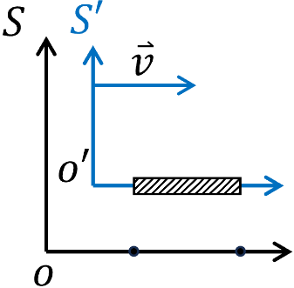
Measure length of a moving ruler
In $S$, $∆t=0$, $∆x=l$ (we need $∆t=0$, because ruler is moving.)
In $S'$, $∆t^{'}=-γβl/c,$ $∆x'=γl$ $⟹$ $∆x^{'}/∆x=γ$ (the ruler is static, so $∆t^{'}≠0$ is finite.)
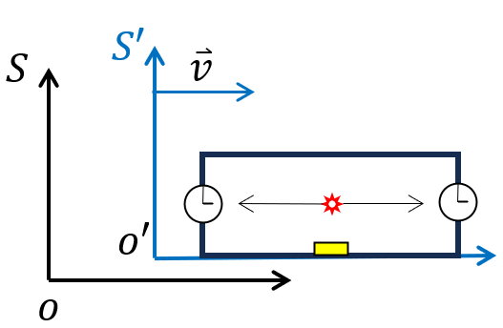
- relativity of simultaneity
- Suppose that a man moving in a space ship ($S'$ frame) has placed a clock at each end of the ship and interested in making sure that the two clocks are in synchronism. How to do that?
One way is that the man stands exactly at the midpoint between the clocks. Then he send out a light signal, going both ways at the speed of$c$. The light will arrive at both clocks at the same time. This simutanesous arrival of the signals can be used to synchronize the clocks.
What will happen if an observer is in $S$ frame. Does him/her agree that both clocks are synchronous? For viewpoint of the observer in $S$ frame, since the ship is moving forward, the clock in the front end was running away from the light sorce, hence the light had to go more distance to catch up the front clock. On the other hand, the rear clock was advancing to meet the light, since the distance was short. In summary, in $S$ frame, the rear clock was activated earlier than the front clock.
This circumstance is called “failure of simultaneity at a distance”. The simultaneous events occurring at two positions in S' frame must happen at different time in other coordinate systems.

- If $∆t=0$, $⟹$ $∆t^{'}=-γβl/c≠0$.
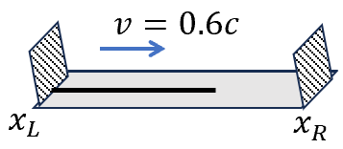
The snake paradox: a snake with proper length $100cm$, travel with respect to the table $v=0.6c$. Two cleavers with distance $100cm$ cut the same time in the lab frame ($S$). What will happen?
In the Lab frame $S$, $∆t=0$: $t_{L}=t_{R}$; $∆x=100cm:{ x}_{R}-x_{L}=100 cm$
Length of snake $\frac{100cm}{γ}=80cm<∆x$. No harm to the snake!
In the snake frame: the snake felt the length between two cleaver $100cm/γ=80cm<∆x$. Then it will be cut. How to understand this paradox?
Lorenz transformation $\left(\begin{matrix}∆x^{'}=x_{R}^{'}-x_{L}^{'} \\ cΔt^{'}=c(t_{R}^{'}-t_{L}^{'})\end{matrix}\right)=γ\left(\begin{matrix}1 & -β \\ -β & 1\end{matrix}\right)\left(\begin{matrix}100 cm \\ 0\end{matrix}\right)$
With $β=0.6, γ=1.25$, $\left\{\begin{aligned}∆x^{'}=x_{R}^{'}-x_{L}^{'}=125 cm \\ cΔt^{'}=-75 cm\end{aligned}\right.$
The right cleave fell at $-\frac{75cm}{c}$at $125 cm$. No problem, the snake will not be cut!
- What’s relative/absolute?
${\left(∆S\right)}^{2}$ does not change.
${\left(∆S\right)}^{2}>0$: space-like
${\left(∆S\right)}^{2}=0$: light-like
${\left(∆S\right)}^{2}<0$: time-like
- If ${\left(∆S\right)}^{2}≤0$, it means the two event can build up causality relativity ($|∆t|≥|∆x/c|$).
Then $cΔt^{'}=γ\left(-βΔx+cΔt\right)=γc(Δt-βΔx/c)$
$\left|∆t\right|≥\left|\frac{∆x}{c}\right|>β|Δx|/c$ ⟹ $∆t$ and $∆t'$ has the same sign.
The segmence of two light-like or time-like events cannot be reversed!! (With causality relation)
- If ${\left(∆S\right)}^{2}>0$, we will have $\left|∆t\right|<|∆x/c|$. Information travel in a speed $v>c$ then $β>1$.
Then $cΔt^{'}=γc(Δt-βΔx/c)$ with $\left|∆t\right|<|∆x/c|<β|∆x/c|$
$Δt^{'}$ and $Δt$ has the reverse sign!!! Time turn backs? Which is not in reality, since the speed can never exceed $c$ according to the special relativity.
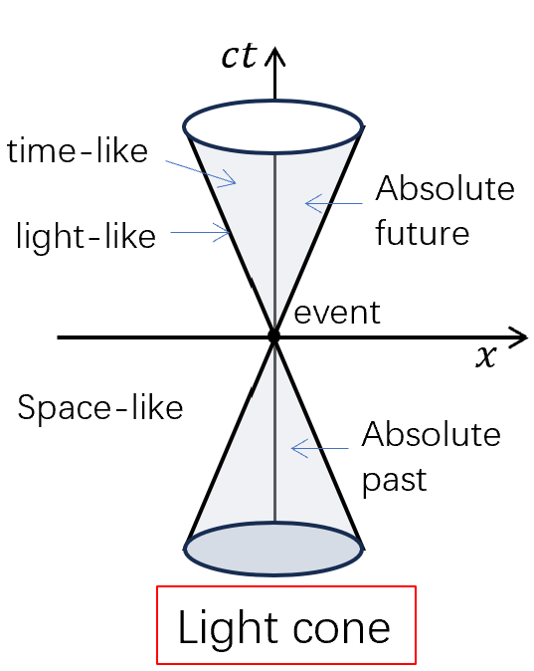

Note: Lorentz and Galilean transformations
Even the simple phenomenon of the drift velocity in a crossed electric and magnetic field configuration, which is typically a high school textbook problem, is incompatible with the Galilean space-time transformation.

